CEBU INSTITUTE OF TECHNOLOGY
UNIVERSITY

COLLEGE OF COMPUTER STUDIES

Software Requirements Specifications
for
DASIGConnect

Change History

Version | Date | Author(s) | Description of Changes | Reason (MVP Validation Findings)
1.0 | 05/02/2026 | Chris Daniel Cabatana, Jaylord Bayonas, Lerah Caones, Mark Anton Camoro, Richemmae V. Bigno | Initial draft — scope, introduction, Module 1 use cases | — (pre-validation)
2.0 | 05/05/2026 | Chris Daniel Cabatana, Jaylord Bayonas, Lerah Caones, Mark Anton Camoro, Richemmae V. Bigno | Added Module 2 use cases; expanded user characteristics | — (pre-validation)
3.0 | 5/09/2026 | Chris Daniel Cabatana, Jaylord Bayonas, Lerah Caones, Mark Anton Camoro, Richemmae V. Bigno | Added Module 3 (AI features, Master Calendar, publishing); expanded NFRs | — (pre-validation)
4.0 | 5/12/2026 | Chris Daniel Cabatana, Jaylord Bayonas, Lerah Caones, Mark Anton Camoro, Richemmae V. Bigno | Added tenant isolation section; revised guard rail taxonomy; expanded notification trigger matrix; incorporated adviser feedback | — (pre-validation)
5.0 | 5/16/2026 | Chris Daniel Cabatana, Jaylord Bayonas, Lerah Caones, Mark Anton Camoro, Richemmae V. Bigno | resolved embedding pipeline specification; added automatic Step 2 publishing failure cleanup; added deployment platform (Vercel/Render); added Voyage AI as external dependency; added accessibility NFR; added data retention policy; added SUS acceptance threshold; clarified token key storage | — (pre-validation)
6.0 | 10/11/2026 | Chris Daniel Cabatana, Jaylord Bayonas, Lerah Caones, Mark Anton Camoro, Richemmae V. Bigno | Updated requirements after implementation verification, including current role scopes, R2 media storage, publishing safeguards, analytics, approval workflow, and onboarding guides | —(pre-validation; implementation verification)
7.0 | 10/17/2026 | Chris Daniel Cabatana, Jaylord Bayonas, Lerah Caones, Mark Anton Camoro, Richemmae V. Bigno | Re-verified every section against release v3.0.2 code and corrected statements the code contradicts (network-wide Moderator review, fixed 8-hour JWT with no silent refresh, Gemini image classification, single-attempt email, configurable guard-rail thresholds and posting window, durable media-processing queue, resubmittable Reject, 30 notification events, Trash/retention, Moderator reschedule caps). Added UC-2.4 A12–A15; numbered the posting window GR-H4 (the code the system reports) and the approval gate GR-H5; added Section 3.6 Validation-Driven Requirement Changes (REQ-124–REQ-127, REQ-218, REQ-320, REQ-321) with learnability NFR REQ-126. | VF-01 readiness score misread as a block (RP-01); VF-02 low unaided completion and SUS 61.8 (RP-02); VF-03 low AI-feature discovery (RP-03); VF-04 mobile review not found (RP-04); VF-05 form-by-form invitations do not scale (RP-05)

Table of Contents

Change History 2
Table of Contents 4
1. Introduction 8
1.1. Purpose 8
1.2. Scope 8
1.3. Definitions, Acronyms and Abbreviations 9
1.4. User Account State Machine 13
1.4.1. State Transition Table 13
1.4.2. Notes 14
1.5. References 15
2. Overall Description 16
2.1. Product perspective 16
2.2. User characteristics 17
2.3. Constraints 17
2.4. Assumptions and Dependencies 18
2.5. Design Philosophy and Operating Model 19
3. Specific Requirements 21
3.1. External interface requirements 21
3.1.1. Hardware interfaces 21
3.1.2. Software interfaces 21
3.1.3. Communications interfaces 22
3.2. Functional requirements 23
1. Module 1: User Access & Content Creation 23
1.1. Administrator Account Management 23
1.1.1. Use Case Diagram 23
1.1.2. Use Case Description 23
1.1.3. Activity Diagram 27
1.1.4. Wireframe 28
1.2. Institution Management 30
1.2.1. Use Case Diagram 30
1.2.2. Use Case Description 30
1.2.3. Activity Diagram 32
1.2.4. Wireframe 33
1.3. Contributor Account Management 35
1.3.1. Use Case Diagram 35
1.3.2. Use Case Description 35
1.3.3. Activity Diagram 37
1.3.4. Wireframe 38
1.4. Login & Session Management 40
1.4.1. Use Case Diagram 40
1.4.2. Use Case Description 40
1.4.3. Activity Diagram 42
1.4.4. Wireframe 43
1.5. Post Drafting & Templates 45
1.5.1. Use Case Diagram 45
1.5.2. Use Case Description 45
1.5.3. Activity Diagram 50
1.5.4. Wireframe 51
1.6. AI & Text Tools Integration 54
1.6.1. Use Case Diagram 54
1.6.2. Use Case Description 54
1.6.3. Activity Diagram 57
1.6.4. Wireframe 58
1.7. Media Attachment Rules 59
1.7.1. Use Case Diagram 59
1.7.2. Use Case Description 59
1.7.3. Activity Diagram 62
1.7.4. Wireframe 63
1.8. Engagement Helpers 64
1.8.1. Use Case Diagram 64
1.8.2. Use Case Description 64
1.8.3. Activity Diagram 66
1.8.4. Wireframe 67
1.9. Draft Submission 68
1.9.1. Use Case Diagram 68
1.9.2. Use Case Description 68
1.9.3. Activity Diagram 70
1.9.4. Wireframe 71
1.10. Moderator Account Management 72
1.10.1. Use Case Diagram 72
1.10.2. Use Case Description 72
1.10.3. Activity Diagram 74
1.10.4. Wireframe 75
2. Module 2: Media Library & Approval Pipeline 77
2.1. Library Uploads & Albums 77
2.1.1. Use Case Diagram 77
2.1.2. Use Case Description 77
2.1.3. Activity Diagram 80
2.1.4. Wireframe 81
2.2. Semantic Search & Filtering 83
2.2.1. Use Case Diagram 83
2.2.2. Use Case Description 83
2.2.3. Activity Diagram 85
2.2.4. Wireframe 86
2.3. Media History Tracking 87
2.3.1. Use Case Diagram 87
2.3.2. Use Case Description 87
2.3.3. Activity Diagram 89
2.3.4. Wireframe 90
2.4. Admin Approval Workflow 92
2.4.1. Use Case Diagram 92
2.4.2. Use Case Description 92
2.4.3. Activity Diagram 96
2.4.4. Wireframe 97
2.5. Automated Watermarking 99
2.5.1. Use Case Diagram 99
2.5.2. Use Case Description 99
2.5.3. Activity Diagram 102
2.5.4. Wireframe 103
3. Module 3: Scheduling, Publishing and Analytics 104
3.1. Master Calendar Visibility 104
3.1.1. Use Case Diagram 104
3.1.2. Use Case Description 104
3.1.3. Activity Diagram 107
3.1.4. Wireframe 108
3.2. Automated Facebook Post Publishing 110
3.2.1. Use Case Diagram 110
3.2.2. Use Case Description 110
3.2.3. Activity Diagram 113
3.2.4. Wireframe 114
3.3. Automated Reminders & Alerts 115
3.3.1. Use Case Diagram 115
3.3.2. Use Case Description 115
3.3.3. Activity Diagram 119
3.3.4. Wireframe 120
3.4. Social Engagement Analytics 122
3.4.1. Use Case Diagram 122
3.4.2. Use Case Description 122
3.4.3. Activity Diagram 123
3.4.4. Wireframe 125
3.5. System Health Analytics 126
3.5.1. Use Case Diagram 126
3.5.2. Use Case Description 126
3.5.3. Activity Diagram 129
3.5.4. Wireframe 130
3.6. Audit Log Review 131
3.6.1. Use Case Diagram 131
3.6.2. Use Case Description 131
3.6.3. Activity Diagram 133
3.6.4. Wireframe 134
3.3. Business Rules and Guard Rails 135
3.3.1. Guard Rail Rules 135
3.3.1.1. Hard Rules 135
3.3.1.2. Soft Rules 136
3.3.1.3. Trigger Rules 137
3.3.1.4. Override & Administrative Action Audit Requirements 139
3.3.2. Application Business Rules 140
3.3.2.1. User Provisioning and Account Management 140
3.3.2.2. Content Submission 142
3.3.2.3. Media and Asset Management 142
3.3.2.4. Content Approval 142
BR-APP-04 — Self-Review Restriction. An Administrator or Moderator may not review, approve, request revisions for, or reject their own submissions. The system unconditionally blocks self-review; another privileged user must perform the validation. 143
3.3.2.5. Notification Behavior 143
3.3.2.6. Analytics 144
3.3.2.7. Publishing 146
3.3.2.8. AI Features 147
3.4. Non-functional requirements 149
3.4.1. Performance 149
3.4.2. Security 149
3.4.3. Reliability 151
3.4.4. Scalability 152
3.4.5. Maintainability and Auditability 152
3.4.6. Data Retention 152
3.4.7. Accessibility 153
3.4.8. Usability 153
3.5. Tenant Isolation (Multi-Institution Data Separation) 153
3.5.1. Core Principle 154
3.5.2. Enforcement Mechanism (Defense in Depth) 154
3.5.3. Visibility by Role and Feature 154
3.5.4. Cross-Institution Access Attempts 155
3.5.5. Audit Logging of Administrator Cross-Institution Actions 155
3.5.6. Tenant Isolation Testing 155
3.6. Validation-Driven Requirement Changes 156
3.6.1. Submission Gate Separate from Quality Tips — REQ-124 (RP-01, VF-01; High) 156
3.6.2. Next Action, Plain-Language Status, and Task Instrumentation — REQ-125, REQ-126 (RP-02, VF-02; High) 156
3.6.3. AI Caption on Upload, Media First, Log-Based Measurement — REQ-320, REQ-321 (RP-03, VF-03; High) 156
3.6.4. Mobile Operability of Role-Critical Actions — REQ-218 (RP-04, VF-04; Medium) 157
3.6.5. Bulk Invitations with Preview and Batch Audit — REQ-127 (RP-05, VF-05; Low–Medium) 157
3.6.6. Status Wording for Notifications and Submissions 157

Introduction

Purpose
The purpose of this document is to provide a complete and detailed specification of DASIGConnect — a centralized Social Media Content Workflow and Scheduling Management System designed for the DOST Acadême–Science and Innovation Group (DASIG) multi-institutional network. This Software Requirements Specification (SRS) defines all functional and non-functional requirements, user characteristics, system constraints, interface specifications, and external dependencies that govern the design, development, and testing of DASIGConnect.
This document also captures a critical design principle that distinguishes DASIGConnect from a workflow-digitization system: the system redistributes coordination work from the Administrator to a self-service model with software-enforced rules, directly addressing the administrative bandwidth bottleneck identified as the root cause of DASIG's current operational failures. This SRS serves as the authoritative reference for the development team, project advisers, and DASIG stakeholders throughout the project lifecycle.

Scope
DASIGConnect is a web-based Social Media Content Workflow and Scheduling Management System scoped to support the social media content coordination operations of the DASIG network under DOST Region 7, specifically for its official Facebook page. The system replaces the current informal, fragmented coordination approach — which relies on manual communication between member institutions and a single overburdened Administrator — with a structured, role-based digital workflow in which Contributors at member institutions self-schedule their content within system-enforced rules, Moderators (network-wide, not institution-bound) triage and review the standard approval queue, and the Administrator retains final authority over exception handling, governance, and strategic configuration.
The system includes the following core functionalities:
- Multi-institution content submission with three-role access control (Contributor, Moderator, Administrator)
- Self-service scheduling by Contributors with automated calendar queue balancing and conflict prevention, governed by a network-wide, admin-toggleable guard-rail ruleset (posting-hours window, daily cap, minimum spacing, minimum lead time)
- A Fast-Track ("Live Event") submission path that bypasses scheduled-slot rules and publishes asynchronously immediately on approval, for time-sensitive coverage
- Post templates (built-in and personal, save-as-template) mimicking Facebook's native composer UI for standardized content creation
- On-demand AI-assisted caption generation from uploaded images using Anthropic Claude Vision, plus AI-assisted album/media matching (tag overlap + visual similarity via Voyage embeddings)
- Fancy Unicode text styling tools for post captions and copy
- Peak-hour posting recommendations based on historical Facebook engagement data
- Mandatory media attachment enforcement, requiring Contributors to attach media from device upload or the media library before a draft can be submitted
- Structured draft submission handoff from the Contributor to the network-wide Moderator/Administrator review queue
- Centralized digital media repository with nested album organization, a shared network library, and per-institution isolation enforced via row-level security
- Media history and asset lifecycle tracking, tiered deletion rules, a 30-day internal purge buffer, and exact-content-hash duplicate detection across the repository
- AI-powered image classification (Google Gemini) and Voyage AI vector embeddings (voyage-4-lite for text and voyage-multimodal-3.5 for images, 1024-dimension) running as a background enrichment pipeline to power semantic media search and album matching
- Moderator/Administrator approval workflow with revision remarks, edit-during-review diff tracking, and reviewer locking
- Automated brand watermarking applied to approved post media at publish time, network-wide configurable
- Master calendar with role-differentiated visibility and editing
- Automated Facebook post publishing via Graph API, and publishing is claimed atomically before any API call to prevent double-publishing
- System and submission lifecycle notification system covering 30 trigger events across state changes, approvals, failures, token health alerts, and empty-schedule warnings — delivered via in-app SSE, email, and (for a subset of events) Facebook Messenger
- Social media and system analytics dashboard tracking posting metrics, page engagement, API token health, and cloud storage capacity, role-scoped with CSV export
- An admin-only, immutable Audit Log — filterable, paginated, structured before/after diff view, CSV export, with a database-enforced append-only guarantee
- An Administrator-only System Health dashboard: database/object-storage capacity, external API status, background job health, and operational metrics (publish success rate, Edit & Approve rate, missed-review rate, and more)
- Optional, contextual, view-only onboarding guides for the submission list, composer, review queue, review decisions, failed publishing recovery, and moderator editing workflows. Guide preferences and dismissed screens are stored per user account and can be disabled or reset.
The system does not include:
- Integration with social media platforms other than the DASIG official Facebook page
- Generative AI image creation or automated content moderation
- Autonomous publishing decisions — all Contributor submissions require Moderator/Administrator approval prior to publication.
- Contributor-facing AI classification suggestion popups — image tagging runs as a background process for media organization and search
- Public post visibility via the Facebook Graph API during development, which remains subject to Meta Business Verification for Live mode

Definitions, Acronyms and Abbreviations
ACTIVE (Account State) — A user account state indicating that the user has completed the invitation token activation flow, set their permanent password, and confirmed their institution membership (for Contributors). An ACTIVE account may authenticate and access DASIGConnect according to its assigned role and tenant scope. ACTIVE is the normal operating state for all user accounts. Contrast with PENDING (token issued, activation not yet completed), EXPIRED (token expired before activation), INACTIVE (account deactivated by an Administrator), and PENDING_EMAIL_UNDELIVERED (invitation email not delivered).
ACTIVE (Institution Status) — An institution status indicating the workspace is fully operational: Contributors may be invited and may submit content, and automated publishing is enabled for the institution. Institutions are created directly in ACTIVE status by an Administrator. The institution may transition to INACTIVE if an Administrator deactivates it.
Administrator — A user role assigned to DASIG administrators operating under DOST Region 7. Administrators have network-wide authority. Routine content review and approval is shared with network-wide Moderators rather than distributed to a separate institutional reviewer role; Administrators also handle exception cases such as failed publishes, institution and account management, and governance. Any Administrator may create content in a Contributor capacity. A single designated Administrator, the Admin Owner, holds sole authority to remove other Administrator accounts.
AI — Artificial Intelligence: The simulation of human intelligence in computer systems, used in DASIGConnect for caption generation, image classification, media recommendation, and album auto-matching.
Album — An event-based grouping of media assets within an institution's media library, assigned either automatically (Auto-Match, based on combined tag and visual similarity) or manually by the actor at the point of upload or during submission organization.
API — Application Programming Interface: A set of protocols that allows the system to communicate with external services, including the Facebook Graph API, the Anthropic Claude Vision API, the Google Gemini API, and the Voyage AI API.
CIT-U — Cebu Institute of Technology – University: One of the primary DASIG member institutions.
Contributor — A user role assigned to faculty, student organization officers, and institutional communications officers at DASIG member institutions. Contributors create content, schedule it within system-enforced rules, and submit it for Administrator approval. Each Contributor operates within their institution's isolated workspace and can only view and manage their own submissions.
CRUD — Create, Read, Update, Delete: The four basic operations of persistent data storage.
DASIG — DOST Acadême–Science and Innovation Group: The multi-institutional academic network under DOST Region 7 for which DASIGConnect is developed.
DASIG Central Visayas — A protected default institution, seeded during initial system deployment, used to attribute content published on the network's behalf rather than on behalf of a specific member institution. Cannot be deactivated through the standard institution management flow.
DOST — Department of Science and Technology: The Philippine government agency overseeing DASIG and its member institutions.
DRAFT — A submission state indicating a saved but unsubmitted post; visible only to the Contributor who created it (or the Administrator, if authored in a Contributor capacity). A submission enters DRAFT when the actor clicks Save as Draft. It transitions to PENDING_APPROVAL upon successful submission, or remains in DRAFT indefinitely until submitted or discarded. If a DRAFT submission with a reserved slot is inactive for 7 days, the slot reservation is automatically released by GR-T2 while the DRAFT record is retained.
Edit & Approve — A Moderator or Administrator action available during content review that combines a direct correction to any field of a submission with approval in the same action, as an alternative to sending content back to the Contributor via Request Revision.
EXPIRED (Account State) — A user account sub-state of PENDING, indicating that the Invitation Token issued during provisioning was not used within its 72-hour validity window. The account record is retained in the system; login is not possible. The account transitions back to PENDING when an Administrator reissues a new Invitation Token (the previous token is invalidated).
Facebook Graph API — Meta's developer API for programmatic interaction with Facebook Pages, used in DASIGConnect for automated post publishing via the verified two-step photo publishing method (image submissions) and the single-call video publishing method (video submissions).
Guard Rail — A system-enforced business rule that automatically prevents, warns about, or triggers autonomous action based on predefined criteria, replacing the need for human coordination. Guard rails are classified as Hard (system blocks the action), Soft (system warns; action proceeds), or Trigger (system acts autonomously). The full guard rail taxonomy is defined in Section 3.3.
HEI — Higher Education Institution: An academic institution such as CIT-U or Silliman University participating in the DASIG network.
HTTPS — Hypertext Transfer Protocol Secure: The encrypted communication protocol used for all client-server communication in DASIGConnect. Unencrypted HTTP connections are not supported.
INACTIVE (Account State) — A user account state indicating that an Administrator has deactivated the account via the account management panel. An INACTIVE account cannot authenticate, and all active JWT sessions are immediately revoked upon deactivation. The account's submission history, media assets, and audit records are retained. An INACTIVE account may be reactivated by an Administrator at any time.
IN_REVIEW — A submission state indicating that a reviewer (Moderator or Administrator) has clicked Review on the submission and is actively reviewing it. A review lock is acquired upon entry into this state, scoped to that reviewer for 15 minutes, preventing concurrent actioning by another reviewer. If the reviewer closes the Submission Detail panel without taking an action, the submission automatically reverts from IN_REVIEW back to PENDING_APPROVAL after the 15-minute lock timeout, releasing the lock. This timeout is distinct from the Approaching Publish Time Priority Flag (see GR-T1), which raises a visual priority indicator when a submission's scheduled publication time is within 30 minutes, regardless of submission state.
JWT — JSON Web Token: A compact, URL-safe token format used for secure user authentication and session management. JWTs in DASIGConnect carry a signed payload including the user's identity, role, institution_id, and Admin Owner designation flag. A session expires a fixed 8 hours after the token is issued; API activity does not extend it. See UC-1.4 A7 for session expiry handling behavior.
KPI — Key Performance Indicator: A measurable metric used to evaluate system performance, including average posting delay, content completeness rate, and total posts published per institution. KPI targets and calculation formulas are defined in BR-ANA-01.
Live Event Fast-Track — A submission mode, selected during drafting, that bypasses standard scheduling and enters the Approval Queue with elevated priority; upon Administrator approval, the submission publishes immediately rather than at a scheduled time.
Master Calendar — A network-wide visual calendar showing all slot reservations and publication states across all DASIG member institutions, color-coded by institution. Visible in read-only mode to Contributors (network-wide slot timing, full detail limited to their own institution and DASIG Central Visayas); fully editable by the Administrator and by Moderators, whose reschedules are capped (UC-3.1). The calendar renders submission cards for all scheduled states: PENDING_APPROVAL (tentatively reserved), SCHEDULED, PUBLISHED, PUBLISHED_MANUAL, and PUBLISH_FAILED.
MVP — Minimum Viable Product: The initial functional version of DASIGConnect that includes all core features required for pilot deployment.
NEEDS_REVISION — A submission state indicating a reviewer (Moderator or Administrator) has requested changes from the Contributor via the Request Revision action. Revision remarks are mandatory (minimum 10 characters, maximum 1,000 characters). The slot reservation is released when the submission enters NEEDS_REVISION. The Contributor must address the remarks, select a new time slot, and resubmit.
PENDING_APPROVAL — A submission state indicating the Contributor has submitted the content and it is awaiting Moderator or Administrator review. The time slot reservation is held while the submission is in this state (not applicable to Live Event Fast-Track submissions). A submission enters PENDING_APPROVAL from DRAFT upon successful submission, and exits to IN_REVIEW, NEEDS_REVISION, REJECTED, or SCHEDULED, or to MISSED_REVIEW if its scheduled time passes before a decision (GR-T9). If the scheduled publication time falls within 30 minutes while the submission remains in PENDING_APPROVAL or IN_REVIEW state, the system raises a priority flag in the Approval Queue (GR-T1).
PENDING — EMAIL UNDELIVERED (Account State) — A user account sub-state indicating that the account was created and an Invitation Token was generated, but the automated invitation email failed to reach the recipient (bounced address, mail server rejection, or delivery timeout). The account cannot be activated until the invitation email is successfully delivered. The Administrator is alerted in the account management panel and may verify the email address and trigger a manual resend. If the email address is confirmed incorrect, the Administrator may update the address and reissue the Invitation Token, which invalidates the previous token and dispatches a new activation email to the corrected address.
PUBLISH_FAILED — A submission state indicating that automated publishing via the Facebook Graph API failed after all retry attempts (3 retries with exponential backoff per GR-T5), or that the submission missed the cron scheduler's processing window (GR-T9). Triggers Administrator in-app, email, and (where configured) Messenger notification (T-06) and becomes available for manual recovery via the Approval Queue's Failed tab (UC-2.4 A8). The submission remains in PUBLISH_FAILED until the Administrator retries with a new schedule or manually publishes (PUBLISHED_MANUAL).
PUBLISHED — A terminal submission state indicating the content was successfully posted to the DASIG Facebook Page via automated publishing through the Facebook Graph API. The platform post ID is stored in the database upon transition to this state. The Master Calendar card changes to the published color and the Contributor receives an in-app notification (T-04). This state is distinct from PUBLISHED_MANUAL (Administrator-executed manual publication).
PUBLISHED_MANUAL — A terminal submission state indicating the Administrator manually published the content on the DASIG Facebook Page after automated publishing failed, via the Approval Queue's Failed tab (UC-2.4 A8). The manual publication timestamp and platform post URL are recorded by the Administrator. The Contributor receives an in-app notification (T-05).
RBAC — Role-Based Access Control: A security model in which system access is granted based on the user's assigned role (Contributor or Administrator, with a Admin Owner designation held by exactly one Administrator at a time). All API endpoints enforce RBAC server-side; requests that do not match the required role return a 403 Forbidden response.
RDBMS — Relational Database Management System: The database system used to store user accounts, submissions, media metadata, and scheduling records. DASIGConnect uses PostgreSQL hosted on Supabase.
REST — Representational State Transfer: An architectural style for the system's back-end API, using standard HTTP methods (GET, POST, PUT, PATCH, DELETE) for communication. API responses are formatted in JSON.
RLS — Row-Level Security: A PostgreSQL feature that enforces per-institution data isolation at the database level. RLS policies ensure that even if an application-layer query omits the tenant filter, the database itself returns zero rows for cross-institution data access. See the Tenant Isolation section for the full four-layer enforcement model.
SCHEDULED — A submission state indicating the post has been approved by an Administrator and assigned a permanent publication time on the Master Calendar; awaiting automated publishing by the cron scheduler. The slot reservation becomes permanent upon transition to SCHEDULED. A submission in SCHEDULED state cannot be actioned by Contributors; only an Administrator, or a Moderator within the reschedule caps (two per submission, within one day of the approved slot), may reschedule it (UC-3.1 A2 or UC-2.4 A9, with guard rail re-validation and audit). The cron scheduler processes SCHEDULED submissions within a ±5 minute window of the scheduled time (UC-3.2).
Self-Service Scheduling — The design principle in which Contributors directly schedule their own posts within system-enforced rules (guard rails), rather than requesting the Administrator to schedule on their behalf. This principle is central to DASIGConnect's bandwidth-bottleneck reduction goal.
Session Warning Banner — A non-blocking, dismissible banner displayed at the top of the application interface when the user's JWT session is within its final 5 minutes before the fixed expiry, showing a countdown. Choosing Stay Logged In opens the re-login modal so the user can sign in again without leaving the current page; there is no silent token refresh. If the user does not act and the session expires, the system proceeds to the session-expired recovery behavior defined in UC-1.4 A7.
Slot Reservation — A tentative hold on a calendar time slot when a Contributor selects a publication time during content submission (not applicable to Live Event Fast-Track submissions). The reservation persists through DRAFT and PENDING_APPROVAL states, becomes permanent on Administrator approval (SCHEDULED state), and is released when: the Administrator requests revision (NEEDS_REVISION), the Administrator rejects the submission (REJECTED), the submission's scheduled time passes without review (MISSED_REVIEW, GR-T9), the Administrator reschedules the post (UC-3.1 A2), the Contributor's DRAFT is inactive for 7 days (GR-T2), or a slot conflict is detected at submit time (UC-1.9 A4).
SRS — Software Requirements Specification: This document, defining all requirements for DASIGConnect.
SSE — Server-Sent Events: A technology used for delivering real-time in-app notifications from the server to the client without requiring a full WebSocket connection.
Admin Owner — A single, designated Administrator account holding sole authority to remove other Administrator accounts. Established during initial system provisioning or via a formal transfer mechanism initiated by the current Admin Owner and confirmed by the incoming Administrator.
SUS — System Usability Scale: A validated, technology-independent questionnaire for measuring the perceived usability of interactive systems (Brooke, 1996). DASIGConnect targets a minimum SUS score of ≥70, above the 68 "average" threshold per Bangor, Kortum, and Miller (2009), as defined in the Usability section.
Two-Step Publishing — The verified Facebook Graph API publishing method used by DASIGConnect for image submissions: (1) POST to /{PAGE_ID}/photos with published=false to stage the photo and obtain a photo_id without immediately posting; (2) POST to /{PAGE_ID}/feed with the approved caption and attached_media referencing the photo_id, producing a proper feed post. For submissions with multiple images, each image is staged in a separate Step 1 call before a single Step 2 feed post references all photo_id values. This method applies to image-only submissions. Video submissions use a separate single-call method via POST /{PAGE_ID}/videos.
UAT — User Acceptance Testing: A phase of testing in which designated DASIG users validate that the system meets their operational needs.
UI — User Interface: The visual interface through which users interact with DASIGConnect.
Watermark — A configurable brand overlay, composed of up to three canvas elements (image, text, shape), automatically applied to approved photo content at the point of publication, scaled proportionally to each photo's dimensions. Configurable at the network level only (institution-specific overrides are not supported), with a per-asset opt-out available during drafting.
This table complements the submission state machine defined in the functional requirements (Section 3.2).

User Account State Machine
The following table defines all valid states for a DASIGConnect user account, the transitions between them, the triggering event, and the responsible service. Any transition not listed below is invalid and must be rejected by the application layer with a 409 Conflict response for explicit state transition API calls.
This table complements the submission state machine defined in the functional requirements (Section 3.2).

State Transition Table
From State | To State | Triggering Event
(none — account does not exist) | PENDING | An Administrator creates an Administrator or Contributor account record via the account management panel. The system generates an Invitation Token and dispatches an activation email.
PENDING | PENDING — EMAIL UNDELIVERED | Automated invitation email dispatch fails (the email provider is called once; there is no automatic retry) — bounced address, mail server rejection, or delivery timeout. The token remains valid but unreachable.
PENDING — EMAIL UNDELIVERED | PENDING | Administrator verifies the email address and triggers a manual resend from the account management panel. Delivery is confirmed by the email provider. A new token is generated; the previous token is invalidated.
PENDING — EMAIL UNDELIVERED | EXPIRED | The Invitation Token expiry timestamp is crossed while the account is in PENDING — EMAIL UNDELIVERED state (i.e., the Administrator did not correct and resend the email within 72 hours of account creation). The account transitions to EXPIRED. Subsequent resolution requires the Administrator to correct the email address and reissue a new token, which follows the EXPIRED → PENDING path.
PENDING | ACTIVE | User clicks the activation link in the invitation email, sets their permanent password meeting all complexity requirements, and account activation is confirmed (UC-1.1). Row-Level Security binding to the user's institution_id is established.
PENDING | EXPIRED | The Invitation Token expiry timestamp is crossed without the user completing activation. The account record is retained with EXPIRED status. Login is not possible. The Administrator may reissue a new token, which transitions the account back to PENDING.
EXPIRED | PENDING | Administrator reissues a new Invitation Token from the account management panel (UC-1.1 A4). The previous token is explicitly invalidated before the new token is generated and dispatched.
EXPIRED | INACTIVE | Administrator explicitly deactivates an EXPIRED account via the account management panel (e.g., to archive an account that will never be activated). The account is removed from the active provisioning queue.
ACTIVE | INACTIVE | Administrator deactivates the account via the account management panel. InstitutionService orchestrates the following sequence: (1) AuthService revokes all active JWT sessions for the account immediately; (2) any pending or in-progress submissions owned by the account are handled per the submission state machine.
INACTIVE | ACTIVE | Administrator clicks "Reactivate" on an existing INACTIVE account directly via the account management panel. The account is restored to ACTIVE state without requiring the user to go through the invitation token flow again. Existing credentials remain valid. The Administrator should confirm with the user that their credentials are still known.
INACTIVE | PENDING | Not permitted. Re-inviting a deactivated account of any role is rejected with 409 Conflict (BR-ACC-09); the account must be restored through Reactivation (INACTIVE → ACTIVE), after which the user may use password reset if credentials were lost.

Notes
- Note 1 — State disambiguation (PENDING): The term PENDING refers to two distinct concepts in Note 1 — State disambiguation (PENDING): The term PENDING refers to two distinct concepts in DASIGConnect: (a) this account state, indicating a provisioned account awaiting invitation token activation; and (b) the submission state, indicating a submitted post awaiting Administrator review. Context determines which meaning applies. In this table, PENDING always refers to the account state.
- Note 2 — EXPIRED as a PENDING sub-state: EXPIRED is a sub-state of PENDING introduced to distinguish between "token active, awaiting use" (PENDING) and "token window has closed without activation" (EXPIRED). Both states prevent login. The distinction matters for the account management panel display, for the reissuance flow, and for the PENDING — EMAIL UNDELIVERED → EXPIRED transition, which requires the Administrator to issue a new token rather than simply resending the existing one.
- Note 3 — Invitation token expiry cleanup job: The PENDING → EXPIRED and PENDING — EMAIL UNDELIVERED → EXPIRED transitions are triggered by the InvitationExpiryJob, a scheduled job that runs hourly and queries for account records where invitation_token_expires_at < NOW() and state IN ('PENDING', 'PENDING_EMAIL_UNDELIVERED'). This behavior is defined in Section 3.3 as GR-T8 — Invitation Token Expiry Detection: "Trigger condition: account_state IN (PENDING, PENDING_EMAIL_UNDELIVERED) AND invitation_token_expires_at < NOW(). System action: transition account to EXPIRED; retain record; surface in Administrator account management panel."
- Note 4 — Password reset does not alter account state: Password reset (UC-1.4 A5 — unauthenticated reset, and A6 — authenticated change) does not trigger any account state transition. The account remains in ACTIVE state throughout both reset flows. A5 invalidates all active JWT sessions upon password change (forcing re-login on all devices). A6 does not invalidate other sessions. Neither flow is represented in this state machine.

References
- Anthropic. (2024). Claude API Documentation. Retrieved from https://docs.anthropic.com
- Aral, S., Dellarocas, C., & Godes, D. (2013). Introduction to the special issue—Social media and business transformation. Information Systems Research, 24(1), 3–13.
- Baca, M. (Ed.). (2016). Introduction to metadata (3rd ed.). Getty Publications.
- Brooke, J. (1996). SUS: A "quick and dirty" usability scale. In P. W. Jordan et al. (Eds.), Usability evaluation in industry (pp. 189–194). Taylor & Francis.
- Brown, T. B., et al. (2020). Language models are few-shot learners. Advances in Neural Information Processing Systems, 33, 1877–1901.
- Kaplan, A. M., & Haenlein, M. (2010). Users of the world, unite! Business Horizons, 53(1), 59–68.
- Li, J., Li, D., Xiong, C., & Hoi, S. (2022). BLIP: Bootstrapping language-image pre-training. ICML 2022.
- Meta Platforms. (2025). Graph API Reference v25.0. Retrieved from https://developers.facebook.com/docs/graph-api
- O'Reilly, T. (2007). What is Web 2.0. Communications & Strategies, 65(1), 17–37.
- Radford, A., et al. (2021). Learning transferable visual models from natural language supervision. ICML 2021.
- Schwaber, K., & Sutherland, J. (2020). The Scrum Guide. Scrum.org.
- Turban, E., Whiteside, J., King, D., & Outland, J. (2018). Introduction to information systems (6th ed.). Wiley.
- Van der Aalst, W. M. P. (2016). Process mining: Data science in action (2nd ed.). Springer.
- Bangor, A., Kortum, P., & Miller, J. (2009). Determining what individual SUS scores mean: Adding an adjective rating scale. Journal of Usability Studies, 4(3), 114–123.
- Voyage AI. (2025). Voyage AI Embedding API Documentation. Retrieved from https://docs.voyageai.com

Overall Description

Product perspective
DASIGConnect is a new, purpose-built, standalone web-based system that operates within the DASIG network's digital infrastructure. It is designed to replace the current informal, ad hoc coordination approach — which relies on individual messaging, email chains, and a single overburdened Administrator manually managing the DASIG Facebook page — with a structured, traceable, role-based digital workflow that distributes routine work to where bandwidth exists (member institutions) and reserves the Administrator for exception handling.
The system does not extend or replace any existing institutional software; it introduces a dedicated coordination layer between content contributors across DASIG member institutions and the official DASIG Facebook Page.
The system operates on a three-tier client-server architecture:
- Presentation Tier — A React single-page application served via Vercel's global CDN. Users access the system through a standard browser interface without requiring additional installations. The frontend communicates with the back end exclusively through RESTful API calls over HTTPS and a persistent connection for real-time notifications.
- Application Tier — A Spring Boot REST API server handles all business logic, state machine enforcement, guard rail validation, external API orchestration, tenant isolation, and background job scheduling. The API is stateless, with session state carried via token-based authentication.
- Data Tier — A PostgreSQL database manages all persistent data... Media files and generated derivatives are stored in Cloudflare R2 through an S3-compatible backend integration. The browser uploads directly to the bucket through backend-issued presigned URLs. Media reads are served dynamically: the system defaults to streaming through a backend proxy, but gracefully upgrades to direct-from-CDN delivery (bypassing the backend to save bandwidth) if a custom R2 domain is configured.
The system integrates with the following external services:
- Facebook Graph API — used for automated publishing of Contributor-submitted content to the DASIG Facebook Page, supporting both image and video post formats, with re-authentication handling for expired access tokens (UC-3.5 A5).
- Anthropic Claude Vision API — used for on-demand AI caption generation (UC-1.6).
- Google Gemini Multimodal API — used for background image classification and structured media metadata enrichment to support media organization and search (UC-2.2). Gemini analyzes media to extract descriptive tags, identify subjects, and determine format.
- Voyage AI — used to generate vector embeddings from the media descriptions produced by Gemini, powering semantic similarity search in the media recommendation feature (UC-2.2).
- Cloudflare R2 (S3-Compatible Storage) — used as the primary object store for all media assets. The system generates pre-signed URLs for direct-to-storage uploads from the client, bypassing the application server to optimize bandwidth.
- Email Service Provider (Resend HTTP API) — used for dispatching submission-status notifications, invitation tokens, password reset links, and system alerts via an HTTP-based mail API (avoiding legacy SMTP).
Scheduled publishing and system maintenance (such as embedding retries and token expiry checks) are handled through automated background cron processing. Notification delivery utilizes an event-driven, asynchronous thread model to ensure real-time dispatch without blocking primary transaction commits.

User characteristics
DASIGConnect serves three role categories, reflecting the federated structure of the DASIG network, where each member institution retains editorial control over its own content while DASIG centrally coordinates publication only when human judgment is required.
Contributor
Faculty members, student organization officers, and institutional communications officers from DASIG member institutions. Each Contributor operates within their institution's isolated workspace and can only view and manage their own submissions. Contributors have basic digital literacy and require no technical expertise. They have read-only visibility into the Master Calendar to see network-wide slot availability when scheduling their own posts — they can see institution badges and submission time slots for posts from all institutions, but cannot view the content (caption, media, description) of posts from other institutions. Their submissions and institution-scoped media remain restricted to their institution.
Moderator
Moderators are network-wide reviewers and are not bound to a single institution. They review submissions from all institutions, may invite Contributors where permitted, and use the network-wide Approval Queue. They do not have Administrator-only governance, system-health, token-management, or unrestricted institution-management privileges.
Administrator
DASIG administrators operating under DOST Region 7. Administrators have network-wide authority and are not bound to any single institution. Administrators are expected to have a working understanding of the content approval process and Facebook publishing operations, but require no specialized technical background beyond standard computer literacy. Every Administrator has full access to both the Administrator toolset and the Contributor toolset — meaning an Administrator can, in addition to their oversight duties, create and submit their own content the same way a Contributor would. The Admin Owner is a governance flag on one Administrator account, not a separate role, and is required for selected existing-Administrator actions and Admin Owner transfer.

Constraints
- Internet Connectivity — The system requires reliable internet connectivity at all user endpoints. Users in areas with poor network infrastructure may experience degraded performance or inability to upload media assets.
- Facebook API Development Mode — During the development and evaluation phases, the DASIGConnect application operates under Facebook Development mode, restricting public post visibility to users who hold assigned roles on the registered Meta Developer Application. Transition to Live mode and full public post visibility requires Meta Business Verification by the DASIG organization, which is outside the scope of this capstone project. The codebase requires no changes to support this transition.
- Facebook Graph API Standard Access — The system's publishing functionality requires the pages_show_list, pages_read_engagement, and pages_manage_posts permissions. Any changes to Meta's API policies, rate limits, or access requirements may affect system functionality.
- Vision-Capable Language Model API — AI caption generation, writing checks, and template drafting depend on the Anthropic Claude API; background image classification depends on the Google Gemini API; recommendation features depend on Voyage AI. Caption accuracy may vary based on image quality and content clarity. All AI features degrade gracefully if the API is unavailable, allowing the core workflow to remain functional.
- Voyage AI API — Media recommendation quality depends on the availability of the Voyage AI voyage-4-lite (text) and voyage-multimodal-3.5 (image) embedding services. If enrichment fails at upload time, the durable media-processing job queue retries it up to 5 attempts with backoff and then moves the job to a dead letter; the EmbeddingReconciliationJob (GR-T7) re-queues assets still missing embeddings. Assets whose processing is exhausted are marked FAILED and excluded from recommendation cycles.
- Single Facebook Page & Platform Scope — The DASIG Facebook Page is a single shared resource across all member institutions; coordinating publication timing on this shared resource — addressed through software-enforced guard rails rather than manual Administrator coordination — is the system's primary technical challenge. The system is scoped exclusively to this page: integration with other social media platforms (Instagram, X/Twitter, LinkedIn) is outside the scope of this version.
- Video Publishing Limitation — Mixed-media submissions (containing both images and video) are not supported by the automated publishing pipeline and require recovery via the Approval Queue's Failed tab (UC-2.4 A8). Video-only and image-only submissions are supported by the automated pipeline.
- Media Content Types — The system supports image (JPEG, PNG, WebP, GIF) and video (MP4, MOV, WebM) file uploads only. Other file formats (documents, audio) are not supported in this version. Maximum file size: 50 MB per file (UC-1.7).
- Deployment Platform and Background Processing — The React frontend is deployed through Vercel and the Spring Boot backend is deployed through the selected production hosting environment. Because scheduled jobs run inside the backend process, the deployment must provide sufficient availability for minute-level publishing and five-minute monitoring jobs. If the hosting platform suspends the backend, scheduled publishing may be delayed and must be surfaced through the existing failed-publication and missed-review recovery paths.
- Database and Object-Storage Limits — Supabase is used for PostgreSQL and pgvector. Media files and generated derivatives are stored in Cloudflare R2 through the backend's S3-compatible storage integration. The browser uploads media using backend-issued presigned URLs and reads media through the backend proxy. HikariCP maximum pool size is constrained to 5 connections for the Supabase Session Pooler. Actual database, R2, bandwidth, and hosting limits depend on the selected service plans.

Assumptions and Dependencies
The following assumptions and dependencies are identified as factors that could affect the requirements in this SRS:
- DASIG will designate one active Administrator as the Admin Owner and will identify the member institutions and authorized users who will use the system. Each institution is responsible for maintaining accurate Contributor information and assigning authorized personnel to its DASIGConnect activities.
- The Facebook Graph API remains available and continues to support Page publishing, Page engagement retrieval, and Page-token validation through the permissions and API version configured for the deployment. Changes to Meta's API policies, permissions, rate limits, or availability may affect publishing and engagement features.
- The connected Facebook Page has a valid, authorized Page Access Token. Token expiration, revocation, or permission changes suspend automated publishing and trigger the system's token-health notifications and reauthorization workflow. An Administrator with Admin Owner authority is responsible for connecting a different Facebook Page.
- Meta Business Verification and the transition from Facebook Development Mode to Live Mode are organizational prerequisites for public visibility of published posts. These activities are controlled by DASIG and Meta and are outside the application's implementation scope.
- The Anthropic Claude API remains available and within the configured service limits for caption generation, writing checks, and template drafting, and the Google Gemini API remains available for image classification. If the service is unavailable, the system preserves the core drafting and approval workflow and exposes the applicable unavailable or retry state
- The Voyage AI embedding APIs (voyage-4-lite for text, voyage-multimodal-3.5 for images) remain available and within their configured service limits. If an image embedding fails, the durable media-processing queue and the embedding reconciliation job provide a retry path; assets that remain unsuccessful are excluded from embedding-dependent recommendations until processing succeeds
- Supabase remains available for PostgreSQL and pgvector, and Cloudflare R2 remains available for media objects and generated derivatives. The deployment must provide the database, object-storage, bandwidth, and connection-pool capacity required by the expected user and media volume. HikariCP is configured with a maximum pool size of five for the Supabase Session Pooler.
- DASIG member institutions and users have stable internet access sufficient for browser-based authentication, media upload through presigned URLs, media preview, and real-time notification delivery. Poor connectivity may delay uploads or prevent access without indicating a defect in the workflow rules.
- The email service provider (Resend) remains operational. Email is used for invitations, password resets, account activation, and configured submission or system notifications. Email delivery is independent of in-app notifications: failures are recorded in the email delivery log and do not block submission, approval, or other core workflow transitions. Invitation delivery failures leave the account in PENDING_EMAIL_UNDELIVERED until an Administrator verifies the address and resends the invitation (UC-1.1 A1); in-app notifications remain available (UC-3.3 A1).
- The system's background jobs run within the deployed Spring Boot application. The hosting environment must keep the backend sufficiently available for minute-level publishing, five-minute monitoring and stale-submission detection, notification processing, token checks, embedding reconciliation, and retention jobs. If the backend is unavailable, scheduled processing may be delayed and the affected submission is handled by the existing stale-submission, missed-review, or failed-publication recovery paths.
- The guard-rail thresholds defined in Section 3.3 – a 30-minute network-wide conflict buffer, two-hour minimum lead time, 8:00 AM-8:00 PM posting window, and six-post daily cap represent the initial operating policy for the shared Facebook Page. An Administrator may change these thresholds in Settings → Page and may enable or disable enforcement through the runtime setting. When enforcement is disabled, Standard posts still require a future scheduled time and slot reservation, while Fast-Track posts continue to bypass scheduled-slot rules.
- The system is developed and maintained using the team's selected development process. Changes in stakeholder availability, external-service availability, or deployment configuration may affect delivery and operational timelines without changing the functional requirements defined in this SRS.
- The Admin Owner remains reachable for governance decisions, Page connection changes, and ownership transfers. A planned ownership change is completed through the Admin Owner request-and-confirm flow to another active Administrator; the Admin Owner designation is not a separate user role.

Design Philosophy and Operating Model
DASIGConnect is designed around a single guiding principle that emerged from root-cause analysis of DASIG's current operational failures:
The Administrator's involvement is inversely proportional to the volume of work. Routine, high-volume work is handled by Contributors within system-enforced rules and centralized Administrator review. The Administrator's exception-handling role is reserved for situations where human judgment provides genuine value beyond routine review. The system itself enforces coordination — humans do not coordinate.
This principle directly addresses the bandwidth bottleneck identified in the project proposal: a single overburdened Administrator at DASIG cannot manually coordinate content from 7–12 institutions producing 50+ posts per month while also performing other DOST responsibilities. Any system that funnels routine scheduling decisions through ad hoc manual coordination would reproduce the original bottleneck on a different interface.
DASIGConnect implements this philosophy through a three-layer operational model:
Layer 1 — Self-Service (Contributors). Institution-side. High volume. Routine work. Contributors create content and schedule it directly within system-enforced rules, without requiring institutional-level review before submission. Goal: frictionless content production within fair rules.
Layer 2 — Automation (System Rules and Cron Jobs). Software-enforced. No human in the loop for normal cases. The system automatically enforces the network-wide conflict buffer, posting-hours window, minimum lead time, and daily volume cap when the guard-rail switch is enabled. Administrators may explicitly override a hard scheduling block, with the override recorded. Cron jobs handle scheduled publishing (every minute), stale-submission detection (every 5 minutes), retry logic, notification dispatch, token health checks, embedding reconciliation, and invitation token expiry detection. Goal: coordinate without coordination meetings. Replace bureaucratic approval steps with deterministic rules.
Layer 3 — Exception Handling (Administrator). Human judgment, reserved for genuine exceptions: failed publishes, institution onboarding, strategic overrides, and governance. The Administrator is not in the routine content-review path in the sense of being a scheduling bottleneck — content approval is shared with network-wide Moderators and system-supported, not manually coordinated. Goal: high-value human judgment applied only where it cannot be automated.

Specific Requirements

External interface requirements

Hardware interfaces
DASIGConnect is a web-based system and does not require dedicated or specialized hardware interfaces. End users access the system through standard computing devices — desktops, laptops, or tablets — equipped with a modern web browser and a stable internet connection. No proprietary hardware, peripherals, or drivers are required. The system is hosted on a standard web server (cloud-based or institutionally provided) with sufficient CPU, RAM, and storage to serve concurrent users and store uploaded media files. For media uploads, standard input devices (keyboard, mouse, touchpad) and file storage (local drive, camera-connected storage) are sufficient.

Software interfaces
- Facebook Graph API (v25.0) — Used for automated publishing of approved and scheduled content to the official DASIG Facebook Page. The system authenticates via OAuth 2.0 using a long-lived Facebook Page Access Token. The token is encrypted at rest in the database using AES-256-GCM symmetric encryption. The encryption key is derived as the SHA-256 hash of the FACEBOOK_APP_SECRET environment variable, which is stored in Railway's environment variable dashboard and is never committed to version control, never included in the application repository, and never exposed in any API response or log output. Each encrypted value stores the IV and authentication tag alongside the ciphertext to support authenticated decryption. The API uses the verified two-step publishing method for image submissions: (1) POST /{PAGE_ID}/photos with published=false to obtain a photo ID; (2) POST /{PAGE_ID}/feed with attached_media to create a proper feed post. For video submissions, the system uses a single-call publishing method: POST /{PAGE_ID}/videos with the video file URL, caption text, and published=true. The system requires only the pages_show_list, pages_read_engagement, and pages_manage_posts permissions.
- Anthropic Claude Vision API — Used for on-demand AI caption generation (UC-1.6). The system submits up to four base64-encoded images with a structured prompt to the Claude vision endpoint (model claude-haiku-4-5) and receives one caption in the tone the user selected (professional, community, or energetic). Images exceeding 5 MB are resized in-memory (scaling 70% → 50% → 35% → 25% → 15% until the JPEG falls below 5 MB) before submission to comply with API payload limits. API calls are triggered on demand when the user explicitly clicks "Suggest Caption." The request timeout is 30 seconds. The Claude API is also used for the advisory writing check (UC-1.6, UC-2.4 A14), drafting templates from top-performing posts (UC-1.5 A11), and weekly content-idea suggestions (UC-3.3).
- Google Gemini Multimodal API — Used for image classification and structured description generation (UC-2.2). The system classifies uploaded images into one of fourteen predefined content categories and an asset type, and generates a factual image description, up to 30 tags, and enrichment signals (observed scenes, possible use cases, and temporal classification) using the configured model (default gemini-3.8-flash). API calls are triggered automatically and asynchronously upon each image upload to the media repository. Classification runs as a background pipeline; the Contributor is not blocked by it. The fourteen predefined categories are: Food, People, Event, Technology, Research, Education, Sports, Culture, Nature, Document, Product, Architecture, Artwork, Other. Classification jobs are held in a durable media-processing queue and retried up to 5 times before being moved to a dead letter.
- Voyage AI API (voyage-4-lite text model and voyage-multimodal-3.5 image model, output_dimension=1024) — Embedding API used to generate 1024-dimensional vector representations of AI-generated image descriptions (semantic embedding) and of the image itself (image embedding) for semantic similarity search. Called asynchronously upon image upload after Gemini returns the image description and classification (UC-2.2). The explicit output_dimension=1024 parameter is required for consistent vector dimensionality compatibility with the pgvector VECTOR(1024) column. Vectors are stored in the media_asset_embeddings table via the pgvector extension. If embedding generation fails at upload time, the media-processing queue retries it, and the EmbeddingReconciliationJob re-queues assets still missing embeddings (GR-T7). The system validates returned vector length before storage.
- Vercel — Static hosting and global CDN for the React single-page application frontend. The frontend build artifact is deployed to Vercel on each release.
- Railway — Cloud hosting for the Spring Boot application server. Environment variables (including JWT_SECRET, FACEBOOK_APP_SECRET, R2 credentials, and all API keys) are configured in Railway's environment variable dashboard and are never committed to version control.
- Resend — Used for dispatching submission-status notification emails to recipients within 5 minutes of state change in ≥95% of cases.
- Relational Database Management System (PostgreSQL via Supabase) — The back-end application interfaces with PostgreSQL for persistent storage of all system data including user accounts, institution workspaces, content submissions, media metadata, scheduling records, slot reservations, notification logs, audit logs, and analytics aggregates. Row-Level Security (RLS) policies enforce per-institution data isolation at the database layer. The pgvector extension stores VECTOR(1024) embeddings in media_asset_embeddings (image and semantic embedding types) for cosine similarity nearest-neighbor search; the legacy media_assets.embedding column is retained until migration is verified.
- Web Browser — The DASIGConnect front end is accessible via modern web browsers including Google Chrome (v100+), Mozilla Firefox (v100+), Microsoft Edge (v100+), and Apple Safari (v15+). No browser plugins or extensions are required.
- Operating System — The system is OS-agnostic on the client side, accessible from any operating system that supports a compatible web browser. The server-side application is designed for deployment on Linux-based server environments.

Communications interfaces
- HTTPS / TLS — All communication between the client browser and the application server is encrypted via HTTPS using TLS 1.2 or higher. Unencrypted HTTP connections are not supported.
- RESTful API — The front-end application communicates with the back-end server via a RESTful API using standard HTTP methods (GET, POST, PUT, PATCH, DELETE). API responses are formatted in JSON.
- Server-Sent Events (SSE) — Real-time in-app notifications are delivered using Server-Sent Events to ensure that notification badges update within 30 seconds of a submission state change without requiring page refresh.
- OAuth 2.0 — The system uses OAuth 2.0 for authentication with the Facebook Graph API. Page Access Tokens are stored encrypted at rest in the database and are never exposed in client-side code, API responses, or version control.
- Resend API / Email Protocol — Submission-status notification emails are transmitted via the Resend API, targeting delivery within 5 minutes of state change in ≥95% of cases.

Functional requirements

Module 1: User Access & Content Creation
This module covers the entry points into DASIGConnect and the tools Contributors use to build a post before it enters the approval pipeline. It spans account authentication and role-based access setup, the post composer and template system, AI-assisted content tools, mandatory media attachment rules, scheduling assistance, and the final handoff of a draft into the Administrator's review queue. .

Administrator Account Management

Use Case Diagram
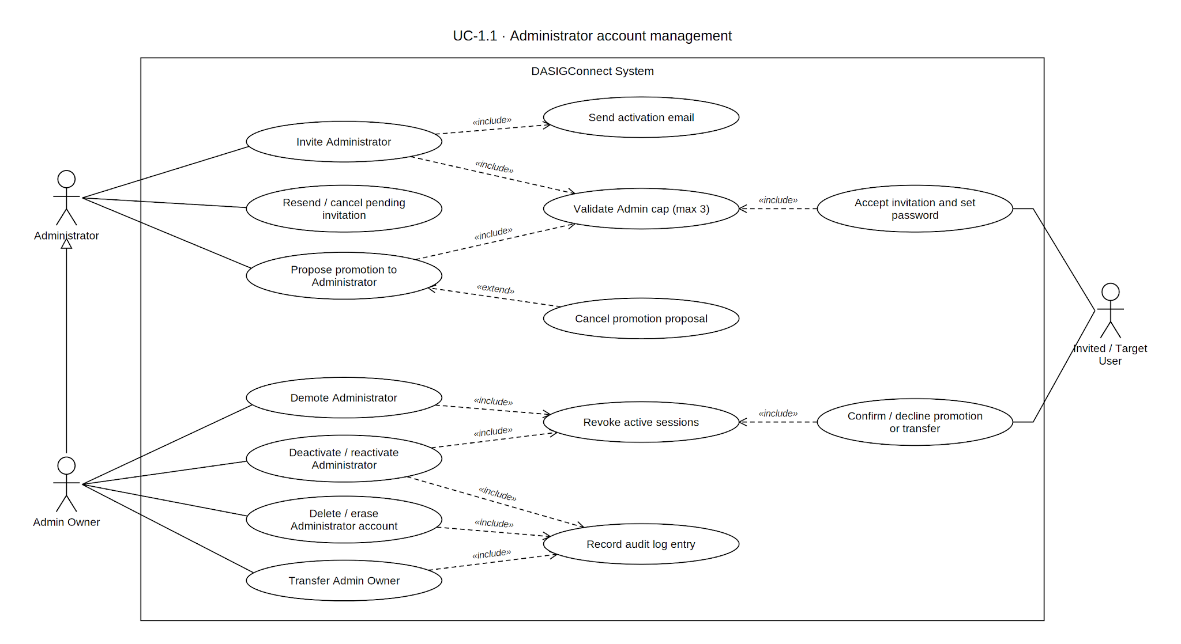

Use Case Description

Use Case ID | UC-1.1
Use Case Name | Administrator Account Management
Actor(s) | Administrator (Admin Owner required for all actions targeting existing Admin account)
Precondition(s) | The actor holds a valid, authenticated ACTIVE session with Administrator privileges. Admin Owner status is required for every action targeting an existing Admin account (A3–A6, the demotion path within A7, and A8): deactivation, reactivation, deletion, erasure, demotion, and ownership transfer. Proposing a promotion (A7) is open to any active Administrator — the target still has to confirm before anything changes, so it carries the same standard as inviting a new Admin. A peer (non-owner) Administrator may invite new Admins (subject to the cap, A2) and manage Moderator/Contributor accounts, including proposing an Admin promotion for one of them (A7). Self-targeting is blocked across every role-change and account-management action, Owner-gated or not. The initial Admin account is provisioned directly by the development team prior to pilot deployment and is outside the scope of this use case.
Main Flow | - The Admin navigates to Admin Management and selects Invite Admin.  - The system validates the request as a network-scoped Admin invitation with no institution assignment, and validates that active Admins plus outstanding Admin invitations number fewer than 3 (A2).  - The system generates a unique, single-use, time-sensitive invitation token bound to the invitee's email address, valid for 72 hours, and stores only the token hash.  - The system creates or updates the invitee's account record in PENDING state, reusing an existing PENDING, PENDING_EMAIL_UNDELIVERED, CANCELLED, or EXPIRED record for that email if one exists (an existing ACTIVE account, or a re-invitation targeting an INACTIVE account, returns a conflict error — the latter must go through Reactivation, A4), and marks any older unused invitation tokens for the same email as used.  - The system dispatches an activation email containing the activation link with the raw token.  - The invitee completes activation by setting their password. The system re-validates the Admin cap at this step (A2) so a stale pending invitation cannot exceed the limit.  - The account transitions to ACTIVE, receives the Admin role, remains institutionless, and gains network-wide Admin privileges.
Alternative Flow(s) | A1 — Invitation Email Undelivered: If dispatch fails (single attempt; no automatic retry), the account remains PENDING_EMAIL_UNDELIVERED until an Admin verifies the address and triggers a resend (A9).  A2 — Admin Limit Reached: The system enforces a single combined count — active Admins plus outstanding Admin invitations plus pending promotions — against a maximum of 3, uniformly across every gate that could grant Admin access: invitation (Main Flow step 2), invitation acceptance (step 6), direct promotion (A7), and reactivation (A4). Each gate excludes only its own in-flight item from the count where relevant. Reactivation is the strictest case, with no exclusions — a deactivated 4th Admin cannot be reactivated into a network already holding 3. When any gate would exceed the cap, the system rejects the action and directs the Admin to remove or transfer an existing Admin first.  A3 — Deactivate Admin Account: (Admin Owner only.) Deactivates another ACTIVE Admin account (a non-active target returns a validation error). Revokes all active sessions, blocks login, retains historical submissions and audit data, and records the action in the audit log.  A4 — Reactivate Admin Account: (Admin Owner only.) Reactivates a previously deactivated (INACTIVE) Admin account, blocked at the Admin cap (A2). The account's existing password remains valid and no new session token is issued. A non-inactive target returns a validation error. Re-inviting a deactivated Admin is explicitly rejected; reactivation is the only path back to ACTIVE.  A5 — Delete Admin Account: (Admin Owner only.) Permanently removes an Admin account only when it is INACTIVE, CANCELLED, or EXPIRED (an ACTIVE target is rejected, requiring deactivation first). If the account has any historical footprint, it is not hard-deleted — it persists as an anonymized-at-rest inactive row with a USER_REMOVED audit entry. Only a completely footprint-free account is hard-deleted.  A6 — Erase Admin Account (Right to Be Forgotten): (Admin Owner only.) Target must be INACTIVE or CANCELLED, must not be the Owner's own account, and must not already be erased. Anonymizes the record in place and writes a USER_ANONYMIZED audit entry.  A7 — Promote Existing User to Admin: (Propose/confirm flow. Proposing is open to any active Admin; only demoting an existing Admin is Owner-only.)  - Propose: Any active Administrator (Owner or peer) selects an existing ACTIVE Moderator or Contributor to promote. The target cannot already be Admin (no-op) or the proposing Admin's own account, and the action is blocked at the Admin cap (A2). The system reserves a slot and creates a pending promotion; the target's role and access do not change yet. Writes ADMIN_PROMOTION_REQUESTED and notifies the target. A target cannot have two pending promotions at once.  - Confirm: The target confirms the promotion on their own account. The system re-checks the Admin cap before applying the change: institution assignment is cleared, the account gains network-wide Admin privileges (Admin Owner flag remains false), and active sessions are revoked. Writes ADMIN_PROMOTION_CONFIRMED. Unconfirmed after 72 hours, the request expires (410 Gone) and the slot frees itself.  - Decline: The target declines; the system clears the request, immediately frees the slot, and notifies the proposing Admin. Writes ADMIN_PROMOTION_DECLINED.  - Cancel: The proposing Admin rescinds a pending promotion before the target responds, with the same effect as a decline. Writes ADMIN_PROMOTION_CANCELLED.  - Demotion (Admin → Moderator or Contributor, Admin Owner only) remains a separate, immediate action with no confirmation step, recorded as USER_ROLE_CHANGED; demotion to Contributor requires assigning an active institution.  A8 — Admin Owner Transfer: The current Admin Owner initiates a transfer request to an existing ACTIVE Administrator target. The target has 24 hours to confirm before the request expires and is cleared. The system writes an ADMIN_TRANSFER_REQUESTED audit entry at initiation.  - Upon confirmation by the target Administrator, the outgoing account's Admin Owner flag is revoked and reassigned to the incoming account; both accounts remain ACTIVE Administrators with no demotions.  - The outgoing account's active sessions are invalidated upon confirmation, and the system writes an ADMIN_TRANSFER_CONFIRMED audit entry.  A9 — Cancel Pending Admin Invitation: An Admin cancels a pending Admin invitation while the target account is PENDING, PENDING_EMAIL_UNDELIVERED, or EXPIRED. The system deletes all outstanding tokens for that email and sets the account to CANCELLED.  A10 — Resend Pending Admin Invitation: An Admin resends an invitation for an account in PENDING_EMAIL_UNDELIVERED, EXPIRED, or CANCELLED state. The system generates a fresh 72-hour token, invalidates all prior open tokens, and resets the account to PENDING.  A11 — Admin Owner Unreachable: If the current Admin Owner cannot be reached to initiate a transfer, resolution is an out-of-scope, post-pilot governance concern requiring direct intervention by the development team or DOST Region 7 oversight.
Postcondition(s) | A new Admin account exists in PENDING or ACTIVE state; an existing Admin account has been deactivated, reactivated, deleted (if footprint-free), anonymized, had a promotion proposed, confirmed, declined, or cancelled, or been demoted; its pending invitation has been cancelled or resent; or Admin Owner status has been transferred. Every state-changing action revokes the affected account's active sessions where applicable, and is reflected in the audit log under one of: INVITATION_ACCEPTED, USER_STATUS_UPDATED, USER_ROLE_CHANGED, USER_REMOVED, USER_ANONYMIZED, ADMIN_TRANSFER_REQUESTED, ADMIN_TRANSFER_CONFIRMED, ADMIN_PROMOTION_REQUESTED, ADMIN_PROMOTION_CONFIRMED, ADMIN_PROMOTION_DECLINED, or ADMIN_PROMOTION_CANCELLED.

Activity Diagram

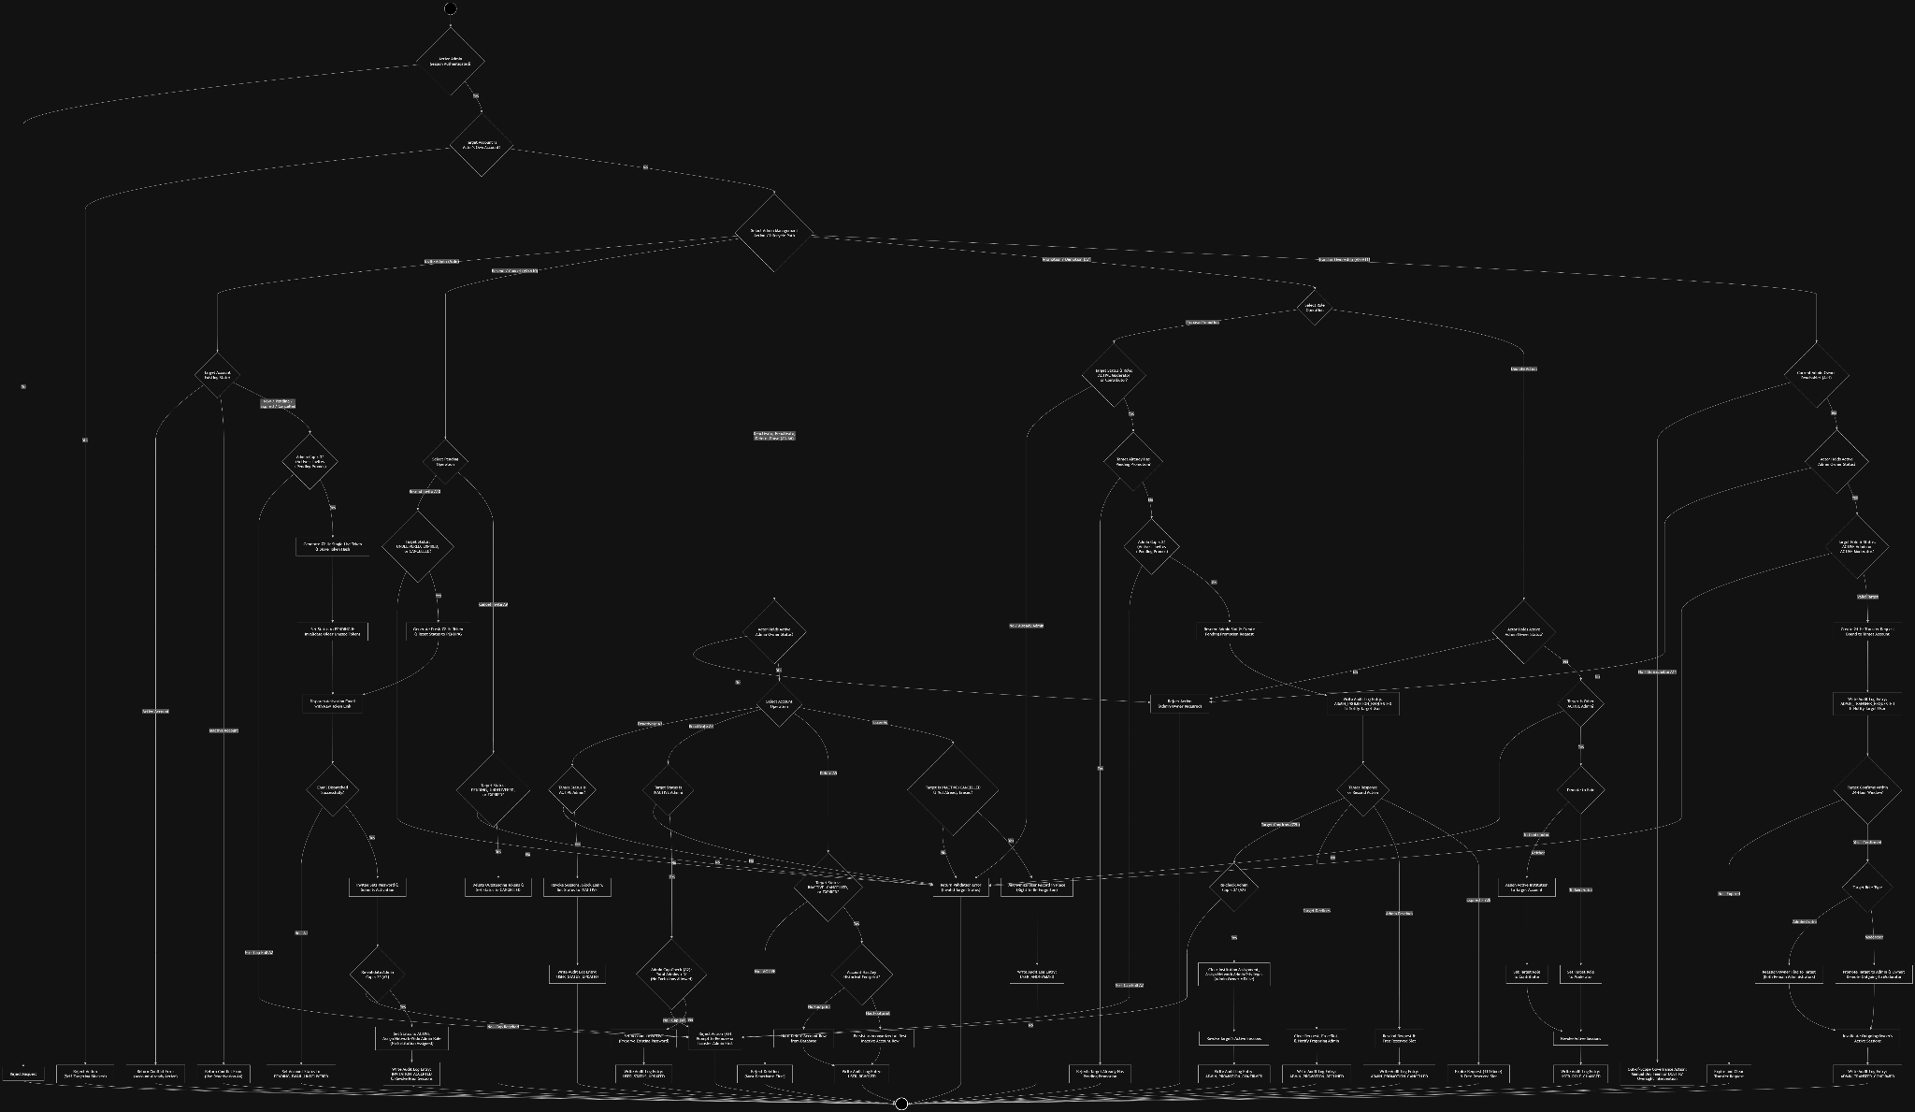

Wireframe

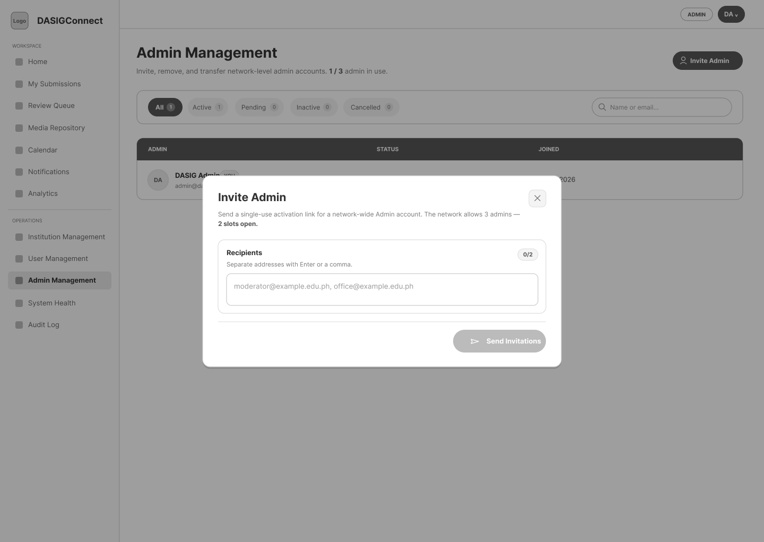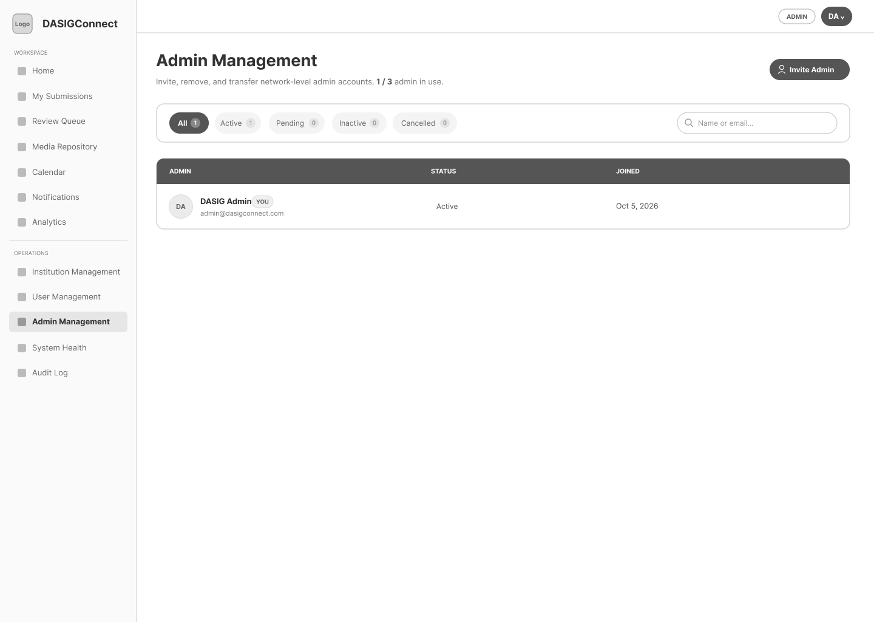

Institution Management

Use Case Diagram
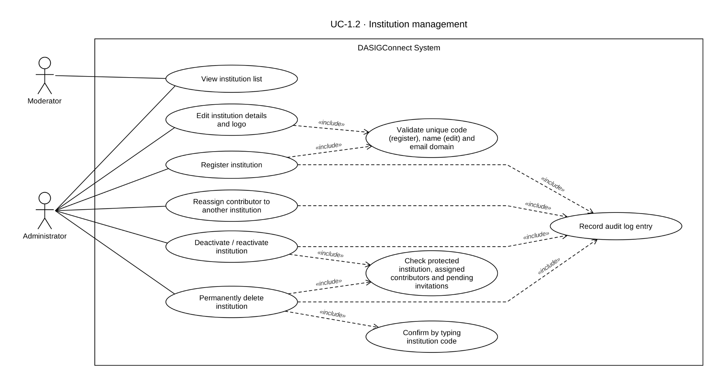

Use Case Description

Use Case ID | UC-1.2
Use Case Name | Institution Management
Actor(s) | Administrator (full access), Moderator (read-only)
Precondition(s) | The actor holds a valid, authenticated ACTIVE session with Administrator or Moderator privileges. At least one Administrator account exists. A protected default institution, "DASIG Central Visayas," is seeded during initial system deployment for network-wide Administrator post attribution and cannot be deactivated (A6) or permanently deleted (A8) through this use case.
Main Flow | - The actor navigates to Institution Management from the admin console.  - The system displays the institution list with each institution's name, status, and Contributor count. Moderators see this list in read-only form; action controls are visible only to Administrators.  - (Administrator only) The Admin selects Add Institution and enters the institution's required identifying details.  - The system validates the input, creates the institution workspace record, and establishes Row-Level Security scoping for that institution.  - The new institution appears in the institution list and becomes available for Contributor assignment.
Alternative Flow(s) | A1 — Edit Institution Details: (Administrator only.)  A2 — Deactivate Institution: (Administrator only.) Blocked if any Contributors remain assigned (must reassign first, A4) or any invitation to the institution is still pending; otherwise deactivates, preventing new Contributor invitations and retaining historical data.  A3 — Reactivate Institution: (Administrator only.)  A4 — Reassign Institution User: (Administrator only.) Target institution must be ACTIVE; historical submissions remain attributed to the original institution.  A5 — Duplicate Institution Identifiers: On creation, a duplicate institution code or email domain is rejected; on edit, a name or email domain already used by another institution is rejected.  A6 — Attempted Deactivation of Protected Institution: Blocks deactivation of DASIG Central Visayas.  A7 — Moderator Attempts a Restricted Action: Rejected with an authorization error; controls aren't exposed in the Moderator's view.  A8 — Permanent Institution Deletion: (Administrator only.) Requires typing the institution's code to confirm. Blocked if: the target is DASIG Central Visayas; any Contributor exists in PENDING, PENDING_EMAIL_UNDELIVERED, or ACTIVE state; any submission of any state has ever existed; or any non-deleted media asset exists. If clear, deletes institution-scoped tokens/reservations/settings/watermark configs, deletes soft-deleted media and albums, removes the institution record, best-effort purges storage post-commit, and writes an INSTITUTION_DELETED audit entry. Irreversible, distinct from Deactivate.
Postcondition(s) | An institution record has been created, edited, deactivated, reactivated, or permanently deleted (if eligible); or a Contributor has been reassigned, with per-institution data isolation enforced accordingly.

Activity Diagram
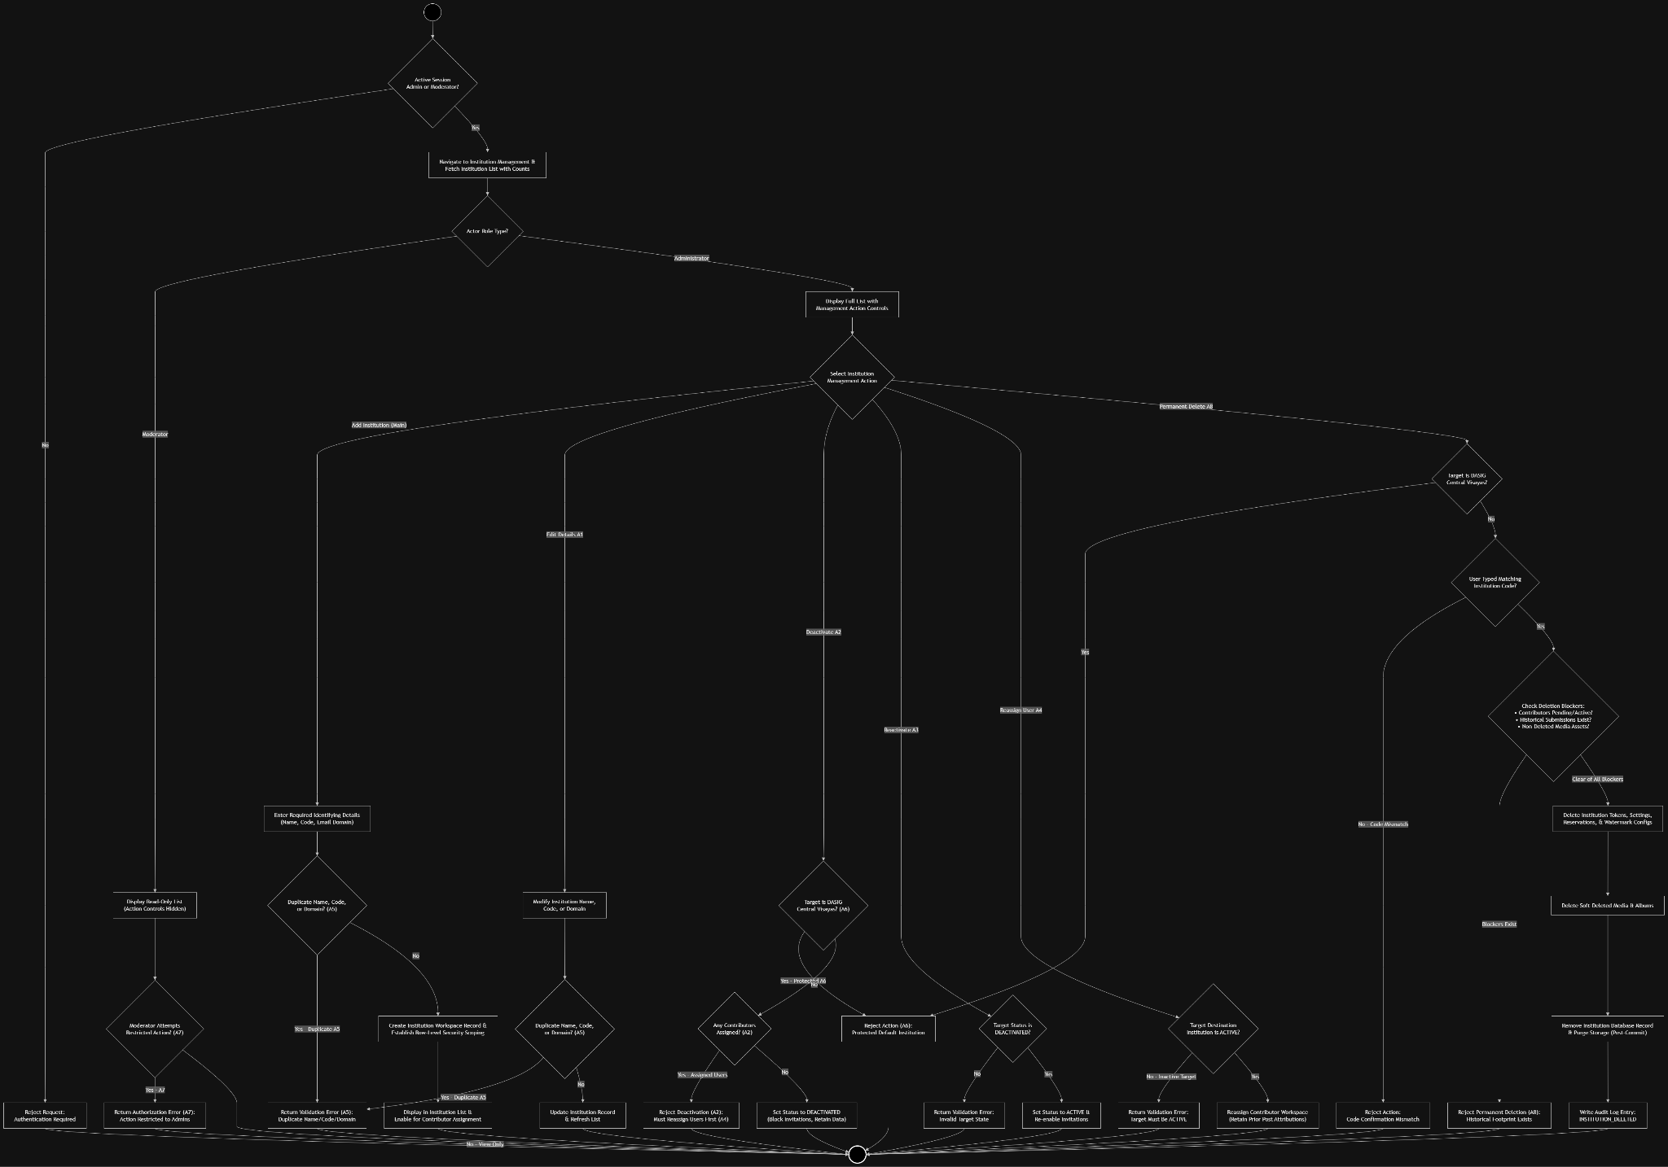

Wireframe

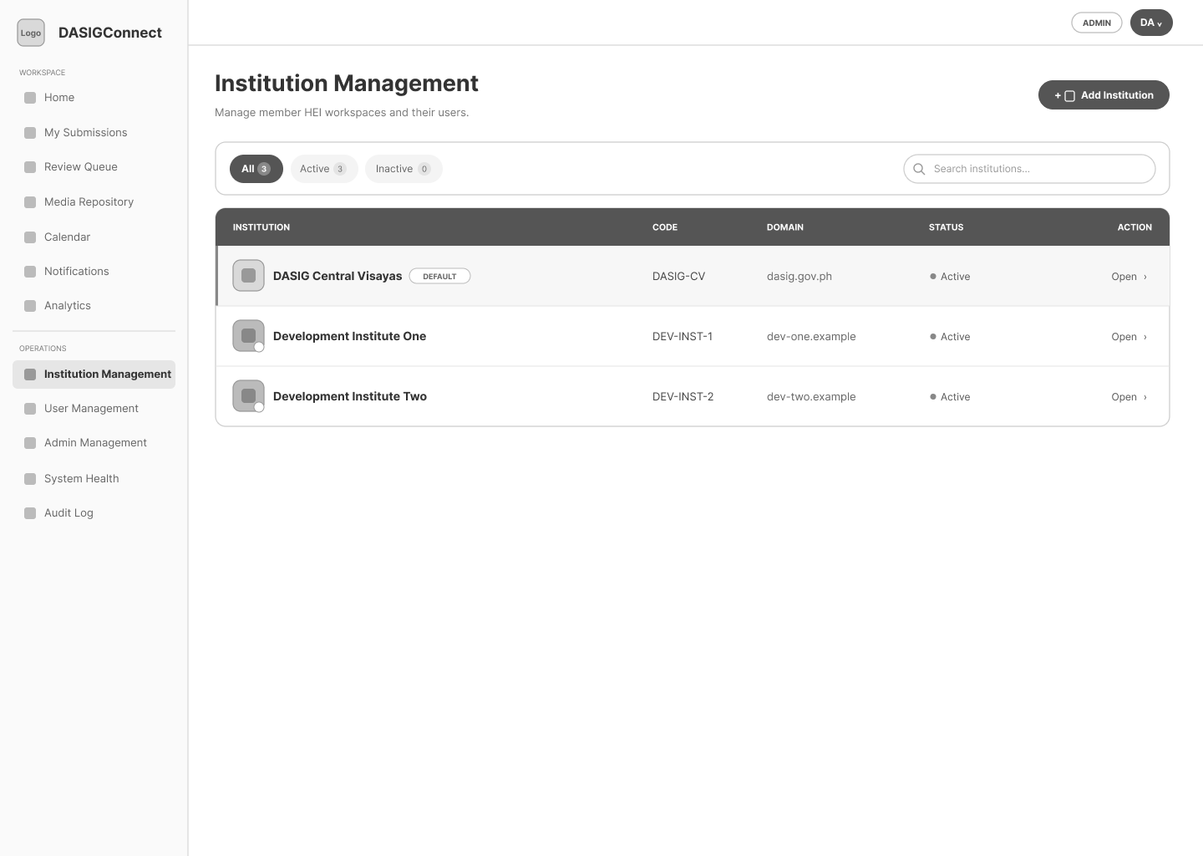
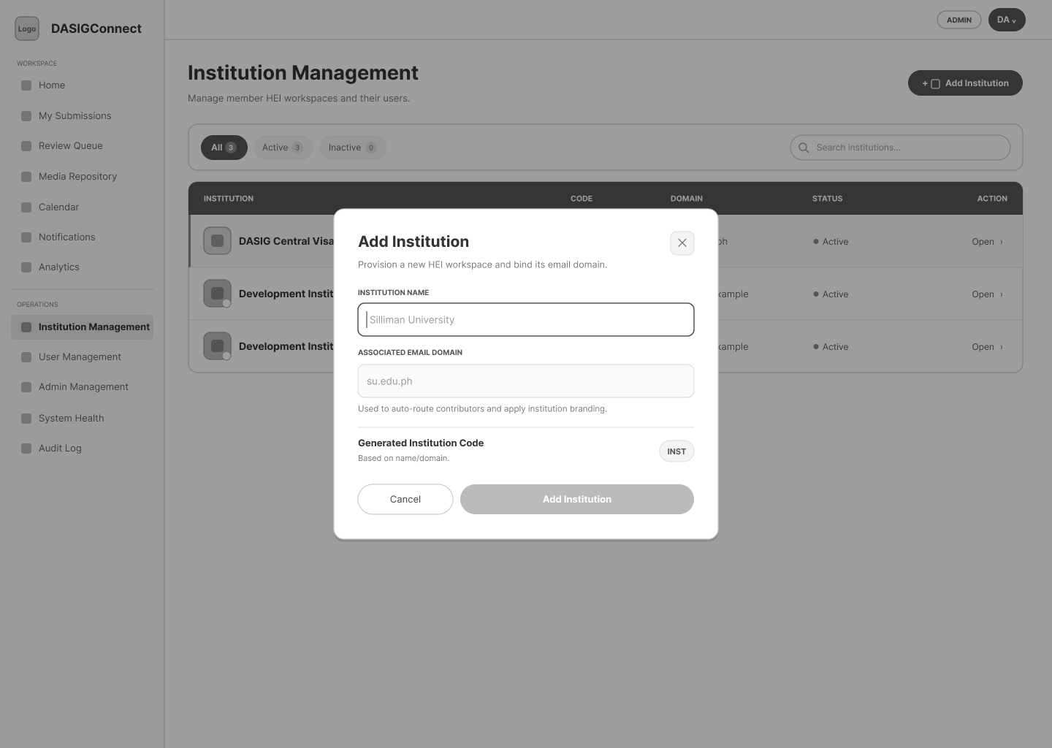

Contributor Account Management

Use Case Diagram
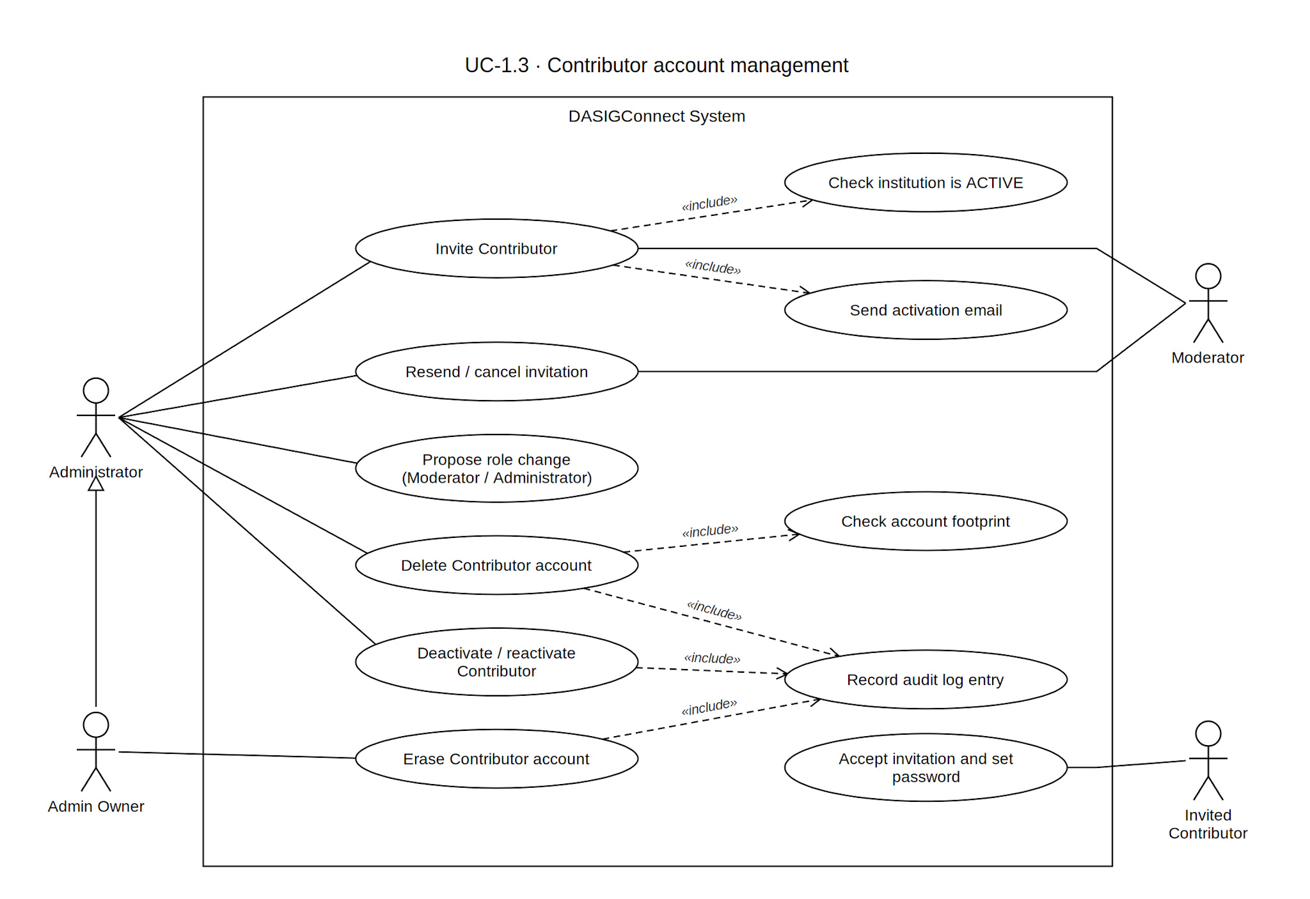

Use Case Description

Use Case ID | UC-1.3
Use Case Name | Contributor Account Management
Actor(s) | Administrator (any active admin), Moderator (invitation actions only, scoped to invitations they personally sent for resend/cancel/delete)
Precondition(s) | The actor holds a valid, authenticated ACTIVE session with Administrator privileges (any active admin), or Moderator privileges for invitation actions specifically.
Main Flow | - The actor navigates to the institution's Contributor management panel and selects "Invite Contributor."  - The target institution must not be INACTIVE  - If the actor is a Moderator, the system permits inviting to any institution (Moderators are network-wide) but restricts the assigned role to Contributor only.  - The system generates a unique, time-sensitive Invitation Token, valid for 72 hours, and creates the account record in PENDING state. If a PENDING, PENDING_EMAIL_UNDELIVERED, CANCELLED, or EXPIRED account row already exists for that email, it is reused rather than recreated; an existing ACTIVE account for that email returns a conflict error, and an existing INACTIVE account for that email now also returns a conflict error (must go through Reactivation, A4) — consistent with how Admin and Moderator accounts are already treated.  - The system dispatches an activation email containing a single-use activation link scoped to that institution.  - The invitee completes activation (password setup) and the account transitions to ACTIVE, with Row-Level Security binding established to the assigned institution.
Alternative Flow(s) | A1 — Invitation Email Undelivered: Account remains PENDING_EMAIL_UNDELIVERED until resend is triggered (email is sent in a single attempt; there is no automatic retry).  A2 — Token Used on Wrong Institution: Generic invalid-token error, no institution information disclosed.  A3 — Deactivate Contributor: (Administrator only.) Deactivates an ACTIVE Contributor account; a non-active target returns a validation error. Revokes all active sessions and retains submission history unaffected.  A4 — Reactivate Contributor: (Administrator only.) Reactivates an INACTIVE Contributor account; a non-inactive target returns a validation error.  A5 — Reissue Invitation: For a Contributor account in EXPIRED, CANCELLED, PENDING, or PENDING_EMAIL_UNDELIVERED state, the actor issues a new Invitation Token, resetting it to PENDING. The previous token is invalidated. (Actor: Administrator, or a Moderator reissuing an invitation they personally sent.)  A6 — Delete Contributor Account: Eligible target states are INACTIVE, CANCELLED, or EXPIRED. If the account has any footprint (a submission, a media upload, a validation/review log, an album it created, or any audit log entry), it is not hard-deleted; it persists as an anonymized-at-rest inactive row with a USER_REMOVED audit entry. Only a completely footprint-free account is hard-deleted. (Actor: Administrator (any account), or a Moderator (only a Contributor they personally invited, whose invitation is CANCELLED or EXPIRED).)  A7 — Erase Contributor Account (Right to Be Forgotten): (Admin Owner only.) Target must be INACTIVE or CANCELLED. Anonymizes the record in place and writes a USER_ANONYMIZED audit entry.  A8 — Contributor as Role-Change Target: Any active Administrator may propose promoting an active Contributor to Moderator. The proposal does not immediately change the Contributor's role, institution assignment, or active sessions. The Contributor must confirm the proposal before the change takes effect. Upon confirmation, the system changes the role to Moderator, removes the institution assignment because Moderators are network-wide, invalidates the user's active sessions, records MODERATOR_PROMOTION_CONFIRMED, and notifies the affected user. The Contributor must confirm within 72 hours; otherwise, the proposal expires automatically without changing the account. Any active Administrator may also propose promoting the Contributor to Administrator. That promotion likewise requires confirmation and follows UC-1.1 A7. Full role-change behavior is specified in UC-1.1 and UC-1.10 and is not duplicated here.
Postcondition(s) | A Contributor account exists in PENDING, PENDING_EMAIL_UNDELIVERED, ACTIVE, CANCELLED, or EXPIRED state, bound to a specific institution, or an existing account has been deactivated, reactivated, hard-deleted (if footprint-free), anonymized (A7), or moved out of the Contributor role entirely via A8. A "deleted" account with any historical footprint persists as an anonymized inactive row rather than disappearing.

Activity Diagram
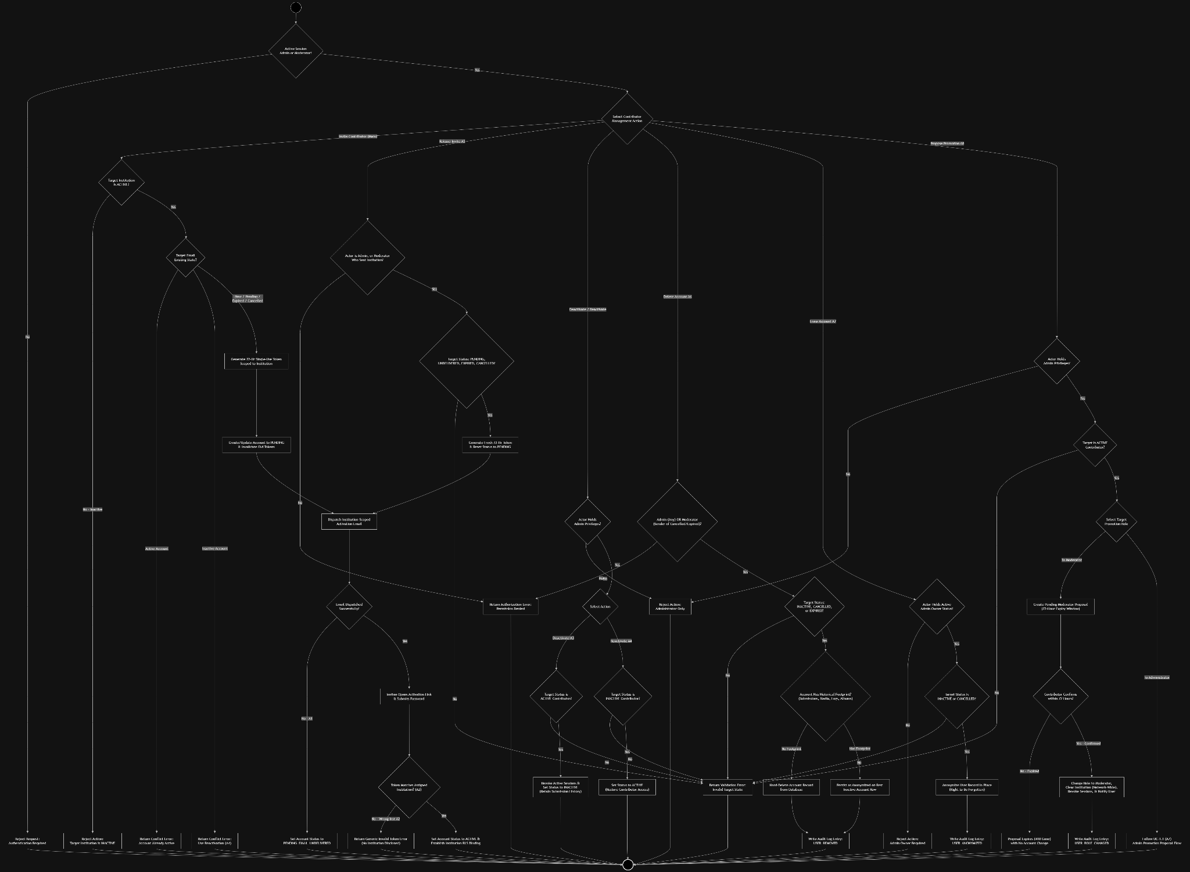

Wireframe

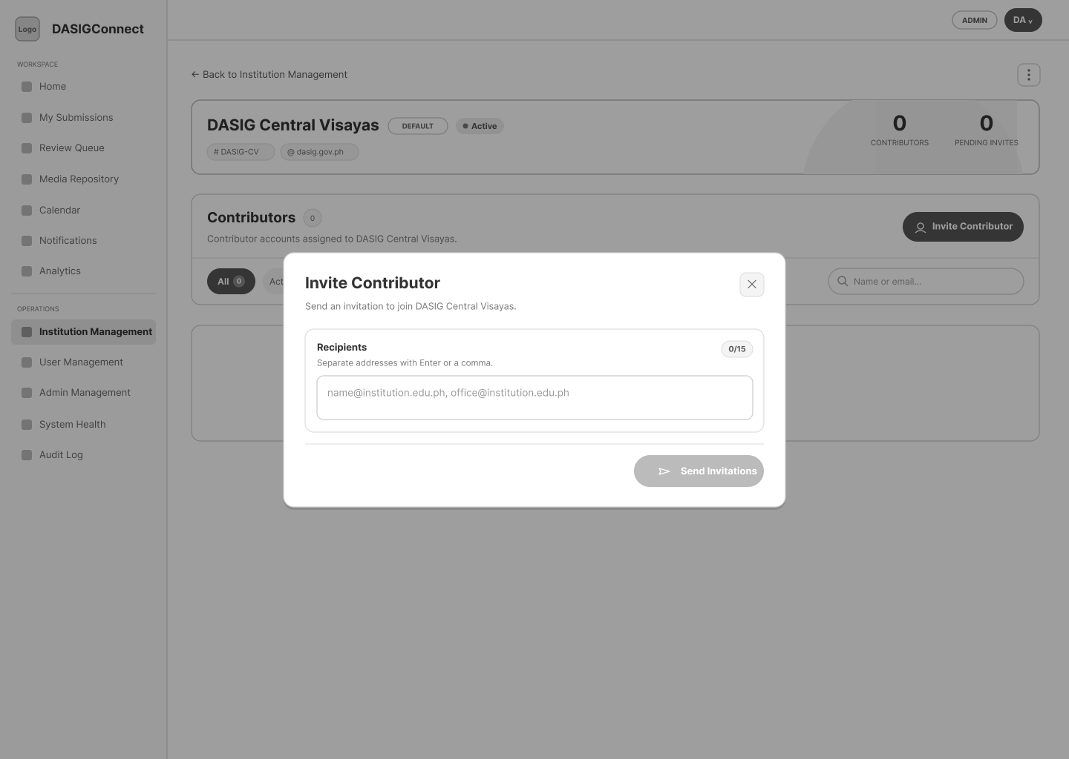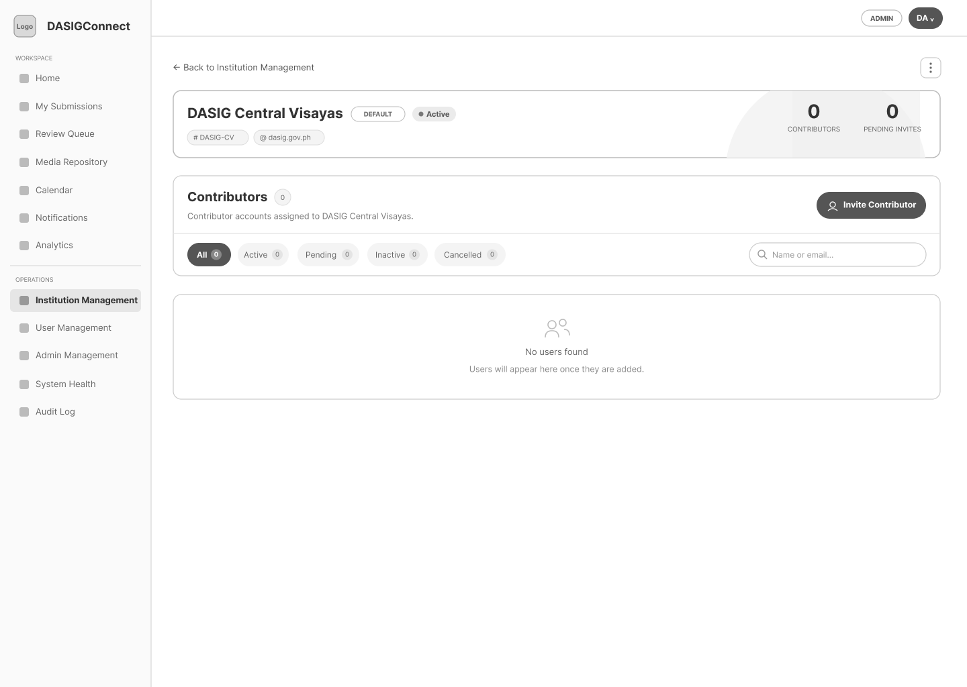

Login & Session Management

Use Case Diagram
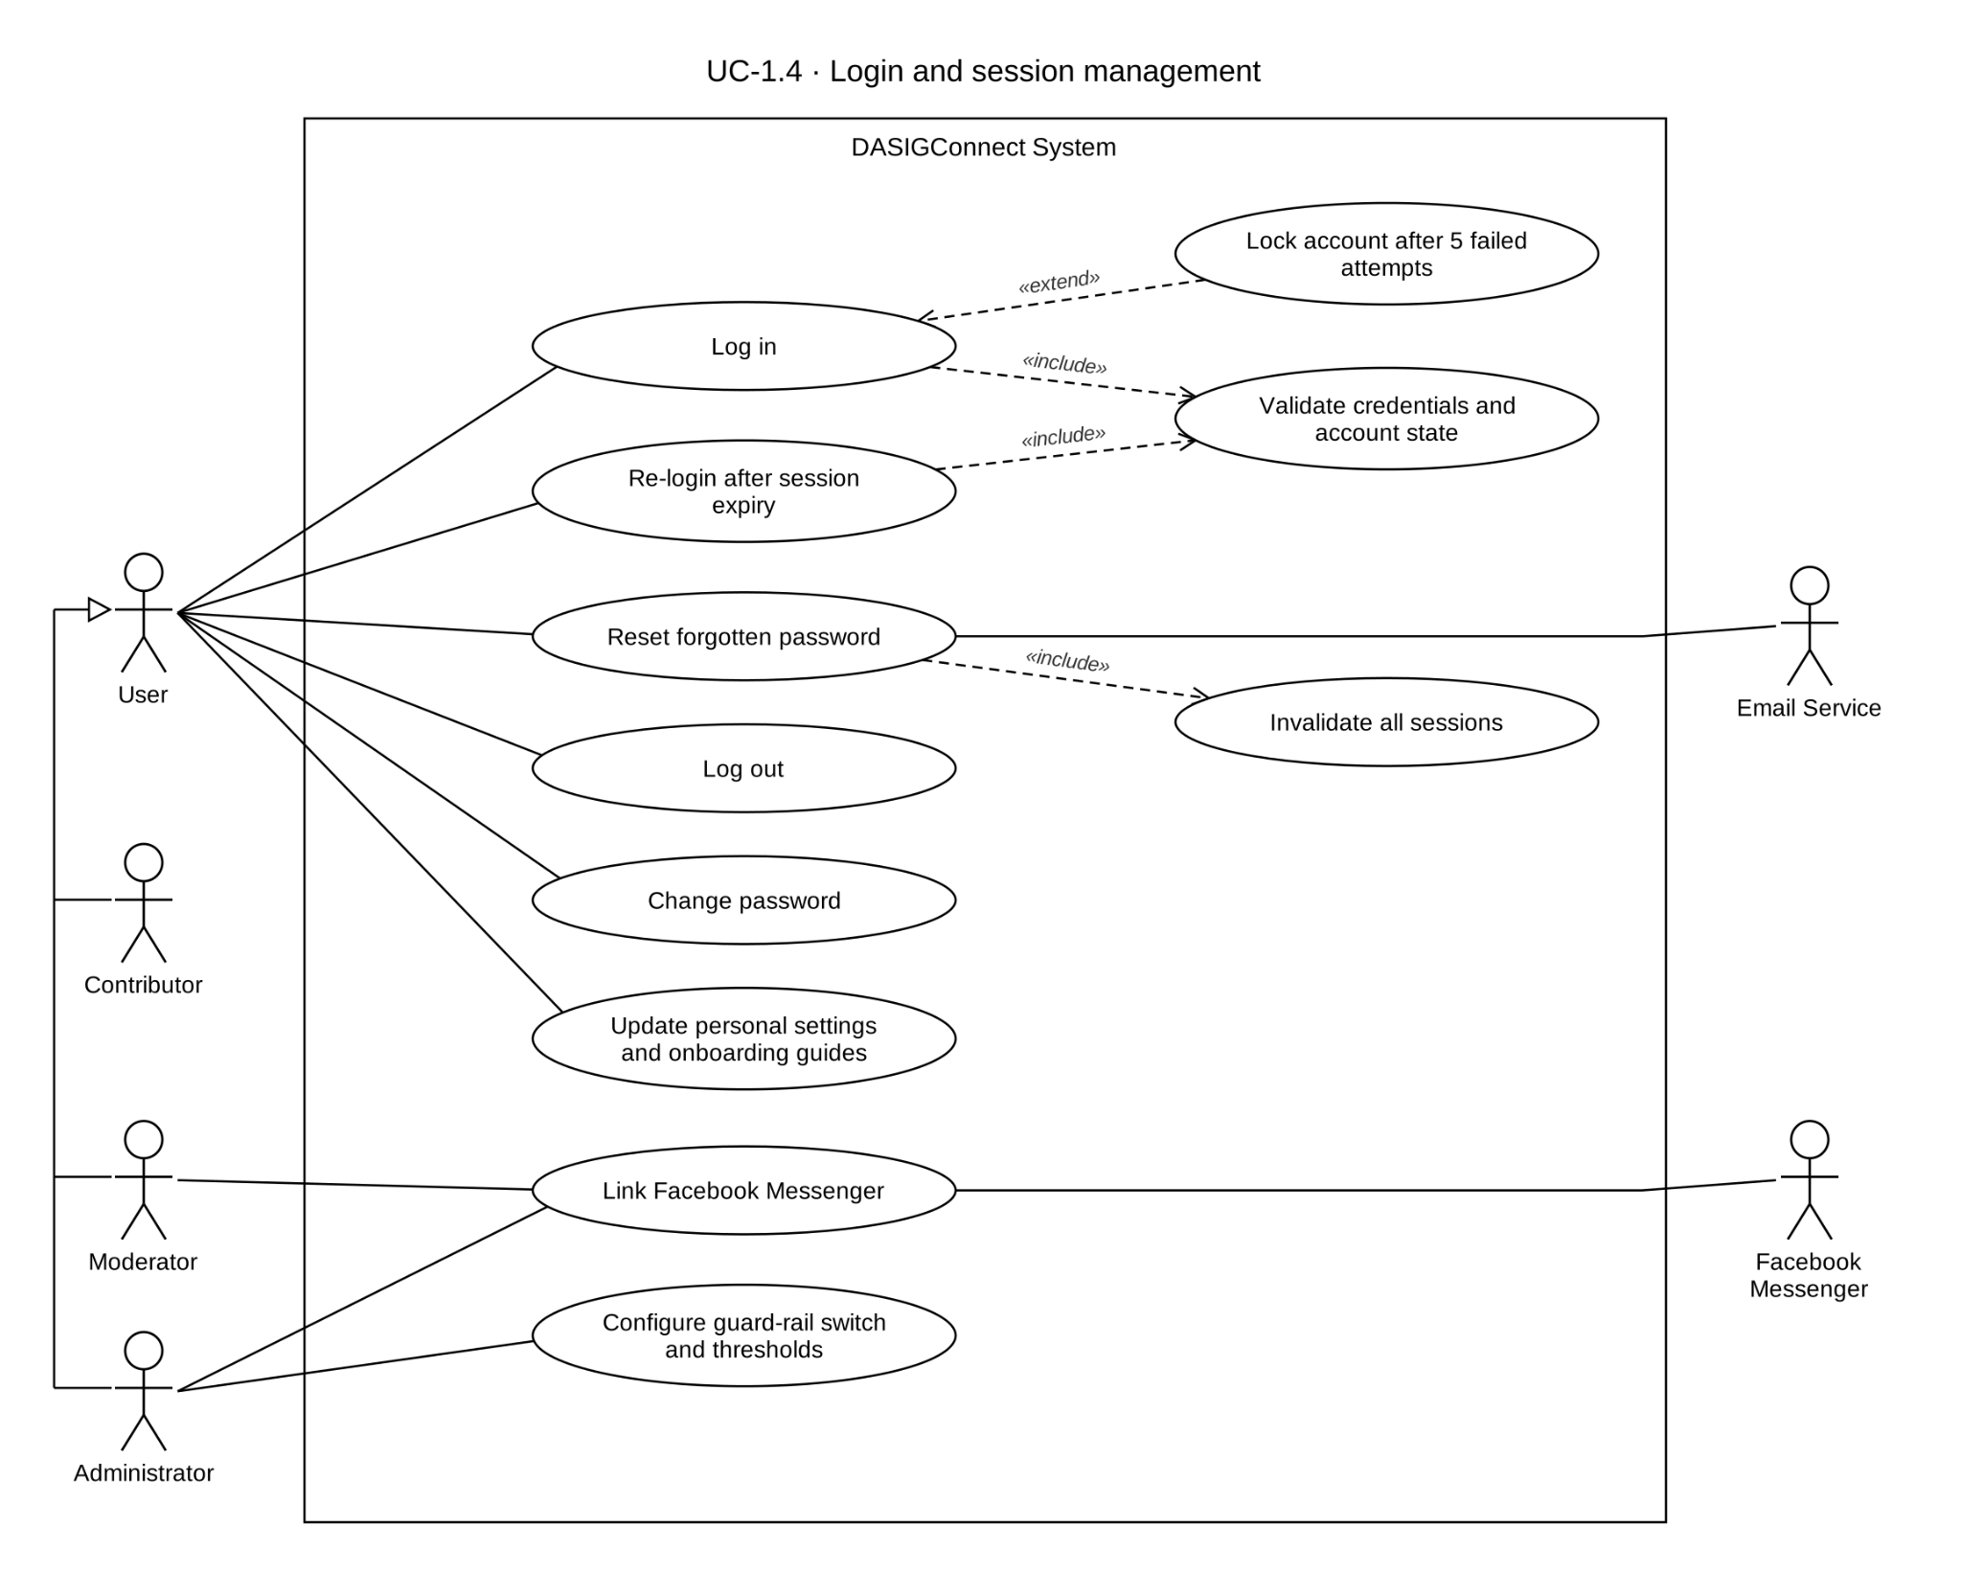

Use Case Description

Use Case ID | UC-1.4
Use Case Name | Login & Session Management
Actor(s) | Contributor, Administrator, Moderator
Precondition(s) | The actor holds an account record in the appropriate state (ACTIVE for login; PENDING for first-time activation, handled under UC-1.1/1.3).
Main Flow | - The actor logs in with registered credentials.  - The system validates the account state and issues a session token (JWT), valid for 8 hours, containing the actor's role, session_version, and tenant scope.  - Contributors receive institution-scoped sessions (the JWT carries institution_id). Moderators and Admins receive network-scoped sessions — neither carries an institution_id claim.  - The system routes the actor to the dashboard appropriate for their role.  - Admin Management, User Management, System Health, Audit Log, Page Settings, and Watermark Configuration are shown only to Admin users and hidden from Moderators and Contributors. Institution Management and the Review Queue are shown to Moderators and Admins. Analytics, Calendar, Media Repository, Notifications, Submissions, and Settings are shown to all three roles — Analytics is role-scoped, not Admin-exclusive.
Alternative Flow(s) | A1 — Invalid Credentials: Generic authentication error shown; no session issued. 5 failed attempts within the window lock the account for 15 minutes.  A2 — Account Not Yet Activated (PENDING/PENDING_EMAIL_UNDELIVERED): Login rejected; actor directed to check email.  A3 — Account EXPIRED: Login rejected; the actor is instructed to contact whoever manages their account (an Administrator, or the Moderator who sent the original invitation, if applicable) for reissue.  A4 — Account INACTIVE: Login rejected with a deactivation notice, directing the actor to contact whoever manages their account for reactivation.  A5 — Password Reset (Unauthenticated): The actor requests a reset link from the login page. Upon use, session_version is incremented, invalidating every previously issued token — forcing re-login on all devices. The new password must satisfy the policy: at least 12 characters, upper- and lower-case, a digit, a special character, no whitespace, and not built from a common fragment (password, qwerty, admin, dasig, welcome, letmein, 123, abc) or the account's own email/name.  A6 — Password Change (Authenticated): A logged-in actor changes their password from Settings, after providing their current password. session_version is not touched, so other active sessions are not invalidated. Same password policy as A5.  A7 — Session Expiry: The frontend decodes the JWT exp claim and displays a warning banner during the final five minutes of the token lifetime, with Stay Logged In and Dismiss actions. Dismiss hides the warning but does not extend the session. Stay Logged In opens the Session Expired modal. When the countdown reaches zero, or when an authenticated request receives a session-related 401 response, the same modal opens automatically. The actor must re-enter their email and password through the normal login flow. A successful re-login issues a new JWT, reloads the user profile, clears authenticated query and application caches, and restarts the expiry countdown. The system does not silently refresh tokens from the frontend. A POST /auth/refresh endpoint exists in the backend but is not currently called by the frontend.  A8 — Link Facebook Messenger for Notifications: From Personal Settings, a Moderator or Administrator (not Contributors) may link their personal Facebook account. Not an OAuth consent flow — the system generates a short, random, 10-minute link code; the actor sends that code as a message to the DASIG Facebook Page in Messenger; a webhook validates it against the stored code hash, completing the link. Eligible for Messenger delivery on applicable triggers (UC-3.3 A4). Unlinking at any time reverts delivery to silent skip (UC-3.3 A5).  A9 — Unauthorized Admin Surface Access Attempt: If a Moderator or Contributor attempts to access Admin Management, User Management, System Health, Audit Log, Page Settings, Watermark Configuration, or Facebook Page integration management by direct URL or API call, the system rejects the request with an authorization error and does not render the restricted screen in navigation. Analytics is not in this list.  A10 — Logout: The actor logs out from a single device/session. The system blacklists only that one token — narrower than A5's account-wide revocation. Sessions open on other devices are unaffected.
Postcondition(s) | The actor holds a valid authenticated session scoped to their role and institution (Contributors) or network-wide (Moderators, Admins), or the requested settings/session action has completed. Admin-only surfaces remain unavailable to Moderators and Contributors; Messenger linking remains unavailable to Contributors.

Activity Diagram
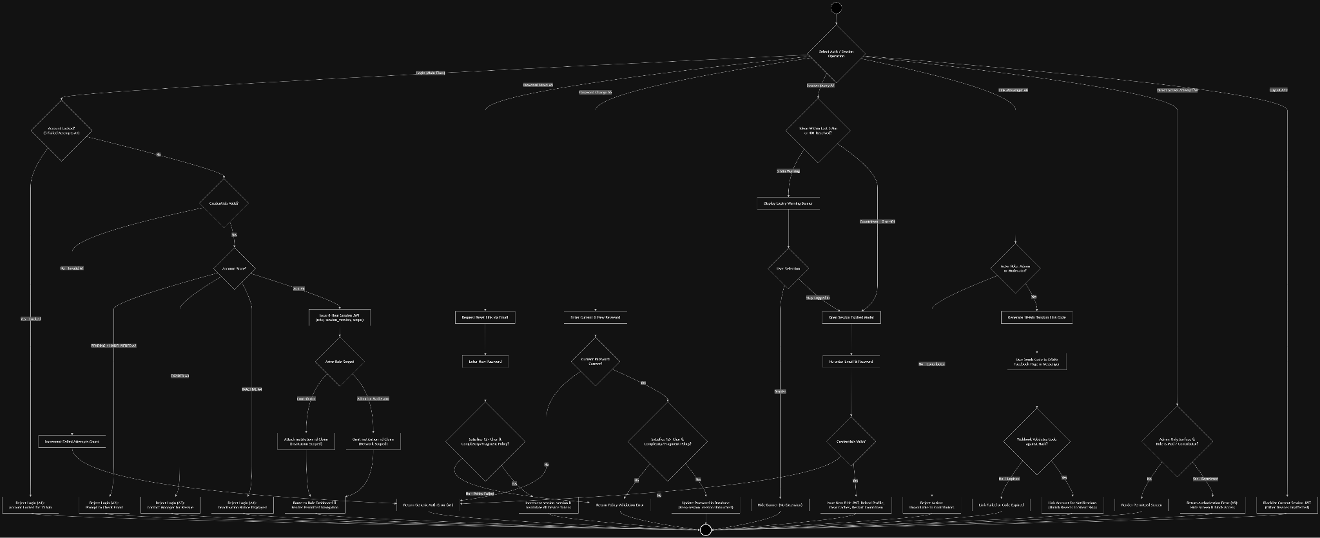

Wireframe
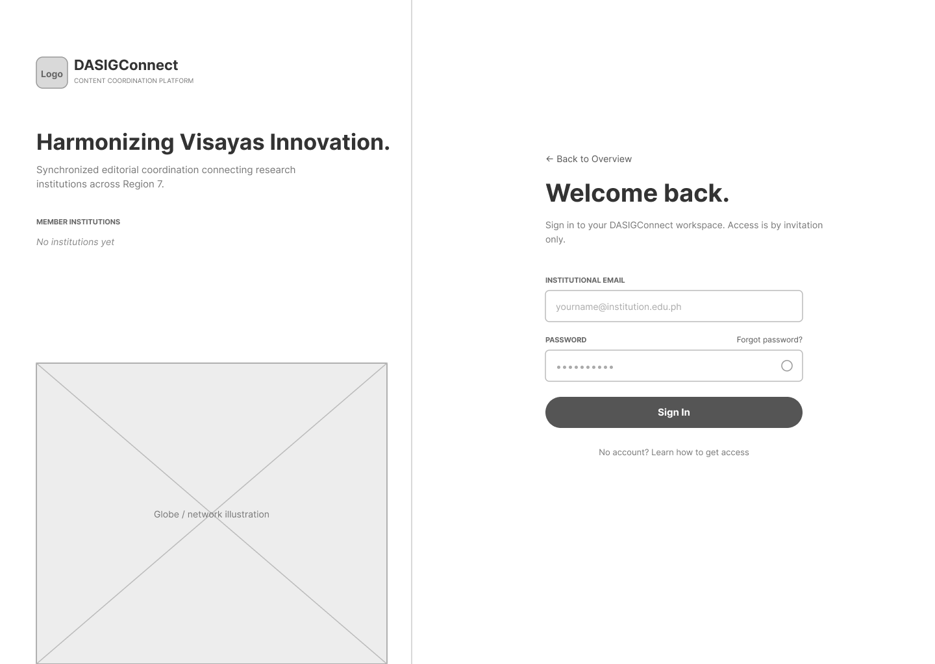
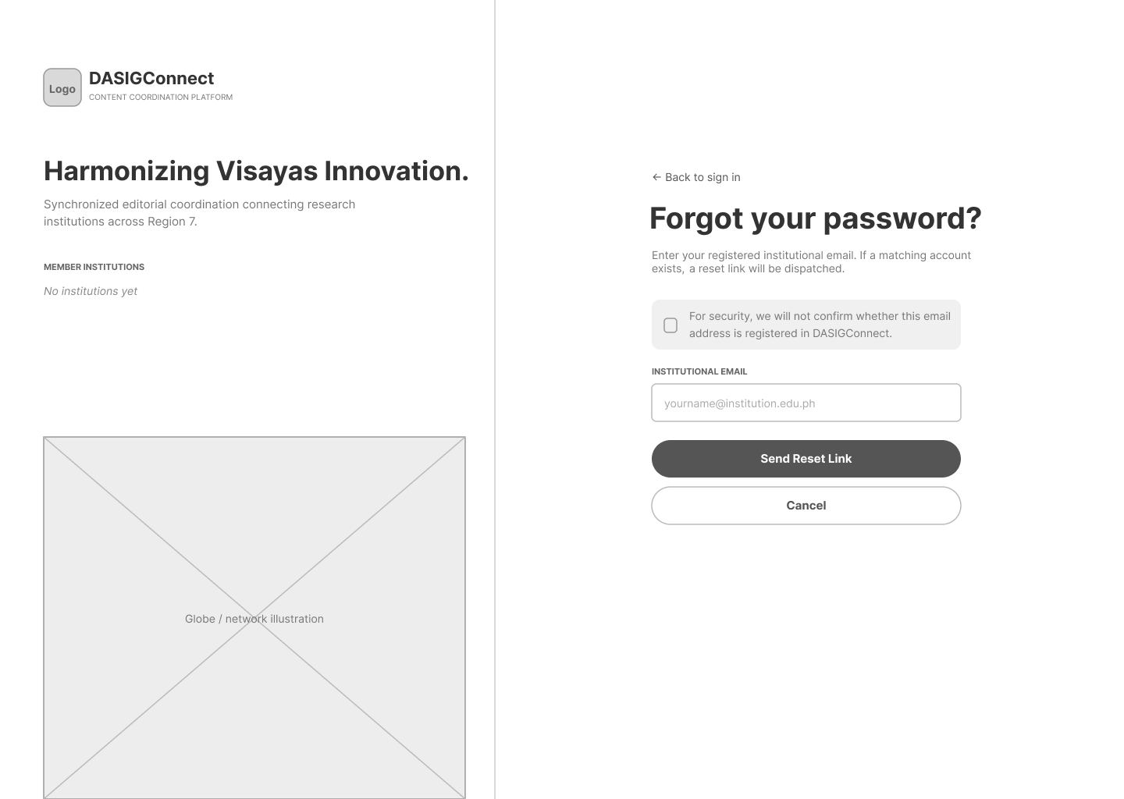

Post Drafting & Templates

Use Case Diagram
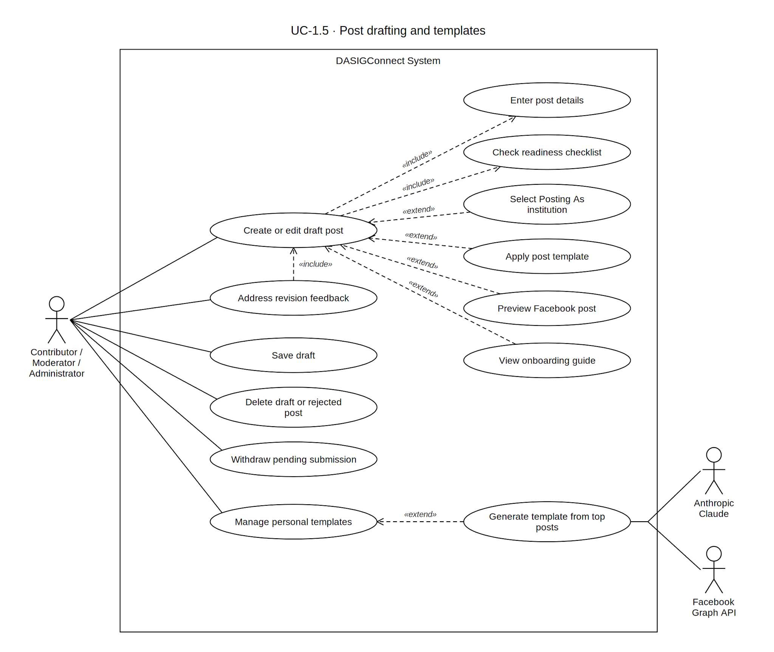

Use Case Description

Use Case ID | UC-1.5
Use Case Name | Post Drafting & Templates
Actor(s) | Contributor, Administrator, Moderator. Any of the three uses the same composer. Administrators and Moderators additionally get a Posting As institution selector; Contributors' posts are always attributed to their own institution.
Precondition(s) | The actor holds a valid, authenticated ACTIVE session (UC-1.4). A Contributor's session is institution-scoped; an Administrator/Moderator session is network-wide and must pick an institution to post as (defaults to the protected network institution, "DASIG Central Visayas").
Main Flow | - The actor opens the composer — either New Post, or an existing item from "My Submissions" to resume editing (A1) or view status. Filters: drafts · action-needed · submitted · published · rejected · failed · all.  - The composer is a three-step wizard: Media → Post Details → Organize & Schedule. Forward progress requires the current step's Required readiness items; backward navigation is always allowed (A8). Data persists across steps within the session.  Step 1 — Media  - The actor attaches media (device upload, library pick, AI-suggested media, per-asset captions, per-asset watermark opt-out) per UC-1.7. Advancing to Details when Details is already complete and no draft exists yet silently creates the draft.  Step 2 — Post Details  - (Administrator/Moderator only) A Posting As dropdown, defaulting to DASIG Central Visayas. Changing it on a saved draft clears the preferred schedule, keeps selected media, prompts confirmation if a schedule was set, and requires a re-save to move the draft.  - The actor enters event title and event date.  - The actor writes the caption directly or via Suggest Caption (UC-1.6), with an optional tone/instruction prompt, returning one caption in the selected tone. Hard character cap of 3000 characters (code points); pasting past it trims with a warning. Caption length within a comfortable range is also a non-blocking Recommended check.  - The actor highlights caption text, clicks the Fancy text button in the caption action row, and selects a Unicode style from the displayed Fancy Text panel. The selected text is replaced with the chosen styled Unicode equivalent.  - The actor adds hashtags — suggested pills or free-typed — inserted into the caption.  - The actor may select a template from the Templates button and panel beside the caption form. Applying a template requires at least one attached media file. When applied, the template replaces the current caption with the template caption and clears the current tags.  - The actor may click Check writing in the caption action row to request an on-demand AI writing check. The system provides advisory spelling, grammar, and clarity suggestions. The actor may apply or dismiss each suggestion; the writing check does not block editing or submission.  Step 3 — Organize & Schedule  - The actor organizes media into an album and adds media tags (UC-1.7). The system files freshly uploaded assets into the assigned album resolved from the post's album name, auto-creating one from the event title if none is set; library picks keep their own album; all attached assets receive the post's media tags.  - The actor chooses Set a Schedule (default, peak-hour suggestions per UC-1.8) or Live Event Fast-Track (hides scheduling fields). The system requires a future scheduled time for all Standard posts. If guard-rails are enabled, the system additionally validates the selected time against network rules.  - The actor may open a Facebook-style preview — a persistent center-panel toggle on any step.  - The actor clicks Submit to send for approval (UC-1.9). Submit is disabled while any blocking required item is unmet; once all 7 required checks pass, Submit for Approval becomes the primary, always-visible action on every screen size (including mobile/compact viewports across all wizard steps). Optional post-quality tips never block submission or imply a pass mark (A7).  Submission Gate & Post Quality Tips: A right-panel checklist (and top-bar status chip + bottom sheet on compact `≤900px` screens) separates submission readiness into two distinct signals instead of a single blended percentage:  - Submission Gate (binary status): Shows Required: 7 of 7 ✓ — Ready to submit when complete, or Required: X of 7 while incomplete. It is the only thing that can block submission. While incomplete, the gate header names the next missing required item (Next: [Field] →) and clicking it jumps directly to the relevant step and field.  - Post Quality Tips (optional advisories): Shown in a separate section labeled `Tips: X of 5 applied`, never as a percentage that implies a pass mark. Each row in both sections is clickable and jumps to the relevant step/field.  Scheduling Guard Rails (network-wide switch): When enabled, the system validates Standard-post schedules against the network-wide scheduling rules: no active post within ±30 minutes, at least two hours of lead time, a posting window of 8:00 AM–8:00 PM, and a maximum scheduling horizon of 30 days. The six-post daily volume threshold (GR-S2) and the three-post per-institution active quota (GR-S1) are reported as soft warnings and do not block scheduling. These values are the defaults; an Administrator may change the thresholds in Settings → Page (Section 3.3). When disabled, these guard-rail checks are skipped, but Standard posts still require a future scheduled time and slot reservation. Fast-Track posts do not require a scheduled slot.  Templates: Built-in templates are provided by the system by default, while custom templates are personal to the actor. The actor opens the Templates button and panel beside the caption form. Applying a template requires at least one attached media file, replaces the current caption with the template caption, records the selected template, and clears the current tags. The actor may add hashtags and media tags separately after applying the template.  Autosave & Explicit Save: Save as Draft is available on every step, independent of Next/Submit gating. Once a draft has an ID, edits autosave silently after a short delay; the first save is always explicit — a draft is never auto-created except when advancing from Media to Details with Details already complete.  Contextual Onboarding Guides: The actor may open optional, contextual, view-only guides for the submission list, composer, and Save Draft workflow. The guides explain the three composer steps, media attachment, Post Details, Organize & Schedule, readiness checks, caption tools, templates, preview, submission, and draft saving. The guides may open the relevant step or panel for demonstration, but they do not create, edit, save, submit, or otherwise mutate a submission. Guide visibility is controlled by the user's account-level guide preference, and dismissed guide screens are synchronized through the authenticated account.
Alternative Flow(s) | A1 — Edit Existing Draft: Loads a draft at Step 1 with all reached steps accessible through backward navigation.  A2 — Delete Draft or Rejected Submission: A confirmation prompt is required before deletion. The submission owner may delete a submission in draft or rejected status. The system removes its slot reservations, purges genuinely orphaned draft uploads, cascades applicable review records, and records SUBMISSION_DELETED.  A3 — Template Not Selected: The flow proceeds normally; “Template used” remains a Recommended item and does not block saving or submission.  A4 — Draft Returned for Revision or Rejected Submission: A needs_revision submission reopens with reviewer remarks parsed into per-field comments. Affected fields pulse and can be marked addressed. Resubmission is accepted from draft or needs_revision. A rejected submission displays the rejection reason and offers Edit & Resubmit; after editing, it may be submitted again. The system displays reviewer remarks only when a submission is returned for revision or rejected.  A5 — Dirty-State Navigation Warning: Closing or navigating away with unsaved changes prompts for confirmation.  A6 — Incomplete Submission Gate at Save: Save as Draft is allowed at any step with unmet Required items or optional quality tips; the checklist persists as a reminder.  A7 — Submit With Unapplied Quality Tips: With all 7 Required checks met (`Required: 7 of 7 ✓ — Ready to submit`), Submit is immediately enabled and promoted on all screen sizes; unapplied optional quality tips (`Tips: X of 5 applied`) are noted as non-blocking advisories in the confirmation dialog without any pass/fail percentage  A8 — Navigate Backward Between Steps: Backward navigation is always allowed; forward progression requires the current step’s Required items. Entered data persists within the editing session.  A9 — Withdraw a Submitted Post: A still-pending submission may return to draft. Withdrawal is refused if a reviewer has already begun evaluating the submission (a review lock exists). The system writes a SUBMISSION_WITHDRAWN audit entry, then the submission re-enters this flow.  A10 — Onboarding Guide: If guides are enabled and the actor has not dismissed the relevant screen guide, the system may display the contextual guide automatically. The actor may advance, skip, close, disable, or later reset the guides. Dismissing a guide affects the actor's account across browsers and devices.  A11 — Generate Template from Top Posts: The actor opens the Templates panel and requests an AI-drafted template based on high-performing Facebook Page posts. The system returns a draft-only template suggestion. The actor reviews and saves it through the normal template workflow.
Postcondition(s) | A draft post record exists in draft state with event title/date, caption, hashtags, attached media (with per-asset captions and watermark opt-outs), resolved album + media tags, template metadata (if used), and schedule type (Standard or Fast-Track) — ready for further editing or submission (UC-1.9). A withdrawn or revision-returned submission re-enters this flow in draft/needs_revision.

Activity Diagram
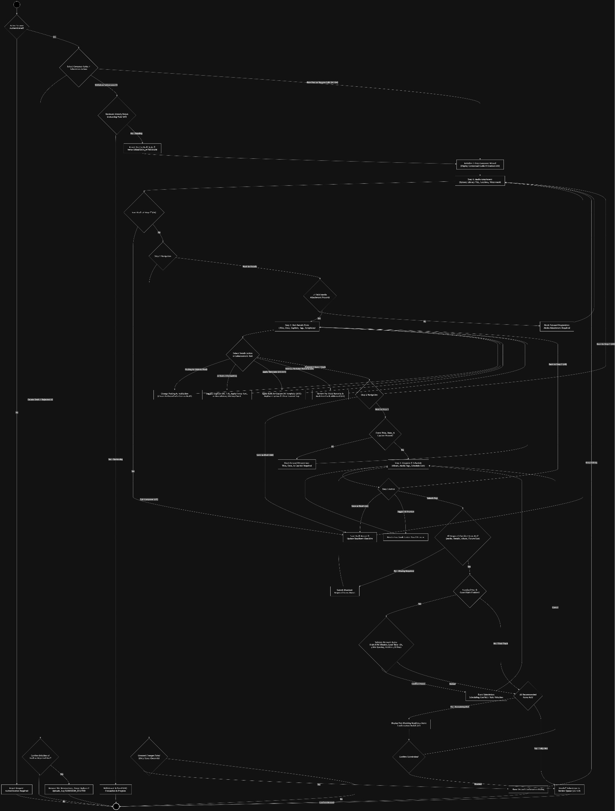

Wireframe

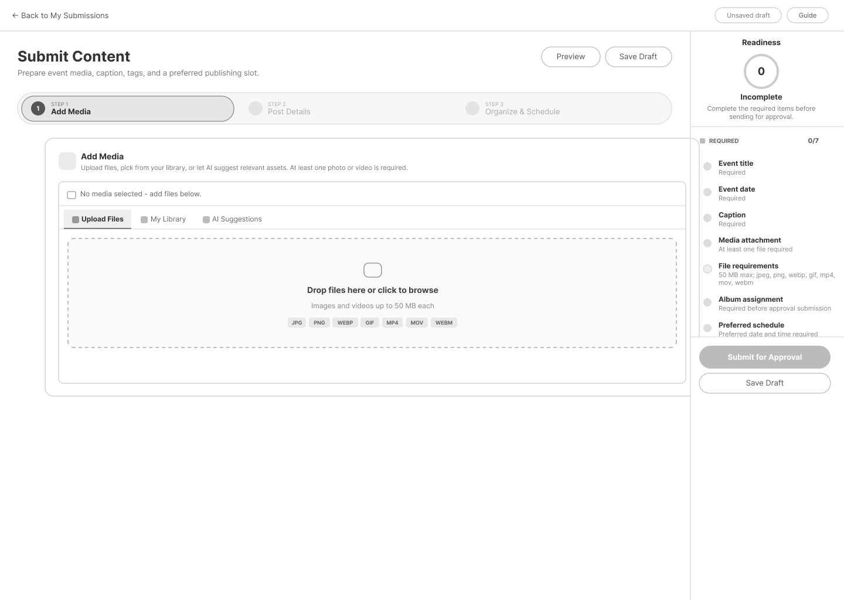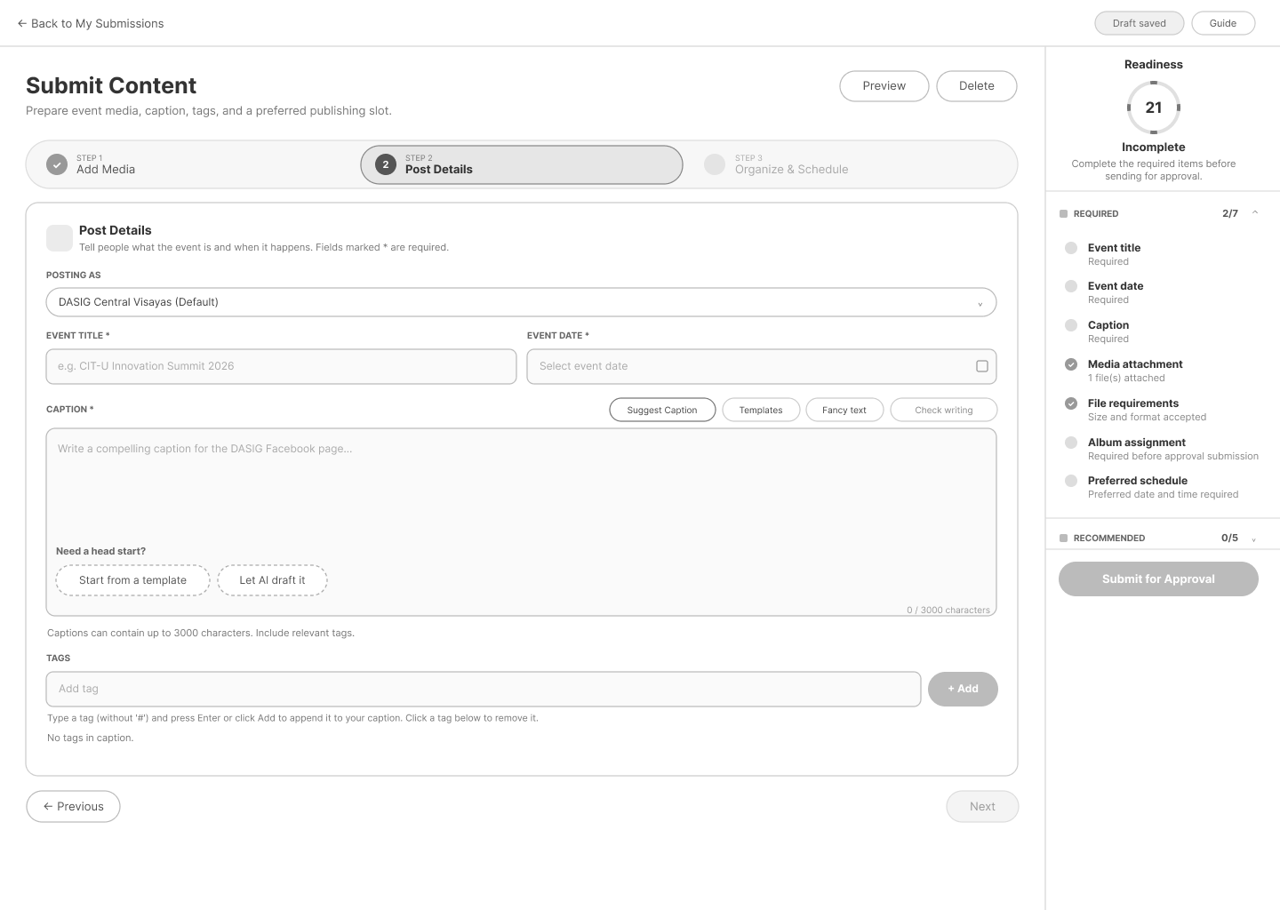
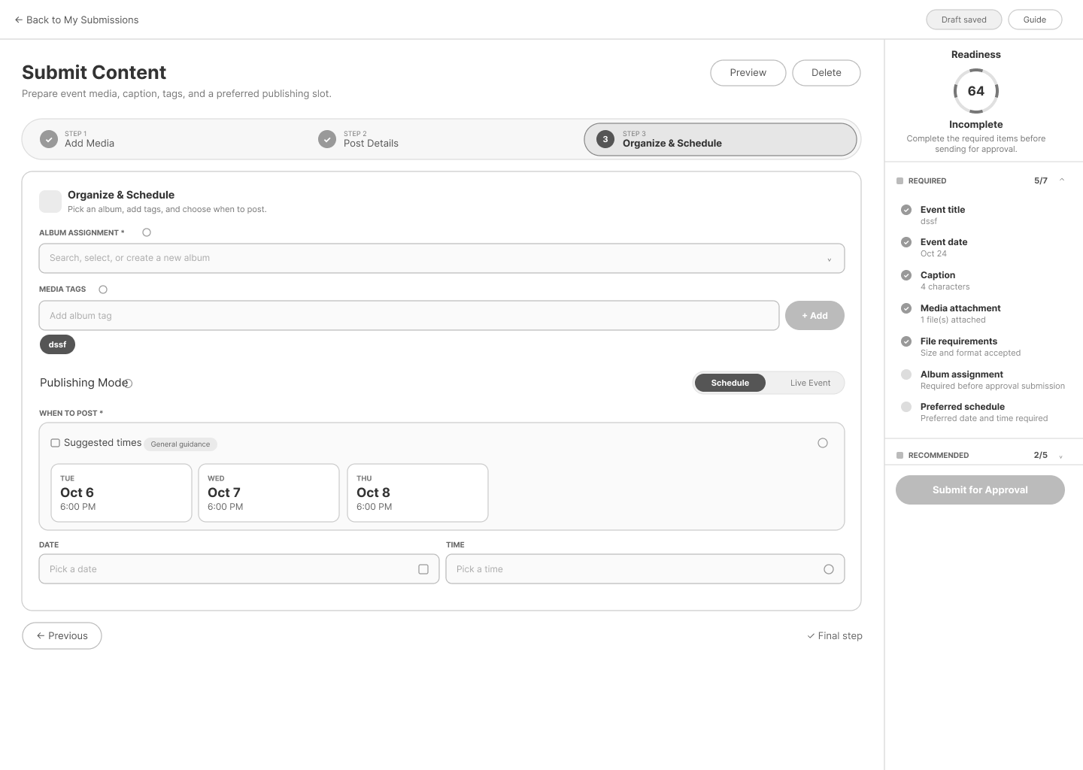

AI & Text Tools Integration

Use Case Diagram
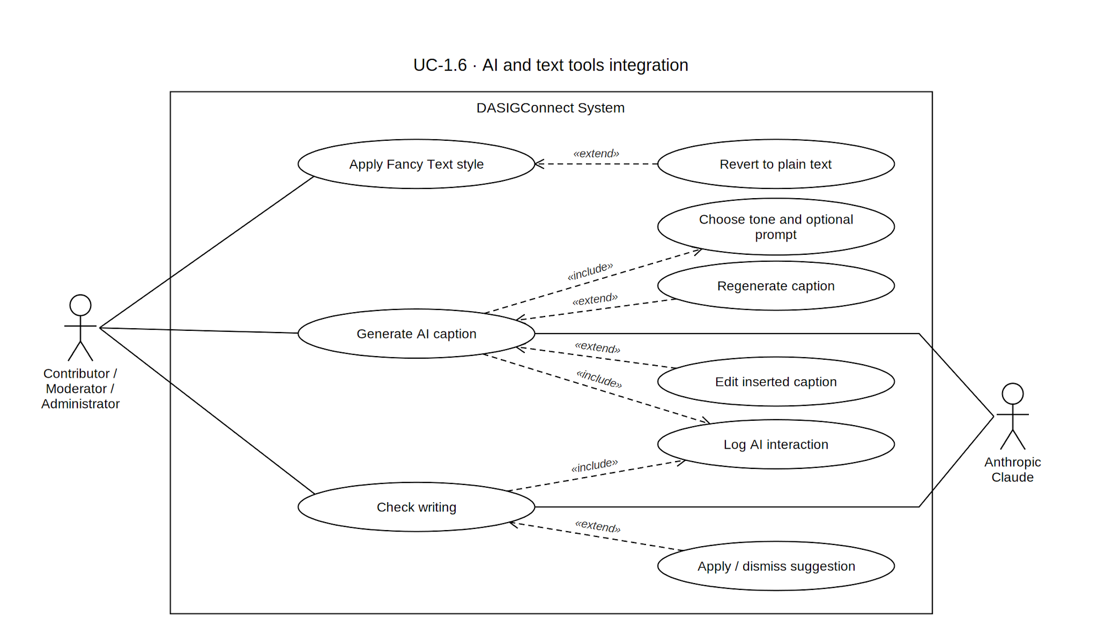

Use Case Description

Use Case ID | UC-1.6
Use Case Name | AI & Text Tools Integration
Actor(s) | Contributor, Administrator, Moderator — all three use the same composer. A Moderator without an institution scope may generate captions for any institution's submission.
Precondition(s) | The actor is in an active, editable composer session (UC-1.5). AI caption generation is available for new and existing editable drafts, including Live Event Fast-Track posts, but not for read-only submissions. If the composer has not yet created a draft, the system automatically saves the draft after validating the required event context before sending the AI request. Fancy Text and Check writing are available on any editable caption and do not require a saved draft.
Main Flow | AI Caption Generation  - The actor clicks Suggest Caption in the caption field's action row.  - A prompt dialog opens. The actor may optionally type instructions and pick one of three tones — professional (default), community, energetic. The dialog proceeds as long as there's an attached image, an existing caption, or a typed prompt.  - The actor confirms. The prompt is limited to 280 characters; Generate is disabled past the limit (also enforced server-side).  - The system processes the submission's images (up to 4, respecting size limits), media metadata, event title/date/institution, existing caption, prompt, and selected tone via the AI service, with a strict timeout..  - The system returns one caption for the selected tone, which the actor may review, insert, dismiss, regenerate, or edit.  - The actor edits the inserted caption freely before saving or submitting.  - Each interaction outcome (e.g., used, edited, dismissed, regenerated) and selected tone is logged on a best-effort basis; a logging failure never blocks the UI.  Rate limit: 30 caption requests per rolling hour per user. Over the limit, the system rejects the request and the UI displays a rate-limited state with the reset time.  Requested word count: if the prompt names a word count, the largest number is parsed; over 2000 is rejected with 400. A requested range triggers up to 3 retries to bring Claude's output into range.  Fancy Text Styling  - The actor clicks the Fancy Text button in the caption field's action row (not triggered by text selection). A panel opens.  - If text is selected, the panel shows that text transformed into each available style, previewed live on hover/focus. If nothing is selected, the panel shows “No caption text selected” or targets the whole caption once open.  - Styles: Bold Serif, Italic Serif, Bold Sans-Serif, Italic Sans-Serif, Script/Cursive, and Plain (revert).  - The actor clicks a style; selected text is replaced with its styled Unicode equivalent. Re-styling already-styled text reverts to plain first, then applies the new style.  - The actor may style other selections or revert via Plain.  Check Writing  - The actor clicks Check writing in the caption action row.  - The system sends the current caption to the proofreading endpoint for an on-demand AI writing check.  - The system returns advisory spelling, grammar, clarity, or meaning-change suggestions.  - The actor may apply or dismiss individual suggestions.  - Applying a suggestion updates the caption; dismissing it removes the suggestion without changing the caption.  - The writing check does not block saving, editing, or submission.  - The feature is available in the composer and reviewer edit form, but not on read-only submissions.  - The check is rate-limited to 30 requests per hour per user. A failed check displays an error but does not affect the caption or workflow.
Alternative Flow(s) | A1 — AI Request Timeout: No response within 30s → timeout notice, stays clickable for retry, auto-returns to idle after ~5s (504).  A2 — AI Service Unavailable: A failed non-timeout call returns 503; the button shows "AI unavailable," disabled, auto-recovers to idle after ~5s.  A3 — No Image Attached: Generation proceeds with an empty image list if there's an existing caption or typed prompt.  A4 — Empty Prompt: Uses the selected tone (default professional), returns one caption in that tone.  A5 — Prompt Exceeds Length Limit: 280-character cap; Generate disabled past it; also enforced server-side with a 400.  A6 — Revert Fancy Text: Selecting styled text and choosing Plain maps each character back to standard.  A7 — Unsupported Character Styling: Only A–Z/a–z (and digits for bold styles) have Unicode equivalents; punctuation, emoji, accented letters, and spaces pass through unstyled.  A8 — Writing Check Failure: If the proofreading request fails or times out, the system displays an error and leaves the caption unchanged. The actor may continue editing or retry.  A9 — Writing Check Rate Limit: If the actor exceeds 30 proofreading requests within the rolling hour, the system displays a rate-limit message. The actor may continue editing manually.  A10 — No Caption: Check writing is disabled when the caption is empty.
Postcondition(s) | The caption field reflects any AI-generated caption, Fancy Text transformation, or proofreading suggestion that the actor chose to apply. The caption remains fully editable and ready for continued drafting under UC-1.5 or submission under UC-1.9. AI caption interaction outcomes and proofreading adoption events are recorded best-effort; failures in telemetry do not block the actor’s workflow.

Activity Diagram
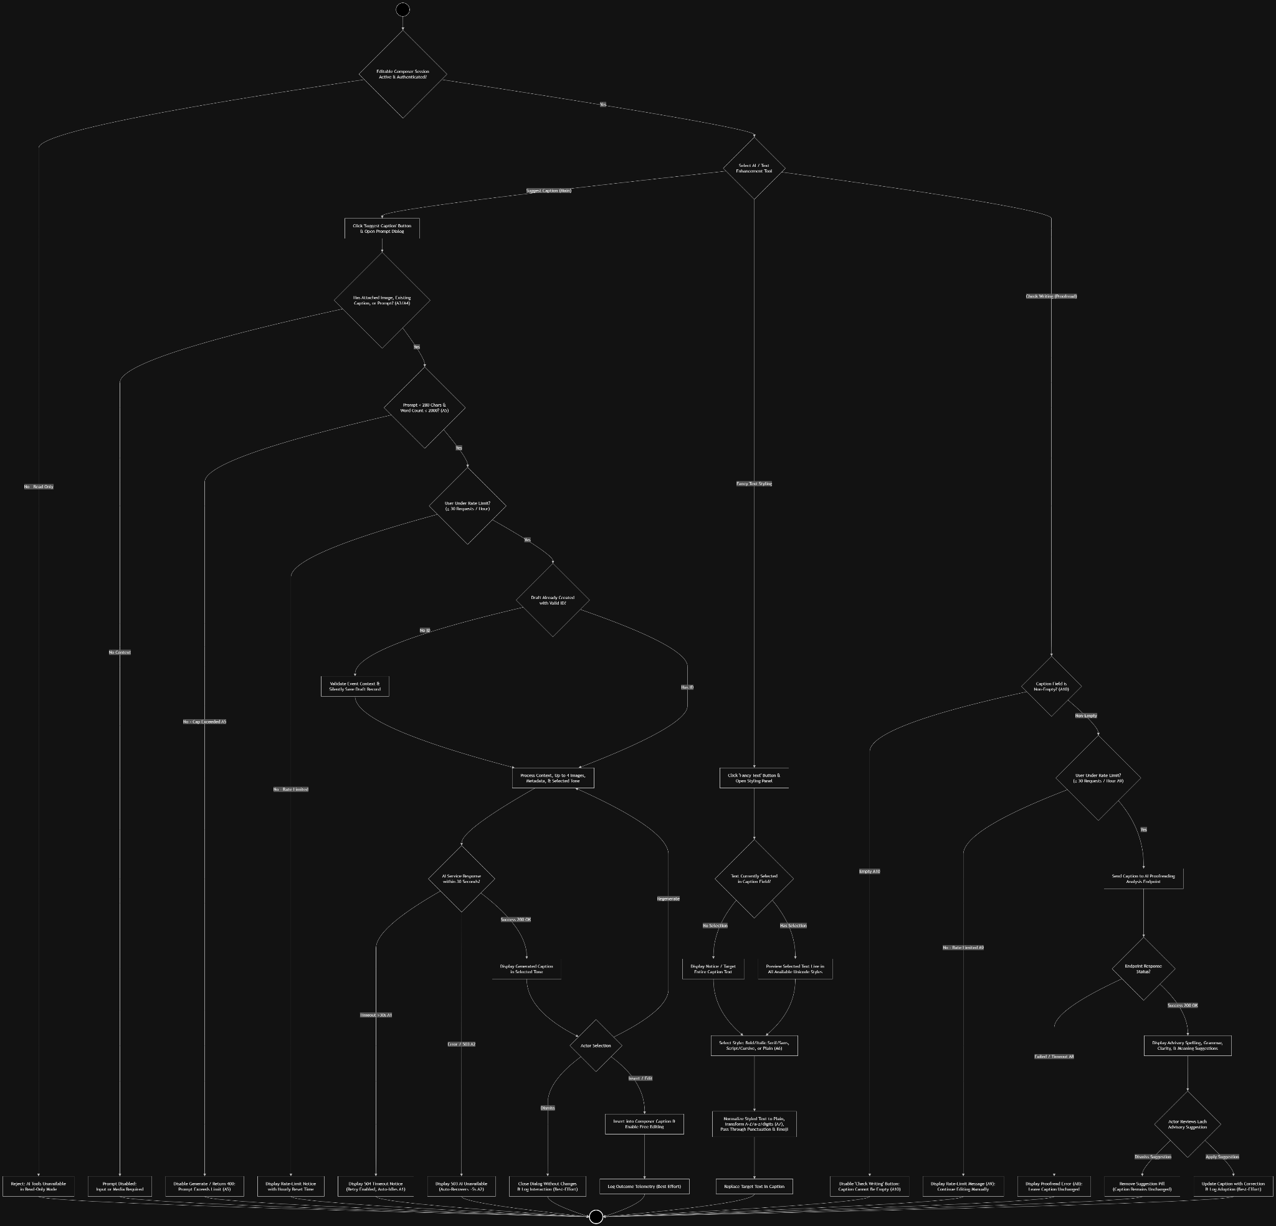

Wireframe
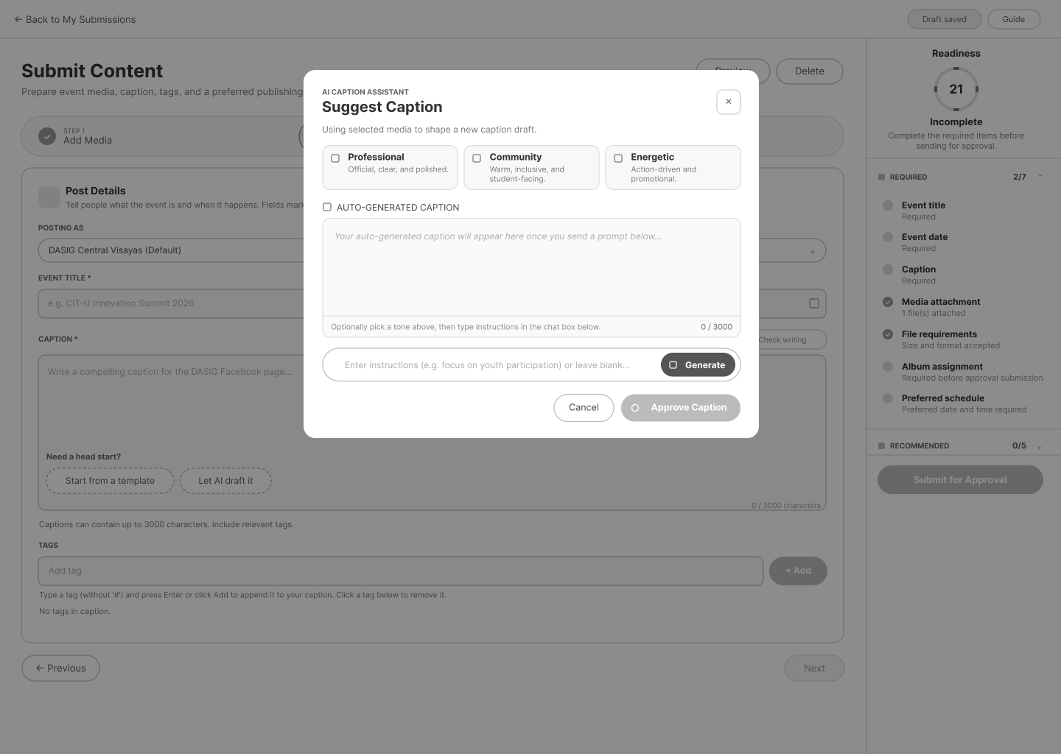

Media Attachment Rules

Use Case Diagram
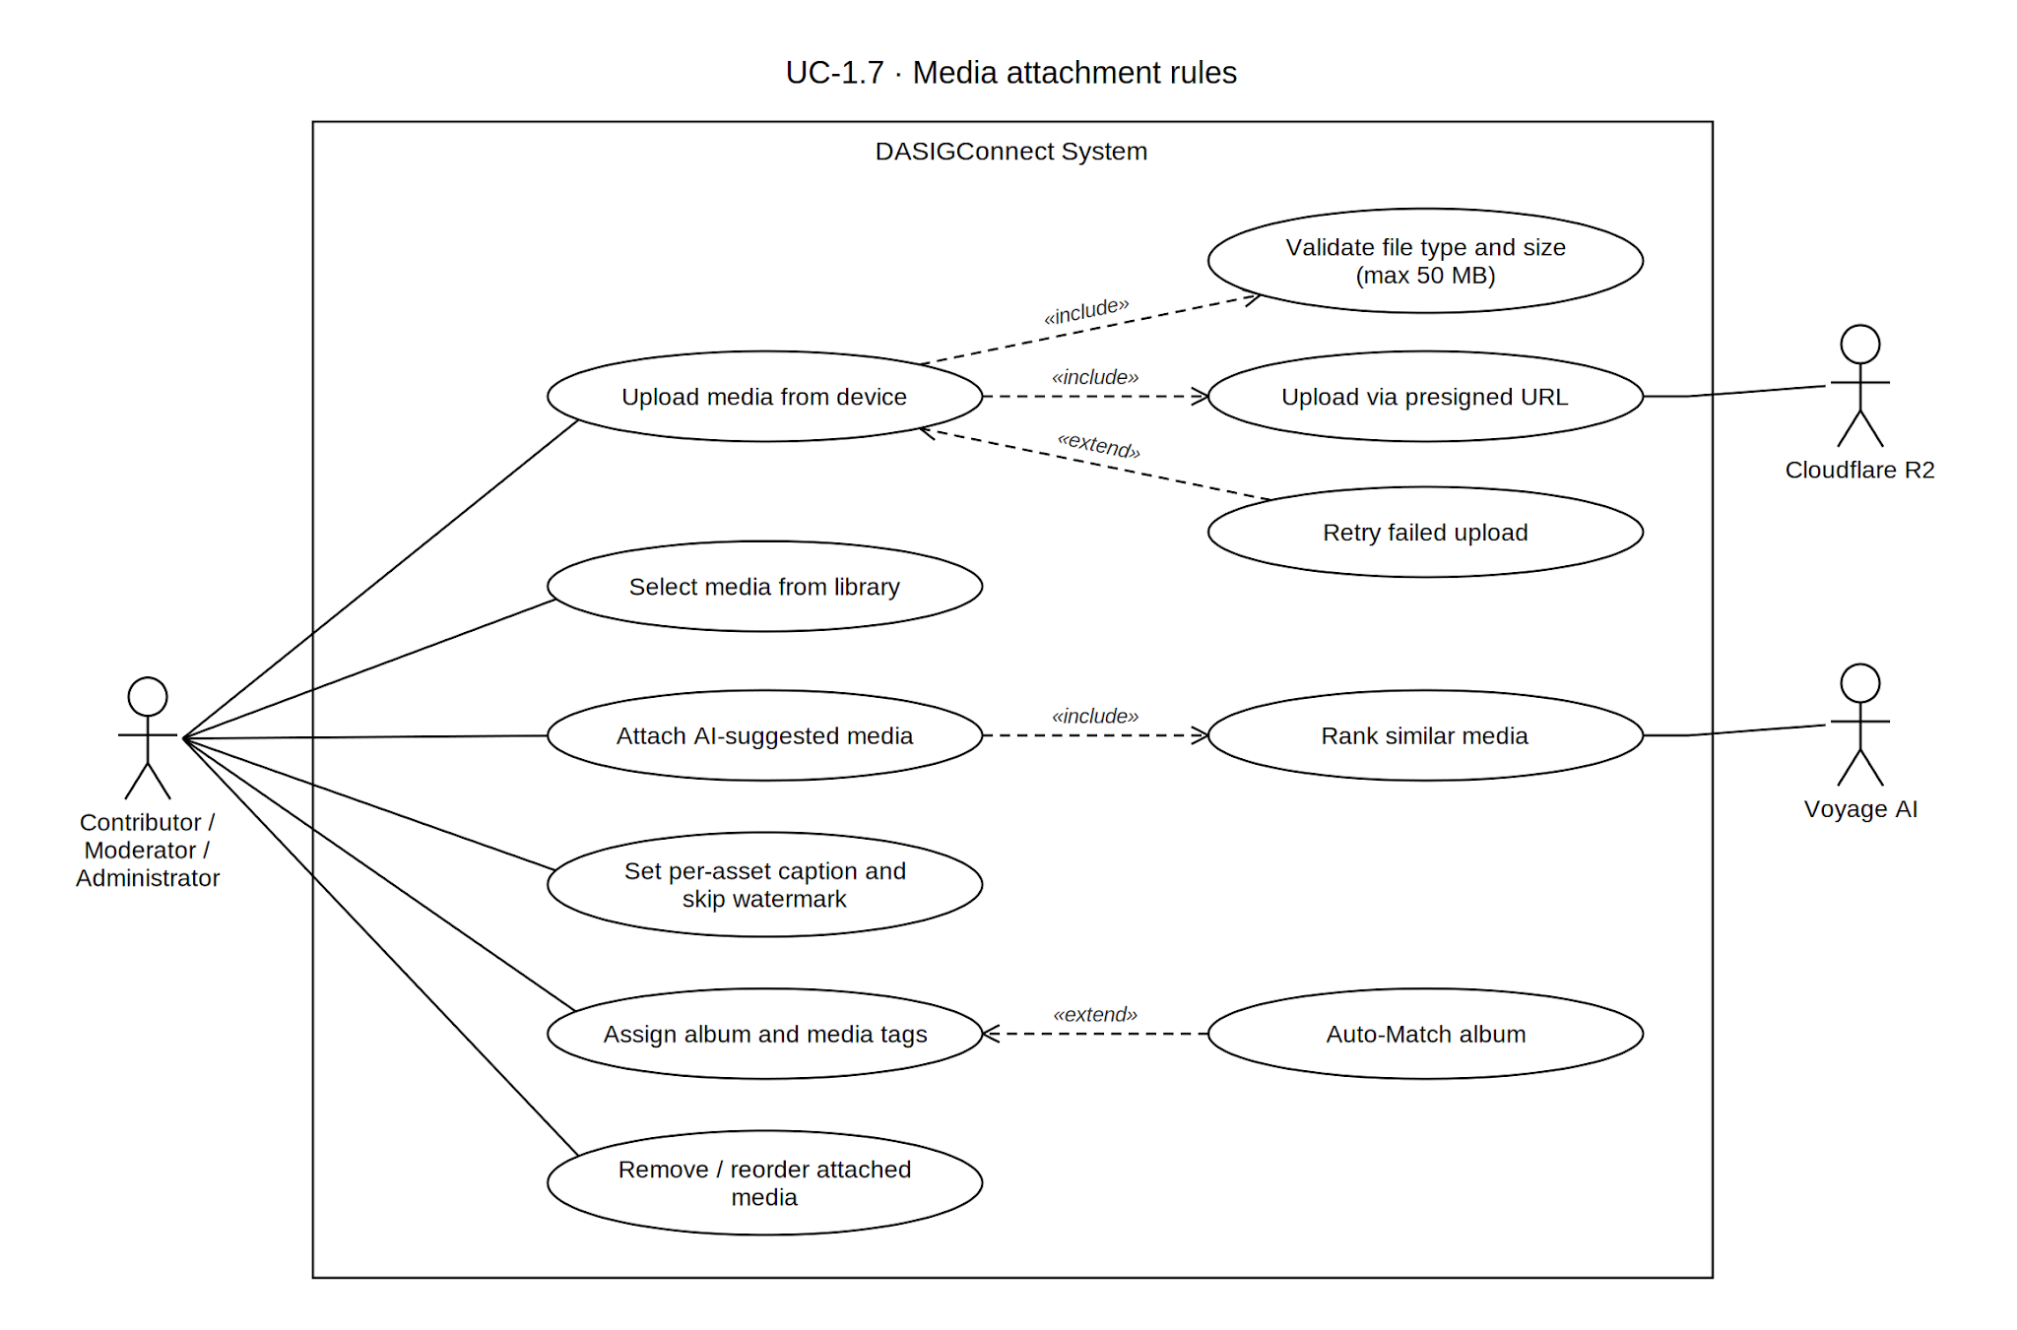

Use Case Description

Use Case ID | UC-1.7
Use Case Name | Media Attachment Rules
Actor(s) | Contributor, Moderator, Administrator — all three use the same composer (UC-1.5); there is no separate "Administrator acting as Contributor" mode.
Precondition(s) | The actor is in an active composer session (UC-1.5).
Main Flow | - The actor initiates media attachment from the composer's Add Media step by choosing to upload a new file from their device or select from the existing media library.  - Device Upload: the actor selects one or more image (JPEG, PNG, WebP, GIF) or video (MP4, MOV, WebM) files from their device.  - The system validates each file: only the seven accepted formats (case-insensitive; jpg normalized to jpeg), and file size must be greater than 0 and no more than 50 MB.  - Valid files are securely uploaded and attached to the draft, with a thumbnail preview shown in the composer.  - Library Selection: alternatively, the actor browses or searches the media repository (UC-2.2) and selects existing asset(s) to attach.  - AI-Suggested Media: Once the actor has entered enough context — event title, caption, and media tags combined — the system enables media suggestions when the combined context reaches at least 10 characters. The system analyzes the context to search the institution's media library, re-ranks candidates using semantic, visual, recency, category, and tag signals. The system displays highly relevant suggestions. If the system finds a highly confident album match, it applies it automatically; if it finds plausible matches, it displays up to three ranked candidates for manual selection. If no relevant match is found, the album field is left unchanged.  - Selected library asset(s) are linked to the draft and shown as thumbnail previews.  - For any attached asset, the actor may open the Media Caption modal to set a per-asset caption (≤500 characters, live counter) scoped to that image or video.  - Within the Media Caption modal, the actor may select Skip watermark for this image for photo assets. The preference is applied when the post is published.  - In the Organize & Schedule step, the actor may assign an album by selecting an existing album, entering a new album name, or choosing Auto-Match. Auto-Match evaluates root albums belonging to the institution selected for the submission. It combines tag overlap with visual similarity to the closest existing asset in each album. A score of at least 0.55 is applied automatically; a score from 0.32 to below 0.55 displays up to three ranked candidates for manual selection; and no candidate reaching 0.32 leaves the album field unchanged and displays a notice.  - The system enforces mandatory media attachment and organization: the draft cannot be submitted (UC-1.9) until at least one valid media file is attached and an album name is set.
Alternative Flow(s) | A1 — Invalid File Type: Rejected with an unsupported-format error listing accepted types; no asset record created.  A2 — File Exceeds Size Limit: Rejected with a size-limit error; no asset record created.  A3 — Upload Network Failure: The composer shows a Retry upload action and does not attach the failed upload to the draft. Any temporary upload state is cleaned up through the existing media-upload recovery process.  A4 — Remove Attached Media: The actor removes a previously attached file from the draft before submission.  A5 — No Relevant AI Suggestions Found: If no candidate clears the 0.40 similarity floor after re-ranking, the suggestions row does not render; the actor proceeds via Device Upload or Library Selection. If semantic search is unavailable, the system falls back to text-based tag matching. If no candidate passes the required score, the suggestions list remains empty.  A6 — Insufficient Event Details for Suggestions: The suggestions row does not appear until the combined event title + caption + category + tags text reaches 10 characters.  A7 — Mixed-Media Attachment: The draft accepts mixed image/video media. When publishing is attempted, the automated publisher marks the submission as failed rather than sending it through the automated Facebook flow. The submission then appears in the Review Queue Failed tab for manual recovery.  A8 — Ambiguous Auto-Match: When the top candidate scores ≥0.32 but below the 0.55 confident bar, the album field is left untouched and the same dropdown instead lists up to 3 ranked candidates (album name, match percentage, and reason — tag overlap and/or visual similarity) for the actor to select, choose a different existing album, or create a new one.  A8a — Auto-Match, No Confident Result: When nothing clears 0.32 (Auto-Match evaluates root albums belonging to the institution selected for the submission.), the field is left untouched with a notice that no confident match was found, and the actor proceeds as if Auto-Match were unavailable.  A9 — Attempted Submission Without Media or Album: Submission is blocked with a combined error message listing everything missing (media attachment, album assignment, or both).  A10 — Per-Asset Caption Skipped: Per-asset captions are optional; they surface only as a non-blocking Recommended readiness item and never block progression to submission.
Postcondition(s) | The draft contains at least one valid media attachment, meeting format and size requirements, with any per-asset captions and watermark preferences set, and an album name assigned — eligible to proceed to submission (UC-1.9). A media tag is always present in practice (the Event Title default), though this is an emergent guarantee from the Event Title being a required field, not an independently enforced "at least one tag" gate.

Activity Diagram
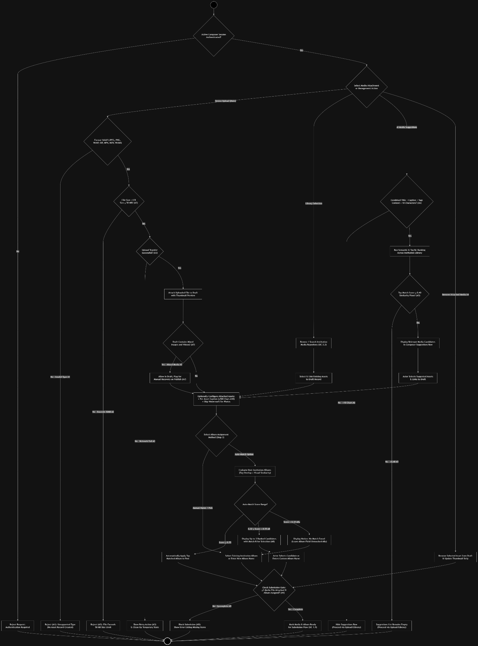

Wireframe
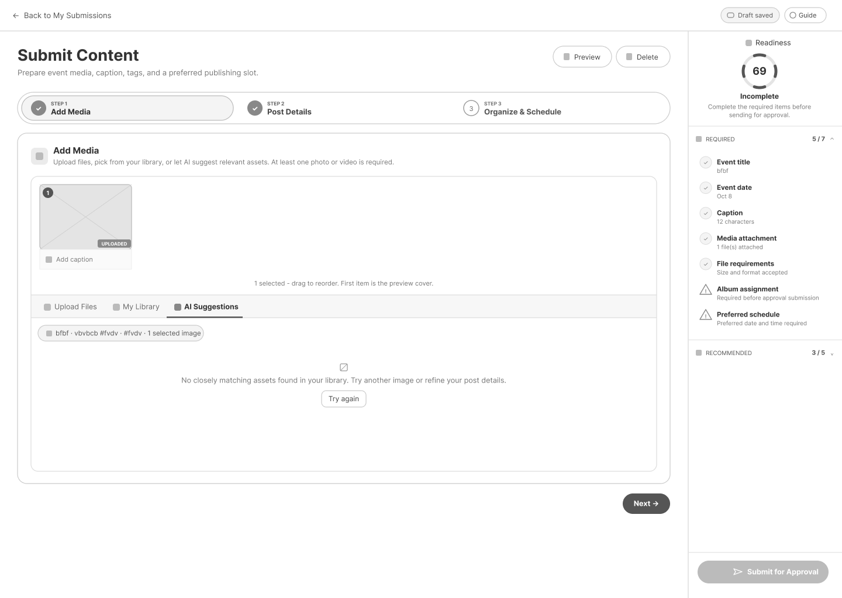

Engagement Helpers

Use Case Diagram
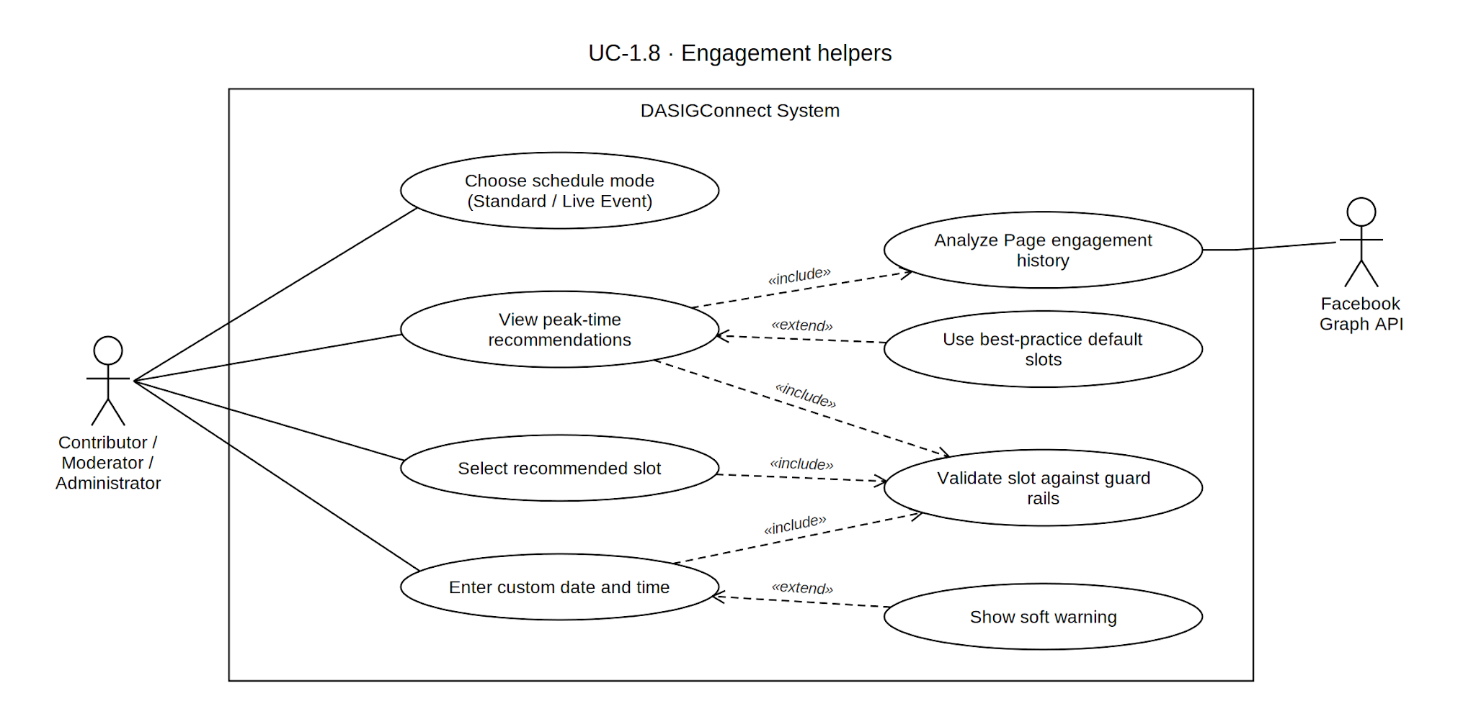

Use Case Description

Use Case ID | UC-1.8
Use Case Name | Engagement Helpers
Actor(s) | Contributor, Moderator, Administrator. The panel is skipped for an Administrator composer until an institution scope is selected. Moderators are network-wide and are not blocked by an institution scope requirement.
Precondition(s) | The actor is in an active composer session (UC-1.5), on the Organize & Schedule step, with a Standard (non-Fast-Track) draft. Live Event Fast-Track drafts skip scheduling entirely.
Main Flow | - The actor opens the scheduling panel within Organize & Schedule; it loads automatically for a Standard draft.  - The system queries recent historical social media engagement for the DASIG Page.  - Samples are bucketed by day-of-week and hour, restricted to the Administrator-configured posting window, averaged per bucket, and the top 5 buckets become candidate windows — provided at least 20 samples exist; otherwise a fixed default of Tuesday/Wednesday/Thursday 6 PM is used (A1).  - For each candidate window, the system walks the next 30 days for the first matching weekday, validates it against the scheduling guard rails, and keeps it only if not hard-blocked — up to 3 recommended slots total, each labeled with a single-hour window (e.g., "Best engagement: Tuesdays 6 PM - 7 PM") and carrying any soft warnings and a rounded score.  - The actor selects a recommended slot, or ignores the recommendation and chooses a custom date/time in the standard picker.  - The system validates the selected slot against the scheduling rules. When guard rails are enabled, conflicts within ±30 minutes, insufficient lead time, and times outside the Administrator-configured posting window are hard-blocked. The six-post daily threshold is surfaced as a soft warning. Validation is debounced as the actor changes the date or time.  - The selected schedule is saved to the draft on the next autosave/save.
Alternative Flow(s) | A1 — Insufficient Historical Data: Fewer than 20 samples (or no engagement in the configured posting window at all) falls back to the fixed default (Tuesday/Wednesday/Thursday 6 PM, descending weight), shown in the panel as "Best-practice guidance" with a notice that recommendations will improve as more Facebook history accumulates.  A2 — Recommended Slot Conflicts with Guard Rail: A hard-blocked candidate slot is excluded from the list entirely.  A3 — Analytics Service Unavailable: If analytics data is unavailable due to integration or network issues, the panel renders nothing; the date/time picker underneath is unaffected.  A4 — Manual Override of Recommendation: The actor may pick any non-recommended time, blocked only by a hard guard rail. If it clears the hard block but carries a soft warning, the composer shows it inline beneath the date/time fields. This applies only when the network-wide guard-rail toggle is enabled.
Postcondition(s) | The draft has an assigned scheduled date and time, either selected from a system recommendation or entered manually. When guard rails are enabled, the time is checked against the applicable hard rules and soft warnings; when disabled, the guard-rail restrictions are skipped. Standard posts still require a future scheduled time and slot reservation. Fast-Track posts do not require a scheduled time or reservation.

Activity Diagram
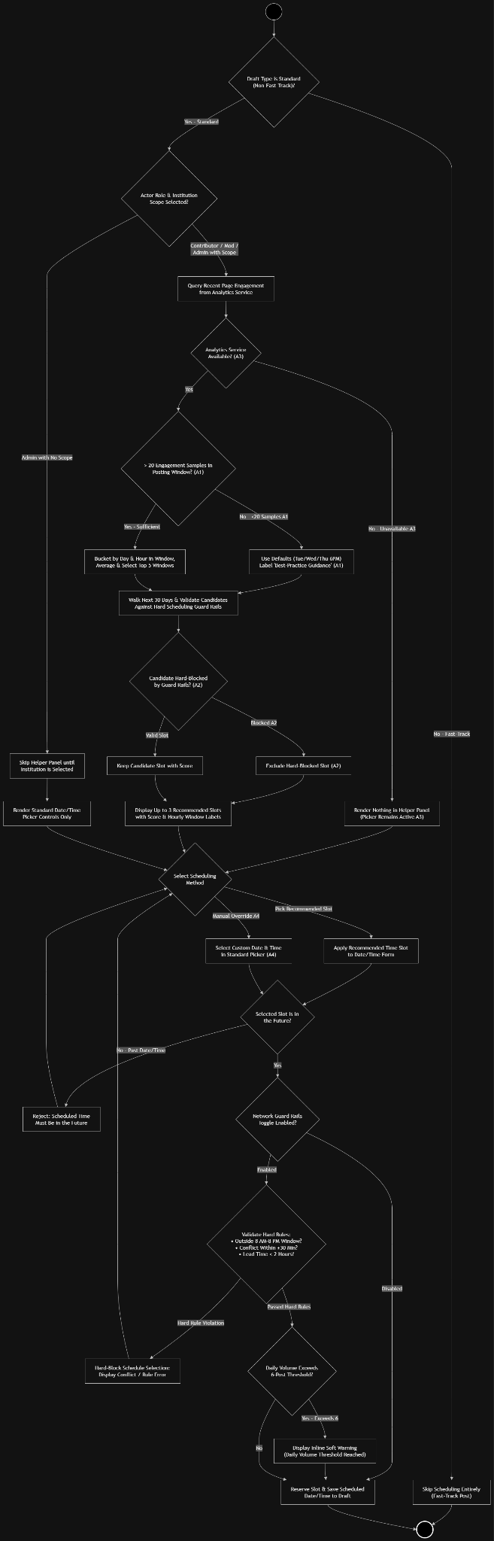

Wireframe

Draft Submission

Use Case Diagram
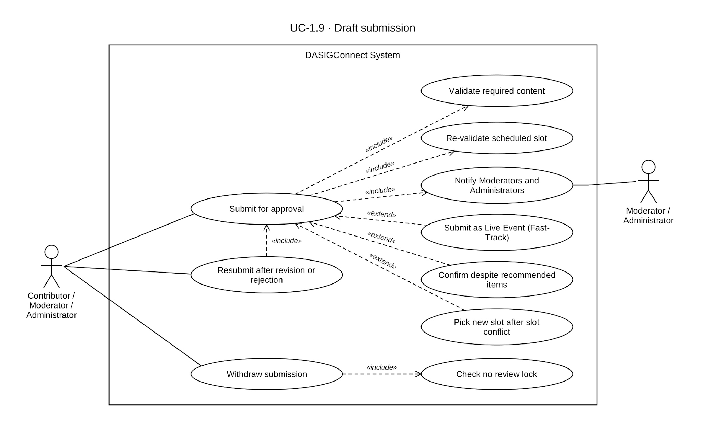

Use Case Description

Use Case ID | UC-1.9
Use Case Name | Draft Submission
Actor(s) | Contributor, Moderator, Administrator — all three use the same composer (UC-1.5) and the same submission endpoint.
Precondition(s) | A submission exists in draft, needs_revision, or rejected state, with at least one valid media attachment assigned to an album. A Standard post must also have a selected future scheduled date/time. Fast-Track posts do not require a scheduled time or slot reservation.
Main Flow | - The actor reviews the completed draft in the composer, including caption, attached media, and scheduled time.  - The actor clicks Submit for Approval. The system locally verifies that the event title, event date, caption, media, album, and (for Standard drafts) schedule are present. If any required field is missing, the actor is redirected to the relevant step to correct it. Optional quality tips never block submission.  - The system performs final validation: event title, event date, album assignment, caption presence and length, and at least one attached media asset are required. For Standard drafts, the scheduled slot is validated against the enabled guard-rail rules. Conflicting slots, insufficient lead time, out-of-window times, and slots beyond the 30-day horizon are hard-blocked. The six-post daily threshold produces a soft warning but does not block submission. Fast-Track skips scheduled-slot validation entirely.  - If validation passes, the submission transitions from draft, needs_revision, or rejected to pending, and further contributor edits are blocked. When resubmitting a rejected post, the previous rejection reason is cleared.  - The system notifies every Moderator and Administrator of the new submission (T-01: in-app notification + Messenger DM where linked).  - The submission appears in the network-wide Approval Queue, and the actor's own draft list reflects its new pending status.
Alternative Flow(s) | A1 — Validation Failure at Submission: If any validation check in step 3 fails, the submission remains in its current state (draft/needs_revision/rejected) and an error message is presented.  A2 — Withdraw Submission: An actor may withdraw a pending submission, which returns it to draft status. Withdrawal is blocked and returns a conflict error if a review lock currently exists for the submission (i.e., a reviewer has opened it). Withdrawing is not permitted from the in_review state.  A3 — Resubmission After Revision or Rejection: A needs_revision submission is editable and resubmits through the exact same flow.  A4 — Concurrent Slot Conflict: If the system detects a newly-conflicting slot during final validation, the submission is rejected. The actor is returned to the Organize & Schedule step and prompted to select a new time.  A5 — Live Event Fast-Track Submission: Scheduling-slot validation is skipped entirely. An immediate high-priority notification (T-11, in-app + email + Messenger) is sent to all Moderators. Fast-Track submissions are prioritized at the top of the active Approval Queue ahead of standard date-based sorting, though this prioritization does not apply to the resolved-items history tab.
Postcondition(s) | The submission exists in pending, is visible in the network-wide Approval Queue, and is locked against further contributor edits until approved, rejected, or returned for revision. Fast-Track submissions are prioritized at the top of the active queue. Standard submissions retain their scheduled slot reservation.

Activity Diagram
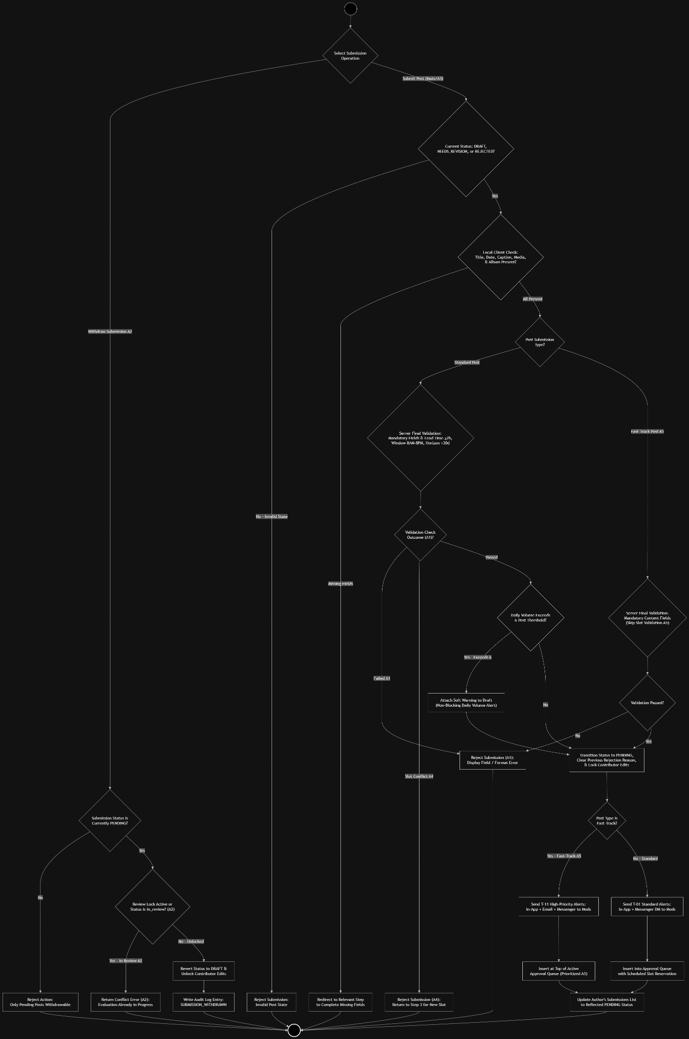

Wireframe
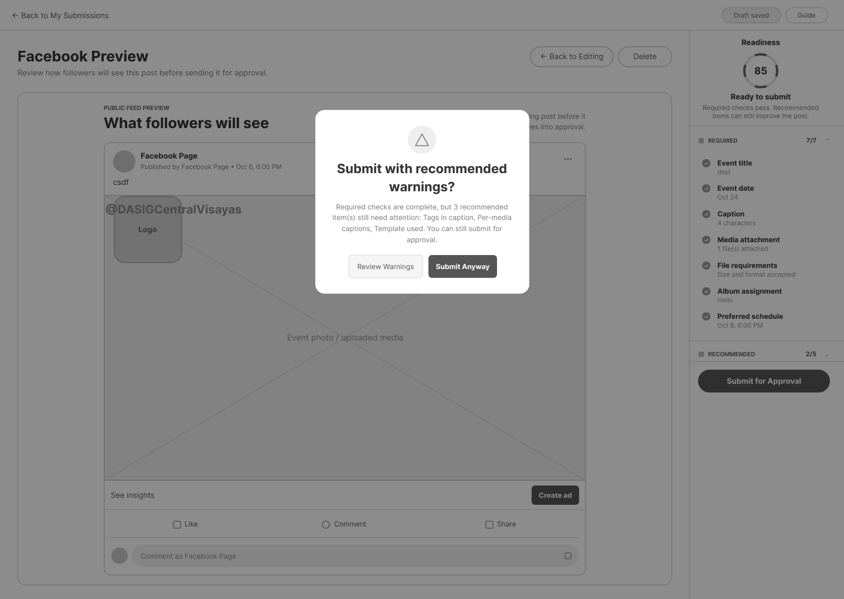

Moderator Account Management

Use Case Diagram
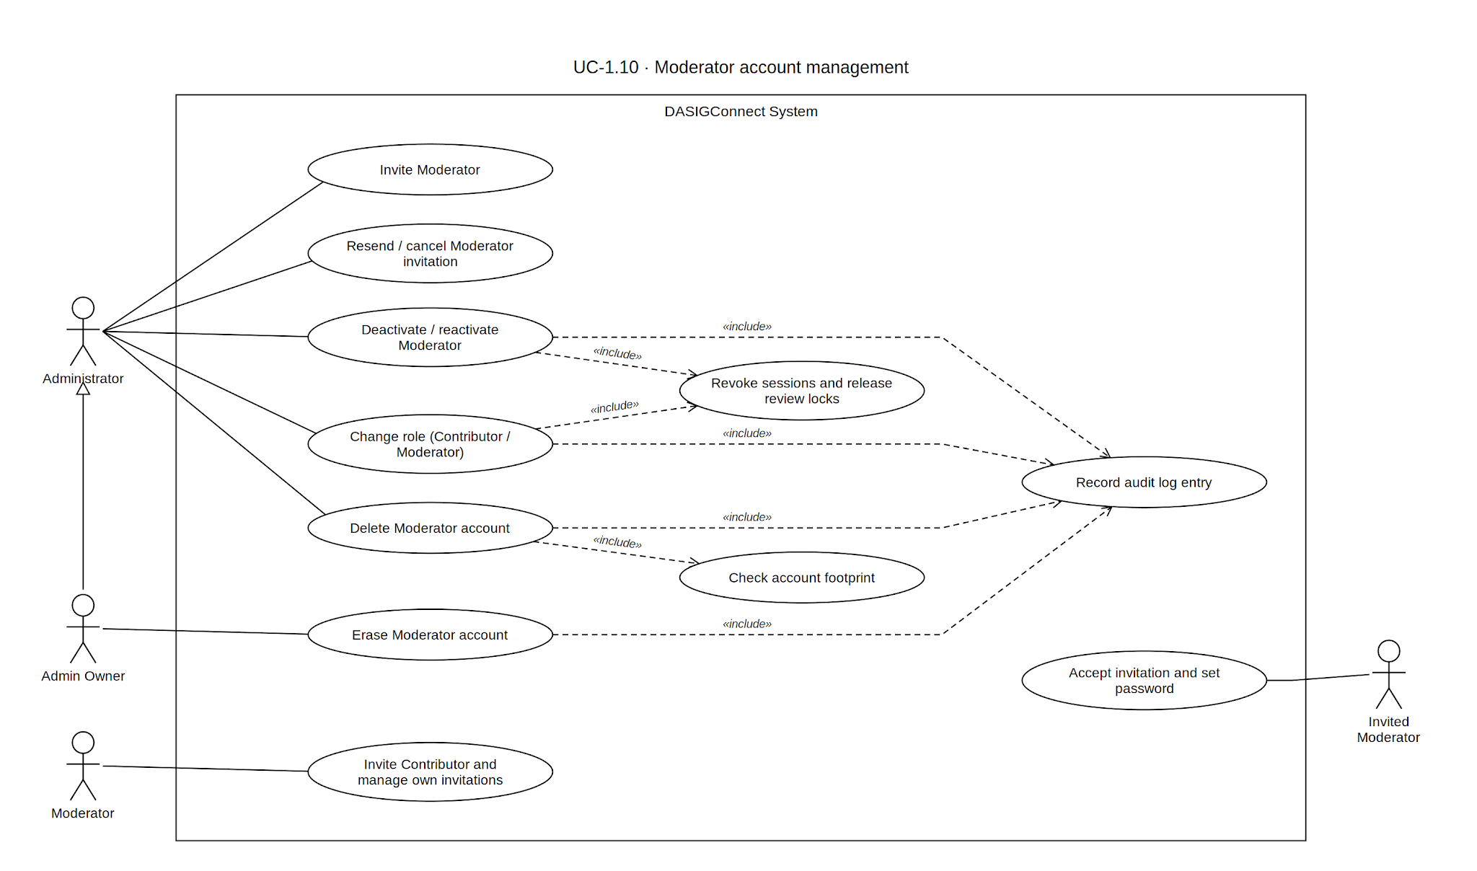

Use Case Description

Use Case ID | UC-1.10
Use Case Name | Moderator Account Management
Actor(s) | Administrator, Moderator (limited to managing Contributor invitations they personally sent)
Precondition(s) | The actor holds a valid, authenticated, ACTIVE session. Administrator privileges are required for all Moderator-account management actions. Moderators hold network-wide scope without an institution assignment.
Main Flow | - The Administrator navigates to User Management and selects Invite User, which opens the invitation modal.  - The Administrator inputs the invitee's email address and selects the Moderator role. Selecting this role hides the destination institution selector, automatically enforcing a network-wide scope.  - The Administrator submits the invitation request.  - The system validates the request as a network-scoped Moderator invitation.  - The system generates a unique, single-use invitation token bound to the invitee's email address, valid for 72 hours, and stores the hashed token.  - The system creates or updates the invitee's account record in PENDING state, reusing any existing PENDING, PENDING_EMAIL_UNDELIVERED, CANCELLED, or EXPIRED record for that email. If an account with the email exists in an ACTIVE or INACTIVE state, the system rejects the invitation. Older unused invitation tokens for the same email are invalidated.  - The system dispatches an activation email containing the activation link.  - The invitee completes activation by setting their password.  - The account transitions to ACTIVE, receives the Moderator role, remains institution-agnostic, and gains network-wide access to the Approval Workflow and Contributor-management privileges.
Alternative Flow(s) | A1 — Invitation Email Undelivered: If email dispatch fails (single attempt; no automatic retry), the account remains in PENDING_EMAIL_UNDELIVERED until an Administrator verifies the address and triggers a resend (A8).  A2 — Deactivate Moderator Account: An active Administrator deactivates an ACTIVE Moderator account. The system revokes all active sessions, blocks login, retains historical review activity and audit data, and records the action in the audit log.  A3 — Reactivate Moderator Account: An active Administrator reactivates an INACTIVE Moderator account. Existing credentials remain valid, and no new session token is issued.  A4 — Delete Moderator Account: An active Administrator permanently removes a Moderator account that is INACTIVE, CANCELLED, or EXPIRED. If the account has any historical footprint (submissions, media uploads, review actions, albums, or audit entries), it is anonymized at rest with a USER_REMOVED audit entry. A completely footprint-free account is hard-deleted with a USER_DELETED audit entry.  A5 — Erase Moderator Account (Right to Be Forgotten): The Admin Owner anonymizes an INACTIVE or CANCELLED account in place, writing a USER_ANONYMIZED audit entry.  A6 — Moderator Invites Contributor:A Moderator invites a Contributor to any institution, assigning only the Contributor role (UC-1.3).  A7 — Moderator Manages Own Sent Invitations: A Moderator may resend, cancel, or delete a Contributor invitation they personally sent. A Moderator cannot deactivate, reactivate, or delete an already-ACTIVE Contributor account.  A8 — Cancel Pending Moderator Invitation: An active Administrator cancels a pending Moderator invitation (PENDING, PENDING_EMAIL_UNDELIVERED, or EXPIRED). The system deletes all outstanding tokens for that email and sets the account to CANCELLED.  A9 — Resend Pending Moderator Invitation: An active Administrator resends an invitation for an account in PENDING_EMAIL_UNDELIVERED, EXPIRED, or CANCELLED state. The system generates a fresh 72-hour token, invalidates prior open tokens, and resets the account to PENDING.  A10 — Moderator as Promotion Target: A Moderator may be the target of an Administrator promotion proposal (UC-1.1 A7).  A11 — Change Role: Any active Administrator may move an active account directly between Contributor and Moderator using the Change Role modal.  - Contributor → Moderator (Promotion): The Admin proposes promoting an active Contributor to Moderator. This requires the Contributor's confirmation. Upon confirmation, the system changes the role to Moderator, automatically clears the account's institution assignment, invalidates active sessions requiring a re-login, and records MODERATOR_PROMOTION_CONFIRMED (the proposal itself records MODERATOR_PROMOTION_REQUESTED).  - Moderator → Contributor (Demotion): The Admin selects Contributor and is required to assign an active target institution. This change is immediate.  - Either direction: Any submissions the account currently holds under an active review lock are released back to the queue.
Postcondition(s) | A new Moderator account exists in PENDING or ACTIVE state, whether created through invitation or through lateral role change from Contributor. An existing Moderator account has been deactivated, reactivated, removed (or deactivated if footprint exists), anonymized, demoted to Contributor, or had its pending invitation cancelled or resent. Any review locks held at the time of a role change or deactivation have been released back to the Approval Queue. All state-changing actions are reflected in the audit log.

Activity Diagram
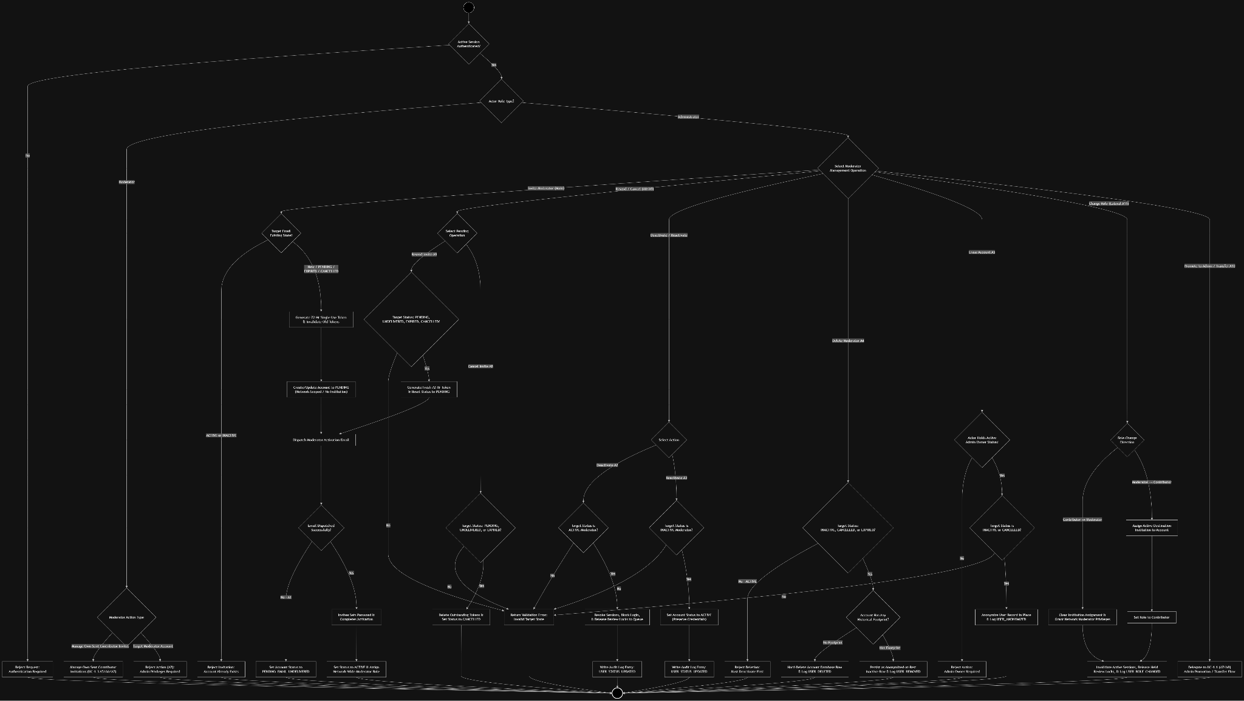

Wireframe
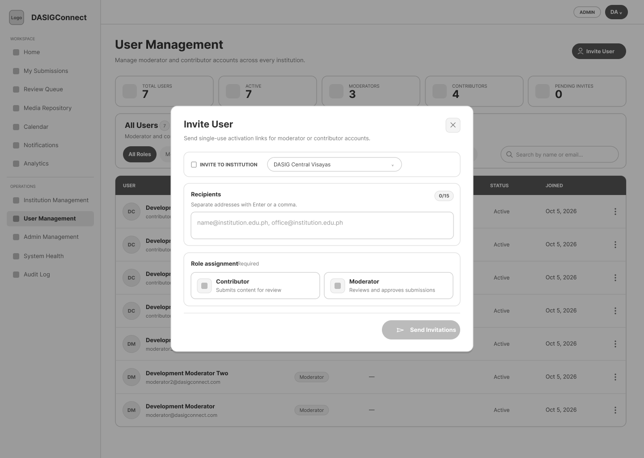

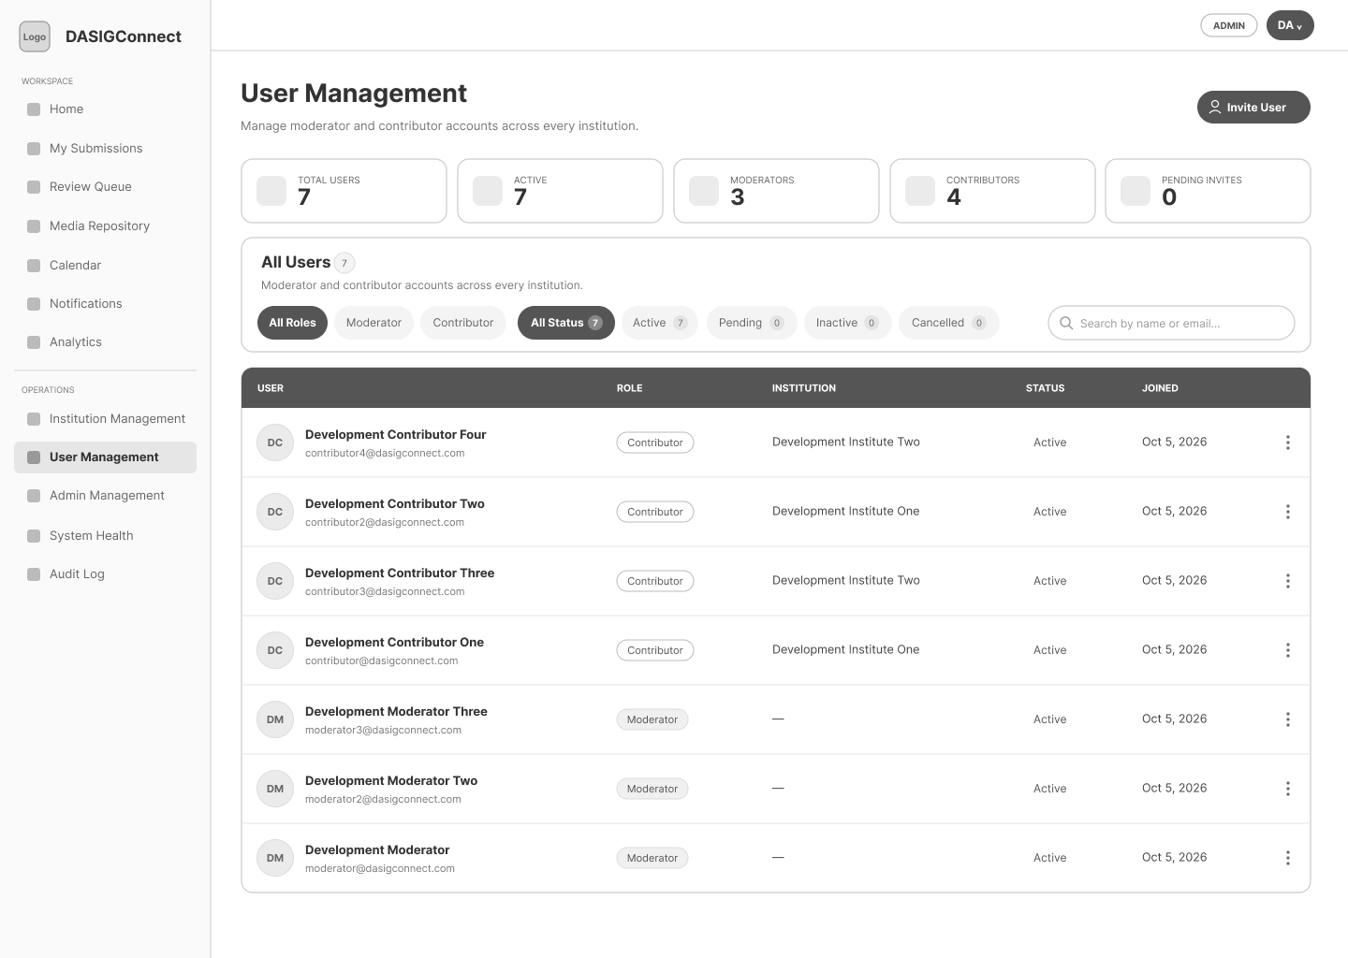

Module 2: Media Library & Approval Pipeline
This module governs the institution-scoped media library — where assets are uploaded, organized into event-based albums, discovered through search and AI-assisted browsing, and tracked across their reuse history — along with the Administrator's approval pipeline for submitted content and the automated watermarking applied at publication.

Library Uploads & Albums

Use Case Diagram
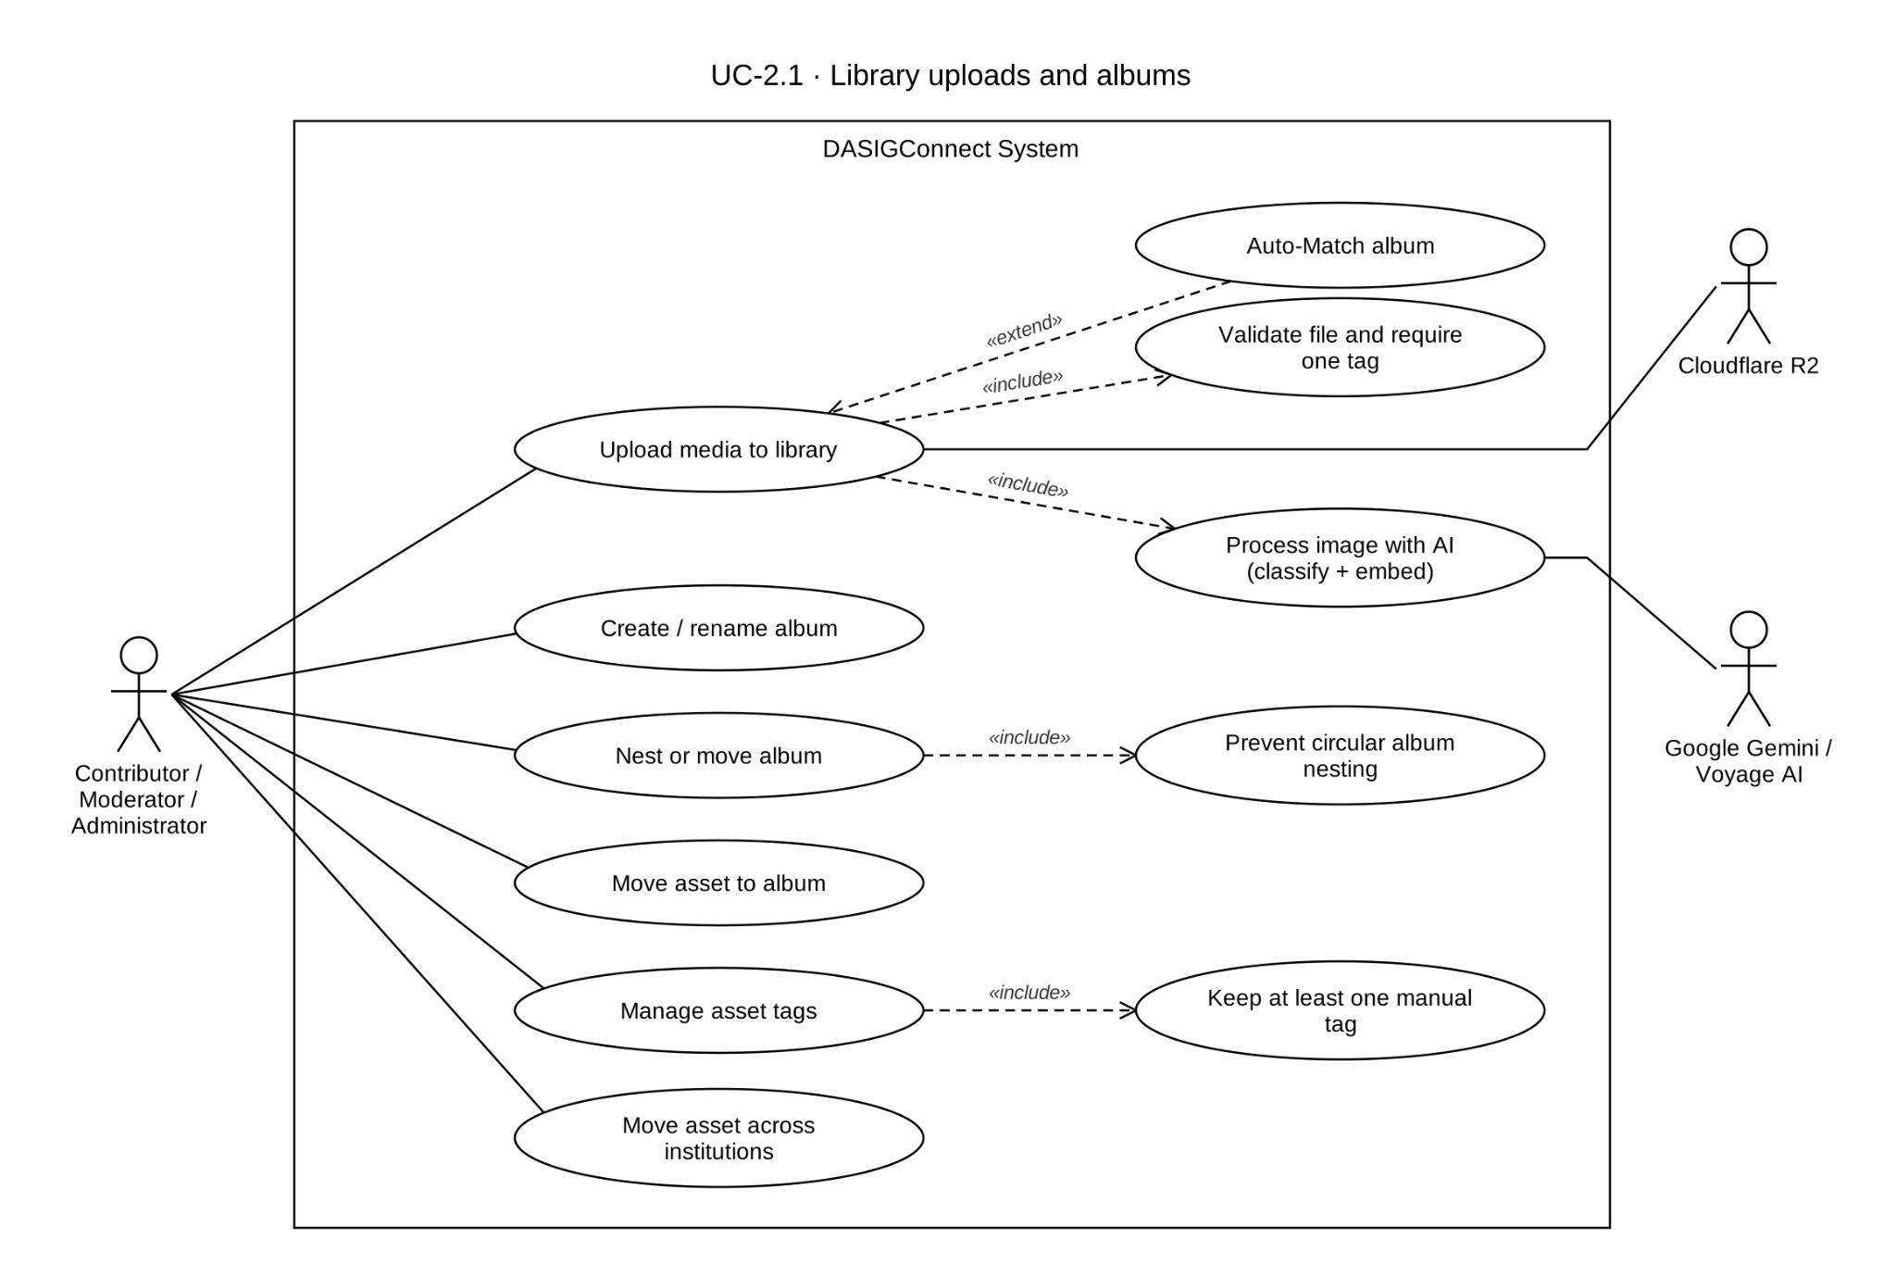

Use Case Description
Use Case ID | UC-2.1
Use Case Name | Library Uploads & Albums
Actor(s) | Contributor, Moderator, Administrator — upload and album management endpoints are open to any authenticated user, not role-restricted.
Precondition(s) | The actor is authenticated with an active session. The institution's media library exists (provisioned upon institution creation, UC-1.2).
Main Flow | - The actor initiates an upload from the Media Library screen, selecting one or more files from their device.  - The system validates each file against accepted formats (JPG, PNG, WEBP, GIF, MP4, MOV, WEBM) and the 50 MB size limit, checked both client-side and server-side.  - Before the upload is finalized, the actor specifies:  - Album: select an existing album, click Auto-Match, or type a new name to create one — or select/type a full folder path to file the upload into a nested album structure (see A8). Auto-Match scores existing albums by tag/filename word overlap and tiers the result — a confident match (≥0.6) auto-fills with a reasons badge; an ambiguous one (≥0.3) lists up to 3 ranked candidates for the actor to confirm or override; no match leaves the field for manual entry.  - Tags: the actor enters at least one tag (server-enforced). A tooltip suggests using the event name as a tag to improve search results.  - On confirmation, the system stores the asset(s) — an image is marked PROCESSING; a video is marked READY immediately, since nothing is queued for it — applies the selected/created album, and saves the actor-entered tags.  - The system triggers AI classification and embedding asynchronously, for image files only. A video upload is never classified or embedded.  - The asset appears in the library grid under its assigned album with a "Processing…" badge that clears once classification and embedding succeed.
Alternative Flow(s) | A1 — Unsupported File Type: Rejected client- and server-side.  A2 — File Exceeds Size Limit: Rejected at the 50 MB limit, both ends.  A3 — Upload Network Failure: Retry prompt, consistent with the composer's own pattern (UC-1.7 A3).  A4 — Ambiguous Album Match (Auto-Match): Auto-Match is text-based (tag/filename overlap), not visual similarity — the file isn't yet uploaded or embedded at album-selection time, unlike the submission composer's Auto-Match (UC-1.7), which scores already-attached, already-embedded assets. A confident match (≥0.6) auto-applies with a reasons badge; an ambiguous result (≥0.3) presents up to 3 ranked candidates inline for the actor to confirm or choose differently.  A4a — Auto-Match, No Confident Result: No text match found; the field is left for manual entry with an inline notice. Upload is blocked with no album name set.  A5 — Manual Album Reassignment: The actor moves an asset to a different existing album. Every library asset always belongs to exactly one album — there is no "unfiled"/unassign state, by deliberate design.  A6 — Manual Album Creation: The actor creates a new album independent of any upload.  A7 — Rename Album: The actor renames an existing album.  A8 — Nested Album Organization: An album may be created as a sub-album of another (a parent-child folder structure). The actor may either create/select a full folder path in one action (each segment created if it doesn't already exist), or re-parent an existing album under a different parent afterward. The system blocks any re-parenting action that would make an album a descendant of itself, preventing a circular folder structure.  A9 — Post-Upload Tag Management: After upload, the actor may add or remove individual tags from the asset’s detail view. At least one actor-entered (manual) tag must always remain. Removing the last manual tag is blocked; AI-generated tags do not count toward this requirement.  A10 — Cross-Institution Asset Movement: A Contributor may move an asset within their own institution or into the shared network-default institution, and may do so only for assets they uploaded. Moderators and Administrators may move assets across any institutions, including into or out of the shared library. Moderators and Administrators are not limited to their own uploads.
Postcondition(s) | The uploaded asset exists in the institution’s media library, assigned to an album that may be nested within a folder structure, with at least one actor-entered tag. An image asset is queued for asynchronous AI classification and embedding, transitioning from PROCESSING to READY on success or FAILED if processing fails. A video asset is stored and organized identically but is marked READY immediately without AI classification or embedding. Tags and album/folder placement may continue to be edited after upload.

Activity Diagram
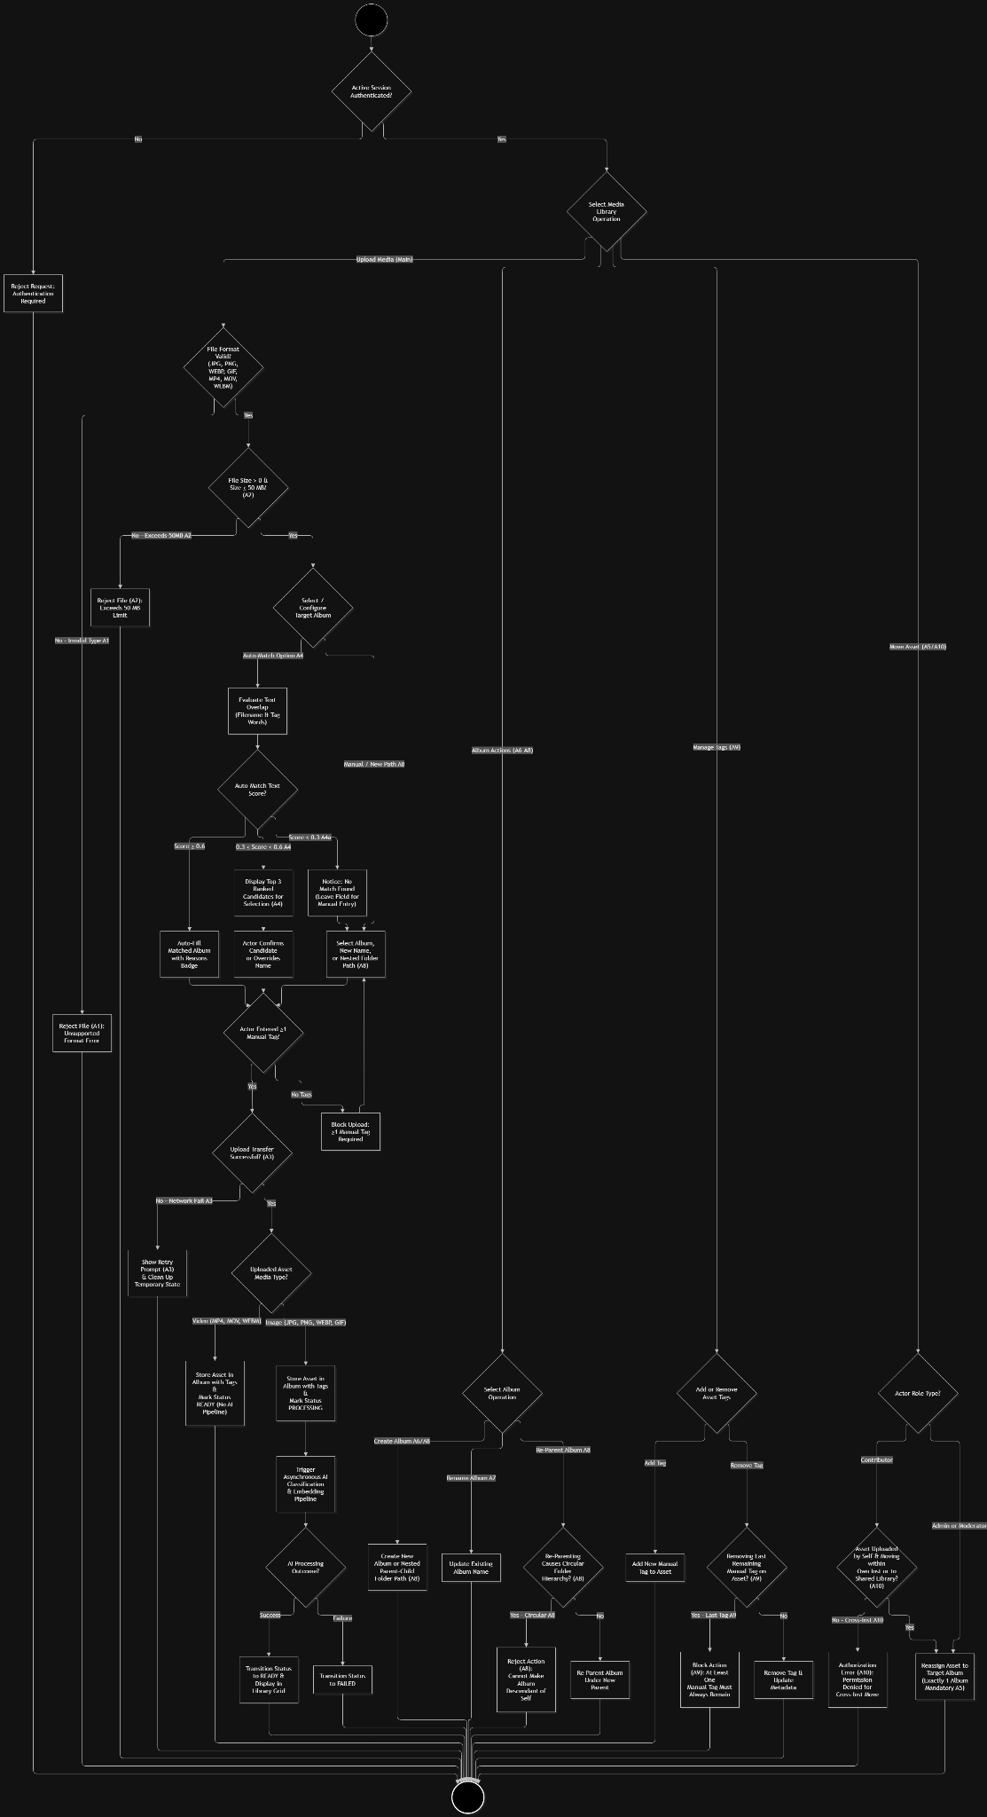

Wireframe
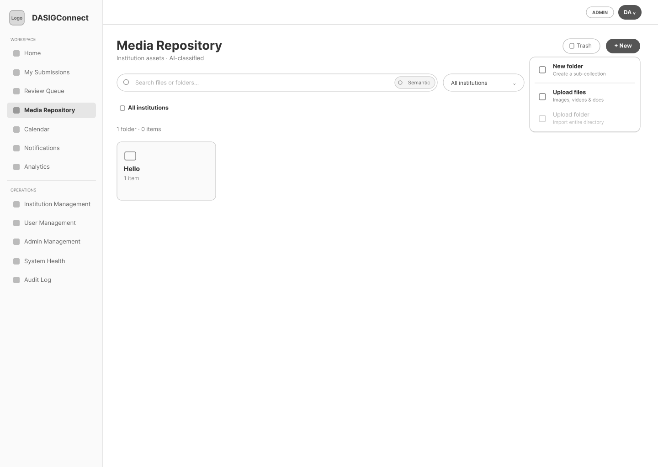
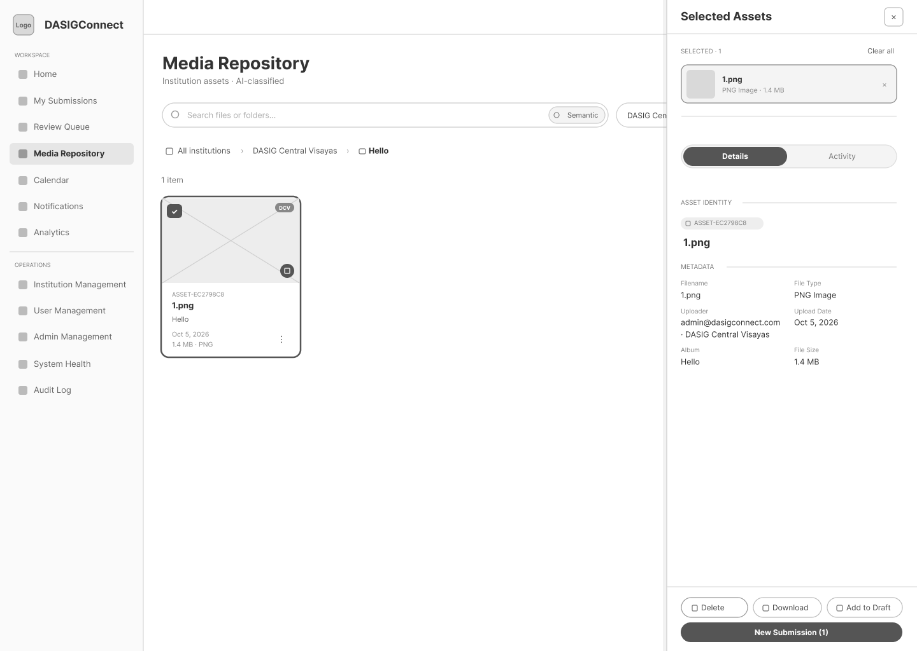

Semantic Search & Filtering

Use Case Diagram
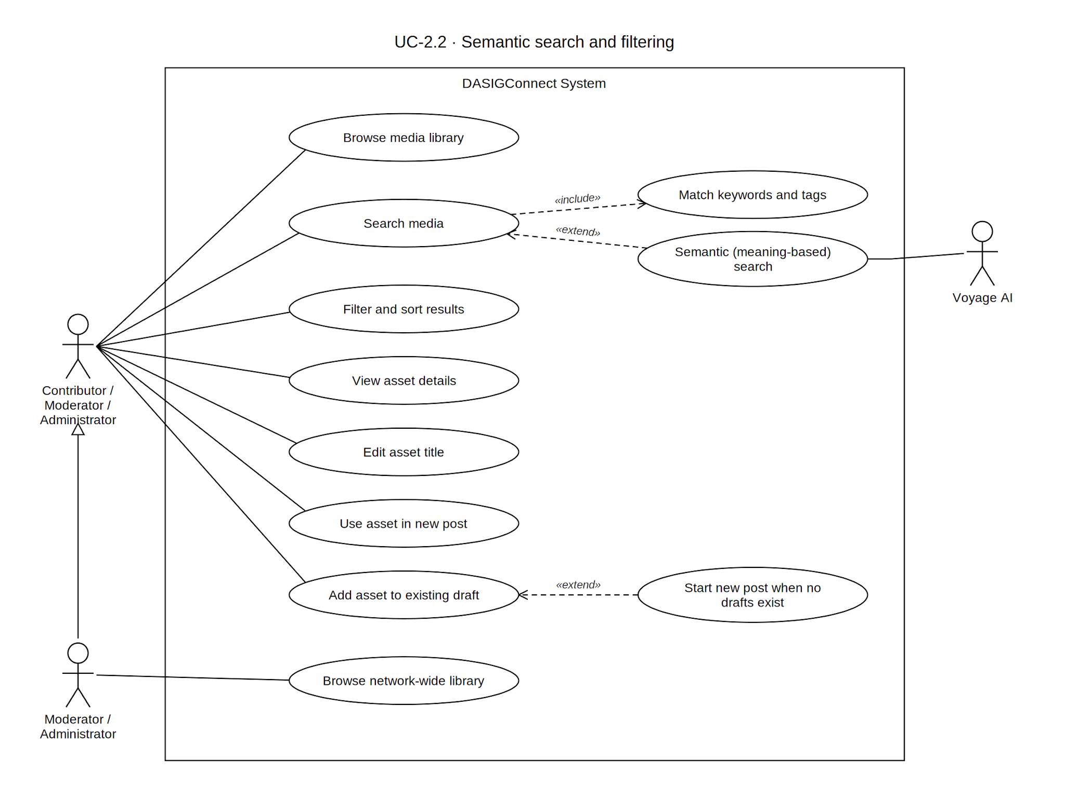

Use Case Description
Scope Note – UC-2.2 governs browsing, discovery, and detailed inspection of the institution's media library — search, filtering, album navigation, and the Asset Detail Panel. It intersects with UC-1.7 when a Contributor browses the library from within the post composer, and with UC-2.1 for asset upload and album assignment. AI classification tags and embeddings displayed here are generated by the background media-processing pipeline started on upload (UC-2.1) and recovered by GR-T7.
Use Case ID | UC-2.2
Use Case Name | Semantic Search & Filtering
Actor(s) | Contributor, Moderator, Administrator
Precondition(s) | The actor is authenticated with an active session. The institution media library exists (UC-1.2, UC-2.1).
Main Flow | - The actor navigates to the Media Library from the workspace sidebar  - The system displays all media assets for the actor's institution in a grid view, grouped/filterable by album. Each asset card shows the asset code, display title, upload date, file size and type, and a "Processing…" badge if processing is ongoing.  - The actor browses using keyword search, meaning-based semantic search, an album or institution filter, sort options (Newest, Oldest, Name, Size), and a grid/list view toggle. Keyword search covers filename, display title, asset code, uploader email, available AI classification metadata, and tags. Meaning-based search uses a Voyage AI query embedding and pgvector similarity ranking, with keyword matching used as a fallback or supplement when semantic results are unavailable. Event names are not directly searchable because they are not stored on the media asset.  - The result strip updates with the matching count and any active filter labels.  - The actor clicks an asset card to open the Asset Detail Panel: media preview; asset code (read-only); an editable title (click to reveal a text field; Enter or blur saves, Escape cancels); a metadata grid (filename, uploader, institution, upload date, album, file size, resolution/duration, file type); an AI Tags block with per-tag confidence percentages; a "Your tags" block with an add-tag field; and a "Used In" history list.  - From the panel, the actor may select "Add to Draft" or "New Submission" — available to all three roles.
Alternative Flow(s) | A1 — No Results Found: The system displays an empty state ("No assets match your filters") with active filters remaining visible and clearable.  A2 — Cross-Institution Access Attempt: Requesting an asset outside the actor’s visible institutions returns a not-found response, reinforced by database-level row security. Contributors can browse their own institution and the shared network-default institution. Network View, which provides full cross-institution browsing, is available to Moderators and Administrators because both roles are network-wide.  A3 — Custom Tag or Metadata Search: A newly added manual tag is immediately searchable through keyword matching. AI-generated tags are also included in keyword matching. Semantic ranking reflects the embeddings available for the asset and is not recomputed after every tag or title edit; therefore, later metadata changes may affect keyword results without changing semantic-ranking order.  A4 — Add to Existing Draft, No Active Drafts: If the actor has no draft-status submissions, the system allows the user to click "New Submission" instead.  A5 — Add to Existing Draft, Asset Limit Reached: If adding an asset would exceed the 10-media-per-submission limit, the system notifies the actor; when adding multiple assets in one action, any assets successfully attached before the limit was reached remain attached, and the cache is updated properly.
Postcondition(s) | The actor has located and, if applicable, reused a media asset. The asset’s detail view accurately reflects its current metadata, editable display title, AI tags, manual tags, album, and available actions. Keyword and semantic search results reflect the metadata and embeddings currently available for the asset.

Activity Diagram
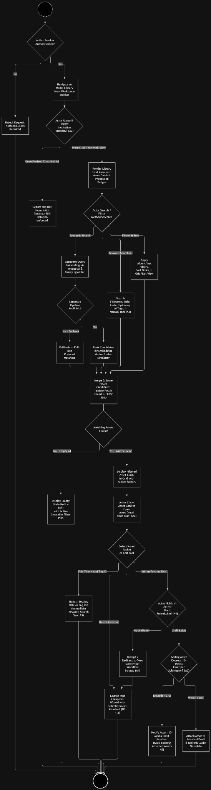

Wireframe
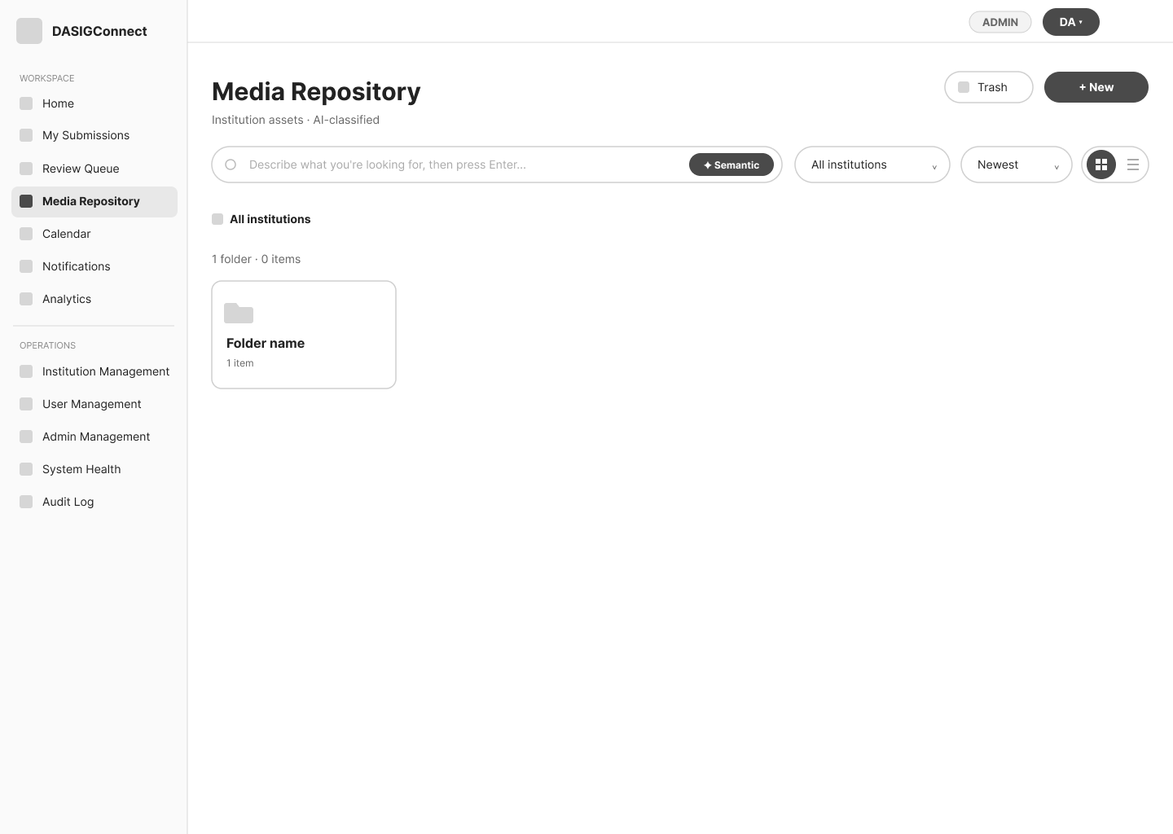

Media History Tracking

Use Case Diagram

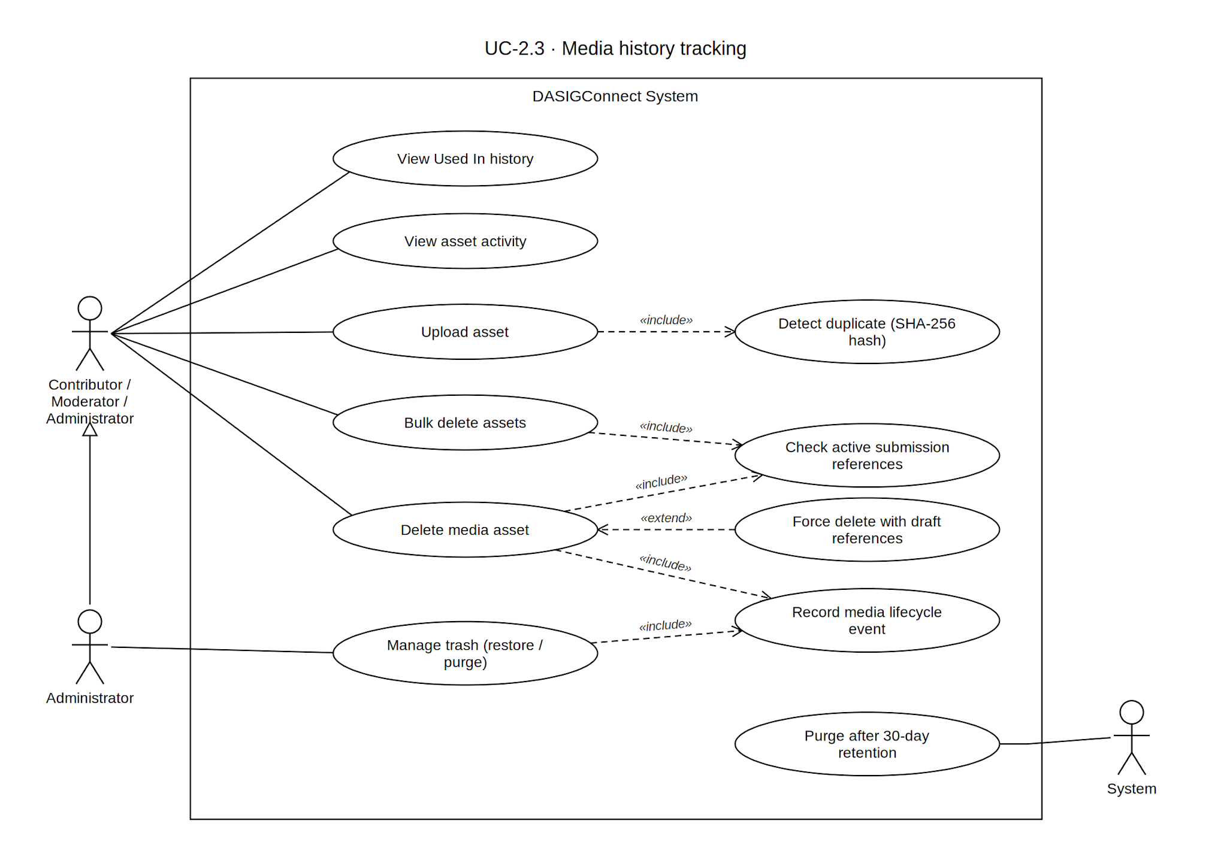

Use Case Description
Use Case ID | UC-2.3
Use Case Name | Media History Tracking
Actor(s) | Contributor, Moderator, Administrator
Precondition(s) | The actor is authenticated with an active session and is viewing an asset via the Asset Detail Panel (UC-2.2) or the audit log. Deletion rights are tiered: an Administrator may delete any asset; a Moderator or Contributor may delete only assets they uploaded. The Trash (A5) is Administrator-only.
Main Flow | - From the Asset Detail Panel, the actor views the Used In block: a chronological list of all submissions that have referenced this asset, each showing submission title, date, current status badge, and a jump link (subject to the actor's access permissions). Deleted submissions display as "[Submission Deleted]."  - The system records every reuse action (attachment to a new post or draft) server-side, updating the Used In block upon draft save or submission.  - The system records every media lifecycle event — upload, edit, album reassignment, reuse, and deletion — to an immutable media audit log.  - An Administrator may view the media audit log from the admin console to review asset history network-wide.
Alternative Flow(s) | A1 — Asset Deletion, Blocked: If the asset is referenced in a submission in PENDING_APPROVAL, UNDER_REVIEW, SCHEDULED, or PUBLISHING state, the system blocks deletion and displays the conflicting submission with a jump link.  A2 — Asset Deletion, Warning: If the asset is referenced only in DRAFT or NEEDS_REVISION submissions, the system prompts for confirmation, warning that the reference will break; the affected draft surfaces a broken-reference warning the next time the Contributor attempts to submit it (UC-1.9).  A3 — Asset Deletion, Free: If the asset is referenced only in terminal-state submissions or has no references, the system prompts for confirmation and, upon approval, marks the asset deleted; Used In entries in terminal submissions update to "[Asset Deleted]."  A4 — Duplicate Asset Detected: Upon upload (UC-2.1), if the system detects an exact duplicate of an existing asset based on a content hash match within the target institution, it flags the new upload and prompts the actor to confirm intent to "Upload Anyway", "Cancel", or "Use Existing" (which safely opens the matching asset in the repository without cross-institution data leaks).  A5 — Trash, Restore, and Purge (Administrator only): A deleted asset is held in the Trash for the retention window (default 30 days) and its search embeddings are removed. An Administrator may search the Trash, restore one or many assets, permanently delete one or many, or empty the Trash. Assets not restored are permanently purged, including their stored objects, by the daily retention purge job.
Postcondition(s) | The asset's full lifecycle — reuse, album changes, and deletion status — is accurately reflected in its Used In block and the media audit log, retained for audit purposes even after deletion.

Activity Diagram
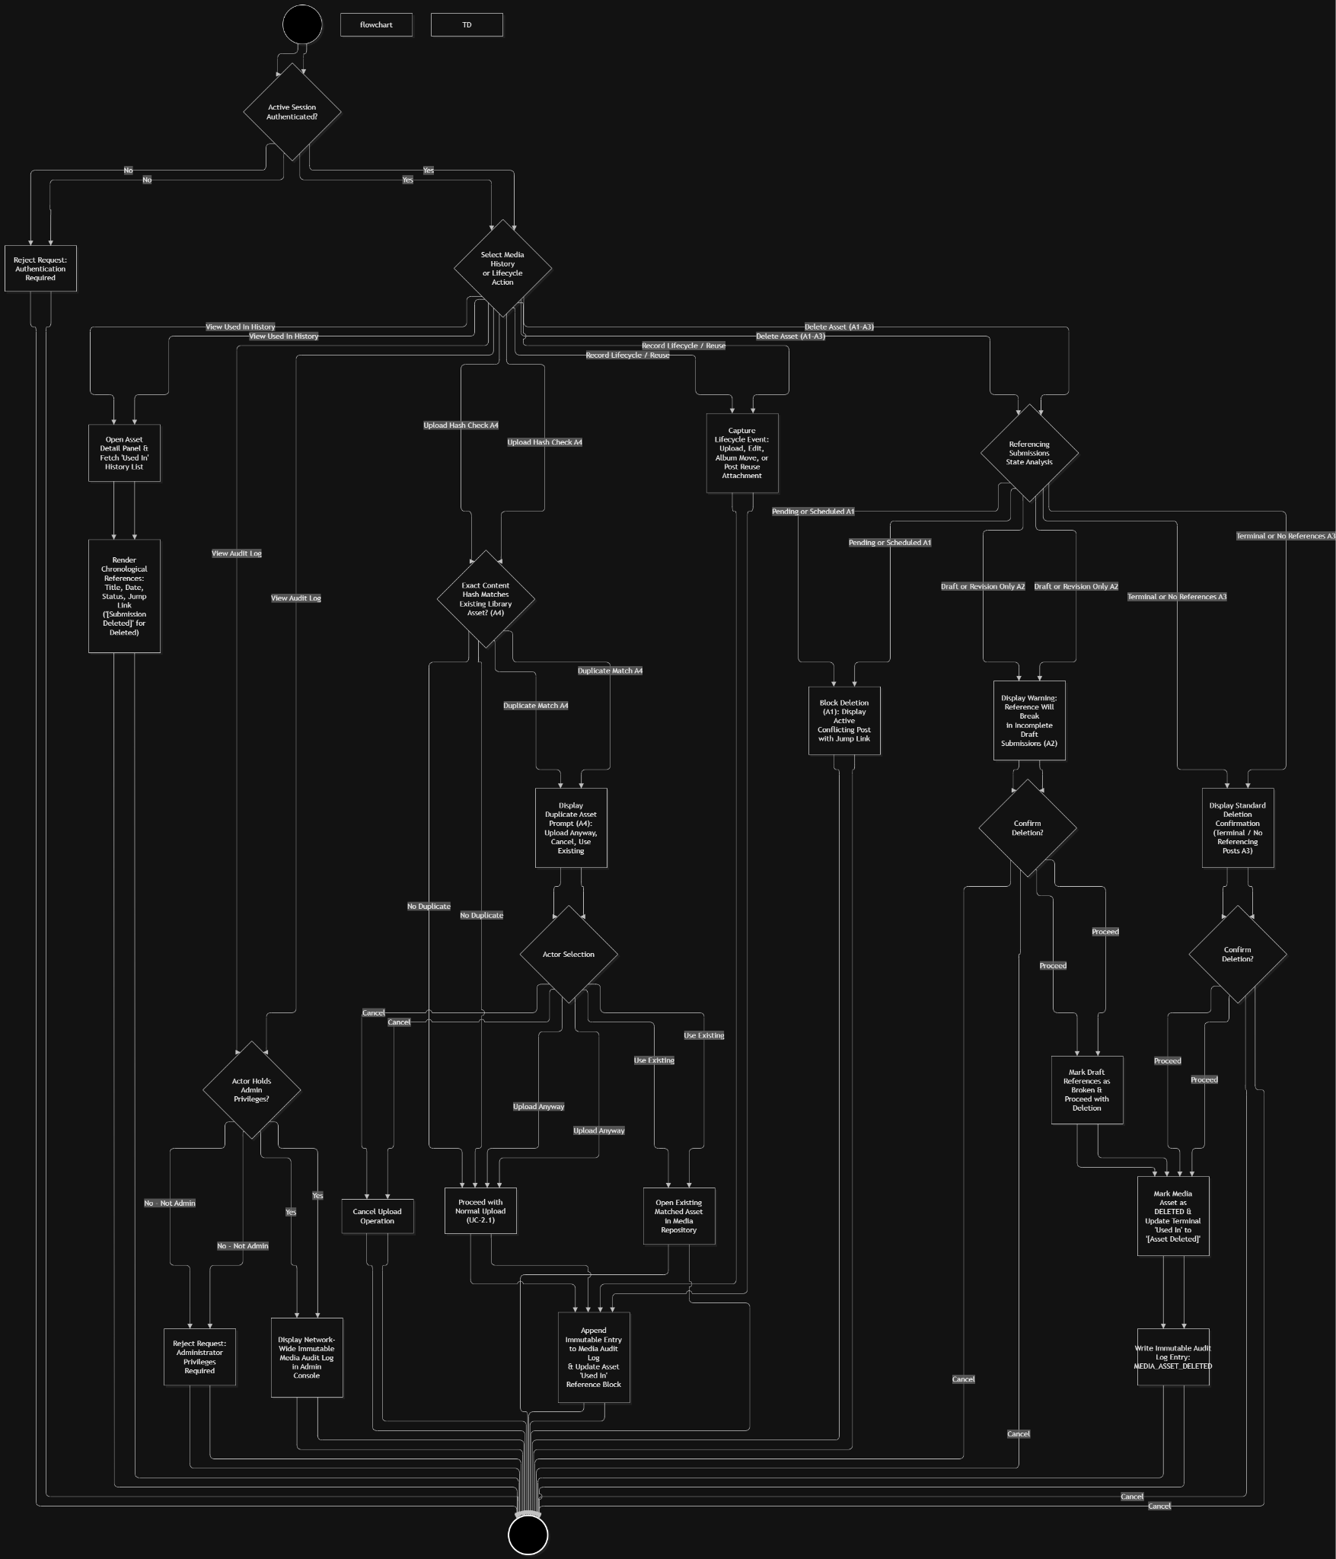

Wireframe

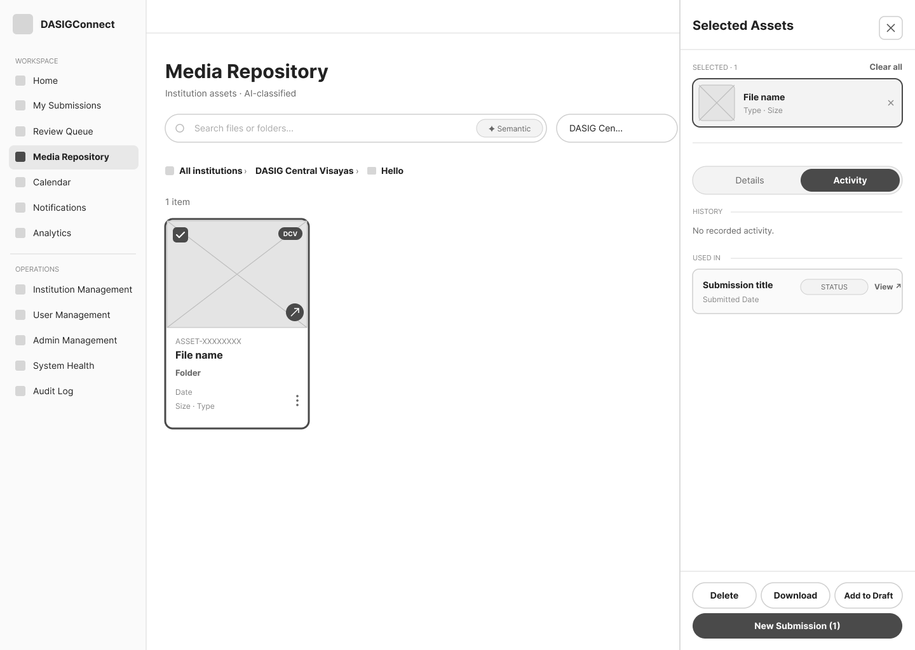
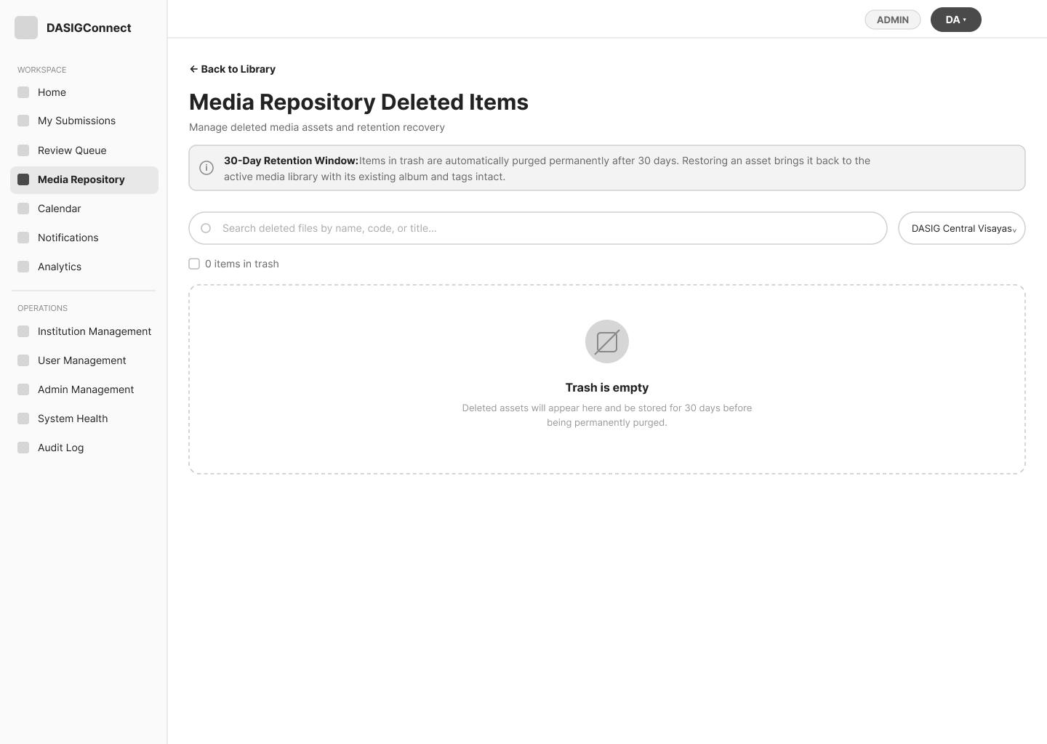

Admin Approval Workflow

Use Case Diagram
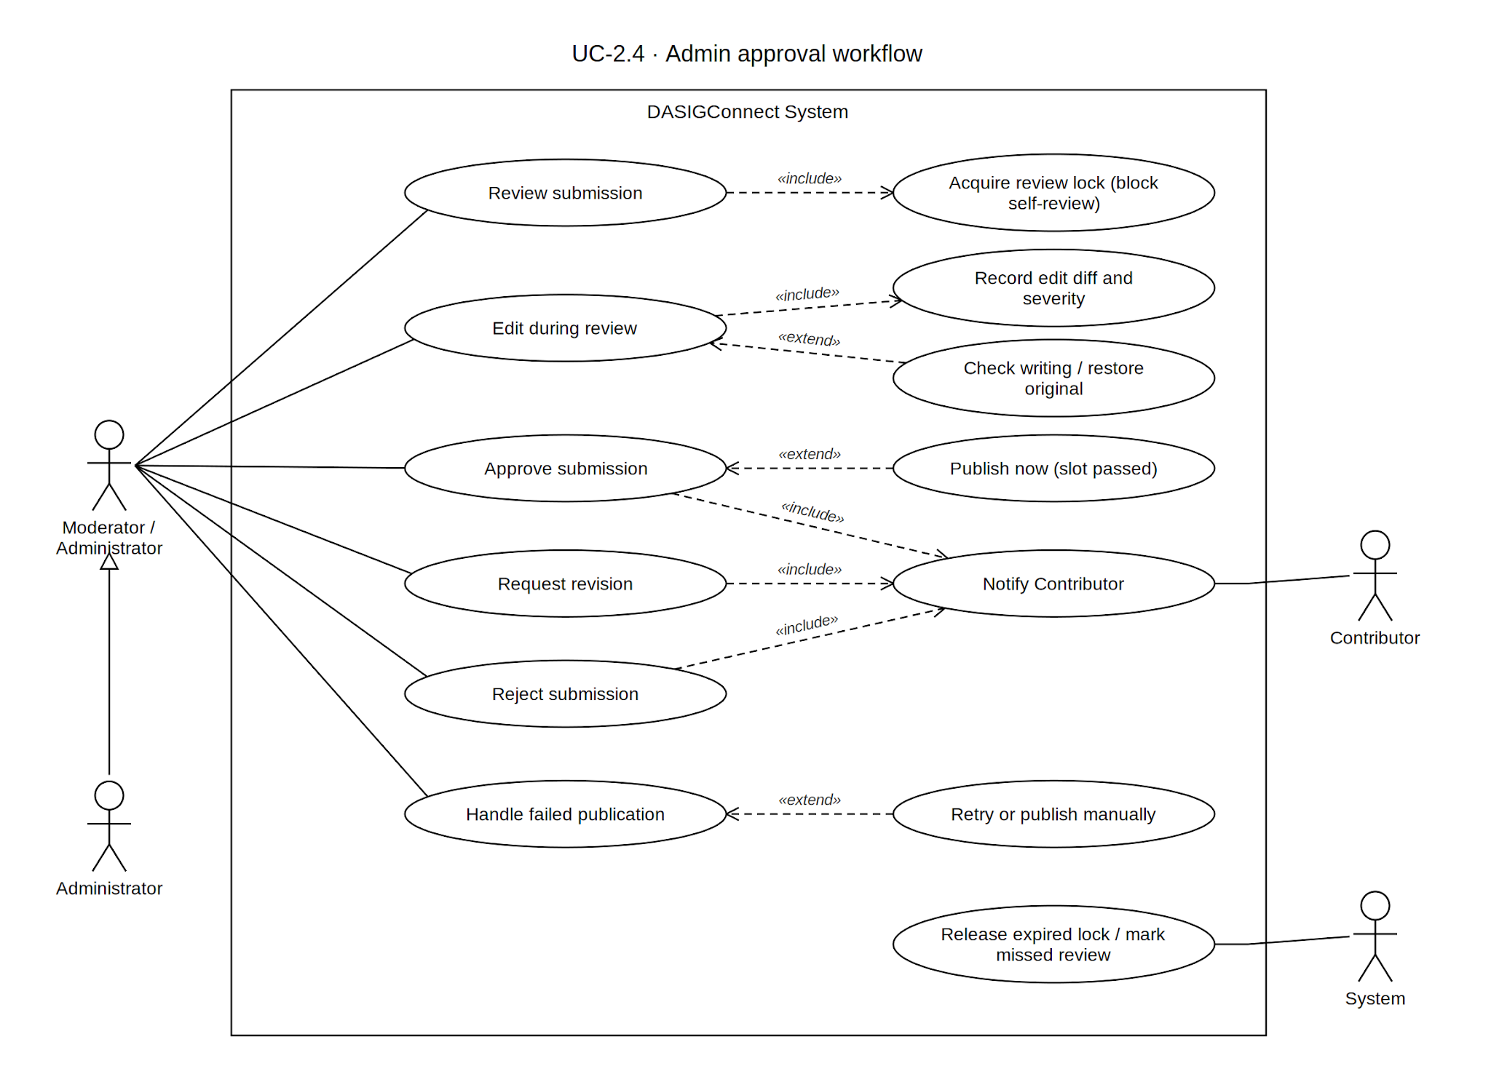

Use Case Description
Use Case ID | UC-2.4
Use Case Name | Approval Workflow
Actor(s) | Administrator, Moderator
Precondition(s) | The actor is authenticated with an active session. The Approval Queue is defined as the union of pending and in_review submissions network-wide.
Main Flow | - The actor navigates to the Review Queue from the main navigation menu.  - The screen displays a list of submission cards and a row of eight tabs across the top to filter the view: All, Pending, In Review, Needs Revision, Scheduled, Published, Rejected, and Failed.  - The queue displays submissions from across the entire network (no per-institution scoping for Moderators or Administrators). The actor may use the search bar or sort controls to locate a specific post.  - The actor clicks on a submission card from the list to open it for review.  - Behind the scenes, the system acquires a 15-minute review lock scoped to the actor and transitions the submission from pending to in review.  - The screen splits into a detailed review interface:  - Facebook Post Preview: A realistic visual preview of how the post will appear on Facebook, showing the attached media, caption, tags, and scheduled time.  - Submission Details Panel: A collapsible sidebar displaying metadata such as the contributor's name, event details, publishing mode (e.g., Scheduled vs. Live Event), and a button to view the full Review History (audit log).  - The actor reviews the content for completeness, accuracy, and appropriateness. If minor adjustments are needed, the actor can optionally edit the media, caption, or schedule directly within the review interface before making a final decision (A9, A10).  - The actor selects one of three terminal action buttons:  - Approve: Transitions the submission to scheduled, or publishes it immediately if it is a Live Event Fast-Track submission.  - Request Revision: Opens a dialog prompting for mandatory remarks (10-1000 characters). Transitions the submission to needs_revision and releases its reserved slot.  - Reject: Opens a dialog prompting for a reason code and notes. Transitions the submission to rejected and releases its reserved slot. Reject declines the post as submitted; it is not final — the Contributor may edit and resubmit it (UC-1.9). Reason codes are limited to problems that editing alone would not fix (A12).  - The system processes the decision, securely logs the action (and any edits made) to the audit log, notifies the original contributor, releases the review lock, and returns the actor to the queue list.
Alternative Flow(s) | A1 — No Submissions in Queue: The system displays an empty state for that view.  A2 — Request Revision Without Valid Remarks: Remarks must be between 10 and 1,000 characters; the system rejects anything outside that range.  A3 — Concurrent Review Attempt: A second reviewer sees who currently holds the review lock, and the panel renders read-only until the lock is released or expires.  A4 — Review Abandoned: If no terminal action is taken within the lock's active period, the submission automatically reverts from in_review to pending and the lock releases.  A5 — Self-Submission Review:Unconditionally blocked. A reviewer cannot acquire a review lock on their own submission under any circumstance — another Moderator or Administrator must make the decision. There is no self-approval path, governed or otherwise.  A6 — Submission Approaching Publish Time Without Review: The system shows a priority badge on a submission whose scheduled time is within 30 minutes (GR-T1); if the scheduled time passes without a review decision, the submission automatically transitions to missed_review, unless a reviewer currently holds its review lock (A15).  A7 — Media Asset Load Failure: If a media asset fails to load within the review panel, the system displays a "failed to load" placeholder with a Retry action that re-requests the asset. The reviewer is not blocked while this is unresolved — Request Revision and Reject remain available throughout.  A8 — Failed Submission Handling: An Administrator may recover a publish_failed or missed_review submission via manual publish, retry, or by changing its publishing mode in either direction. A Moderator may retry (within the same publishing mode) or reschedule a non-Fast-Track submission, but cannot change its publishing mode or convert a Scheduled submission to Fast-Track.  A9 — Edit Scope and Confirmation: Edits to media and scheduling are validated against guard rails and the 10-media-per-submission limit before saving. There is no separate watermark validation rule at edit time; the only watermark-related capability available during review is the existing per-asset skip-watermark setting.  A10 — Edit Audit Trail: The system stores a before/after diff of any edited fields, classified by severity (Quiet, Flagged, or Added Media), alongside the standard action log entry. This tracking spans the entire review cycle — from the last terminal action up to the next — so an edit is correctly counted even across an interrupted session where the review lock is released and reacquired before a final decision, and correctly resets after each terminal action.  A11 — Contributor Notification of Edit: When a submission is edited during review, the Contributor receives a separate notification specific to the edit, in addition to the base approval notification — the base notification itself never mentions edits. The edit notification's wording reflects its severity tier; only Flagged and Added Media edits trigger an email, while a Quiet edit notifies in-app only.  A12 — Rejection Reasons: The reason code must be one of Inappropriate content, Out of scope, Duplicate event, No longer relevant, Rights or privacy concern, Wrong institution, or Other (INAPPROPRIATE_CONTENT, OUT_OF_SCOPE, DUPLICATE_EVENT, NO_LONGER_RELEVANT, RIGHTS_OR_PRIVACY, WRONG_INSTITUTION, OTHER). Problems that only need fixing (incomplete content, wrong format) are refused with a validation error directing the reviewer to Request Revision.  A13 — Review Guides: Optional walkthroughs for the queue, review decisions, failed-publication recovery, and moderator editing are view-only; each step opens the panel it describes but never changes a submission.  A14 — Edit Safeguards: Before an edit is saved, Review & Save lists every change with an Undo control (with an extra warning for a Live Event submission). Restore original puts back the Contributor's value for a field, taken from the review cycle's edit history. An advisory AI writing check runs on demand and automatically after a caption edit, reporting only mistakes or meaning changes the edit introduced; it never blocks saving (30 checks per hour per user).  A15 — Scheduled Time Passes During Review: The review screen shows a countdown in the final 30 minutes and a banner once the slot has passed. The missed-review sweep skips a submission that is currently locked for review. Approving a Scheduled submission whose slot has passed is refused (409 Conflict); the reviewer must pick a new slot, or an Administrator may publish it now, which moves the slot to the current time and is audited as LATE_PUBLISH_OVERRIDE.
Postcondition(s) | On Approve: the submission is scheduled, or published immediately for Fast-Track; the slot is confirmed (non-Fast-Track) or bypassed (Fast-Track); the Contributor is notified via the base approval notification, plus a separate edit notification if the review session included edits; the action and any edit diff are recorded.  On Request Revision: the submission is needs_revision; the slot is released; the Contributor is notified with the reviewer's remarks (in-app and email); the action is recorded.  On Reject: the submission is rejected (terminal); the slot is released; the Contributor is notified with the reason code and any notes (in-app and email); the Contributor may edit and resubmit the same submission.

Activity Diagram
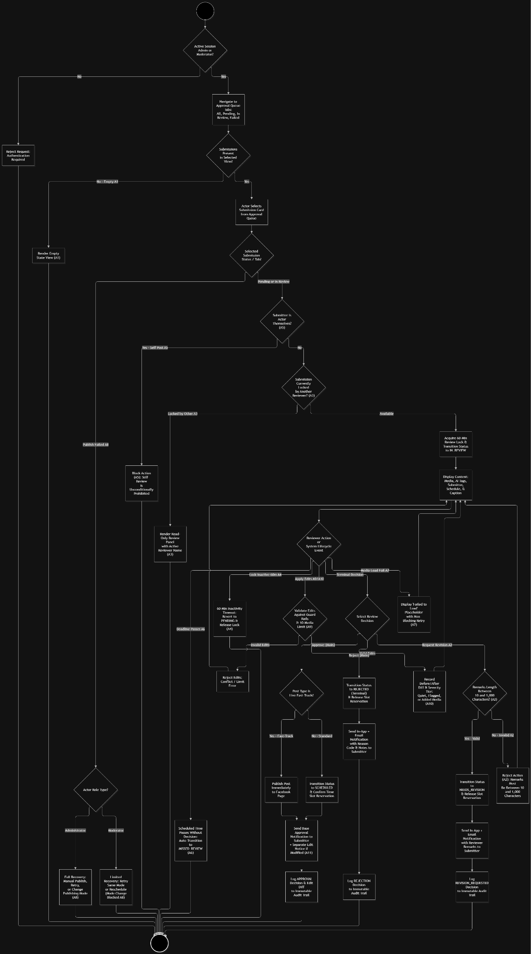

Wireframe
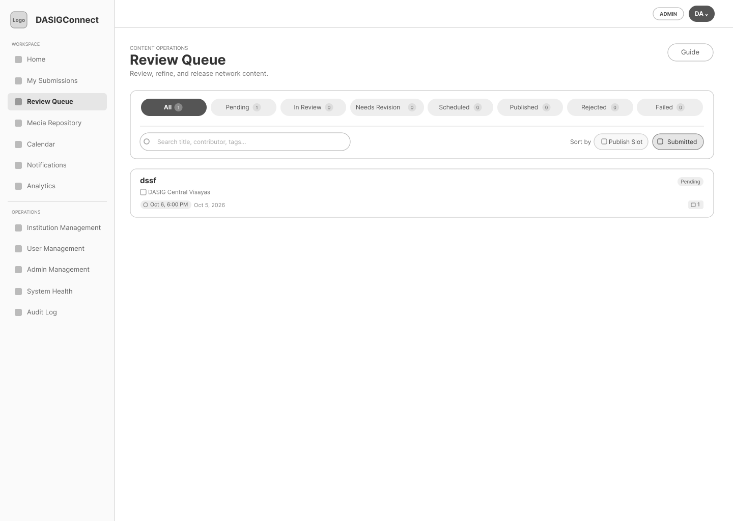
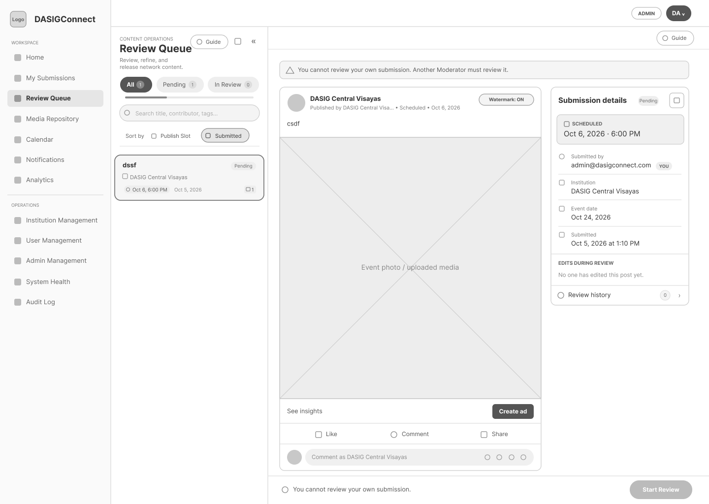

Automated Watermarking

Use Case Diagram
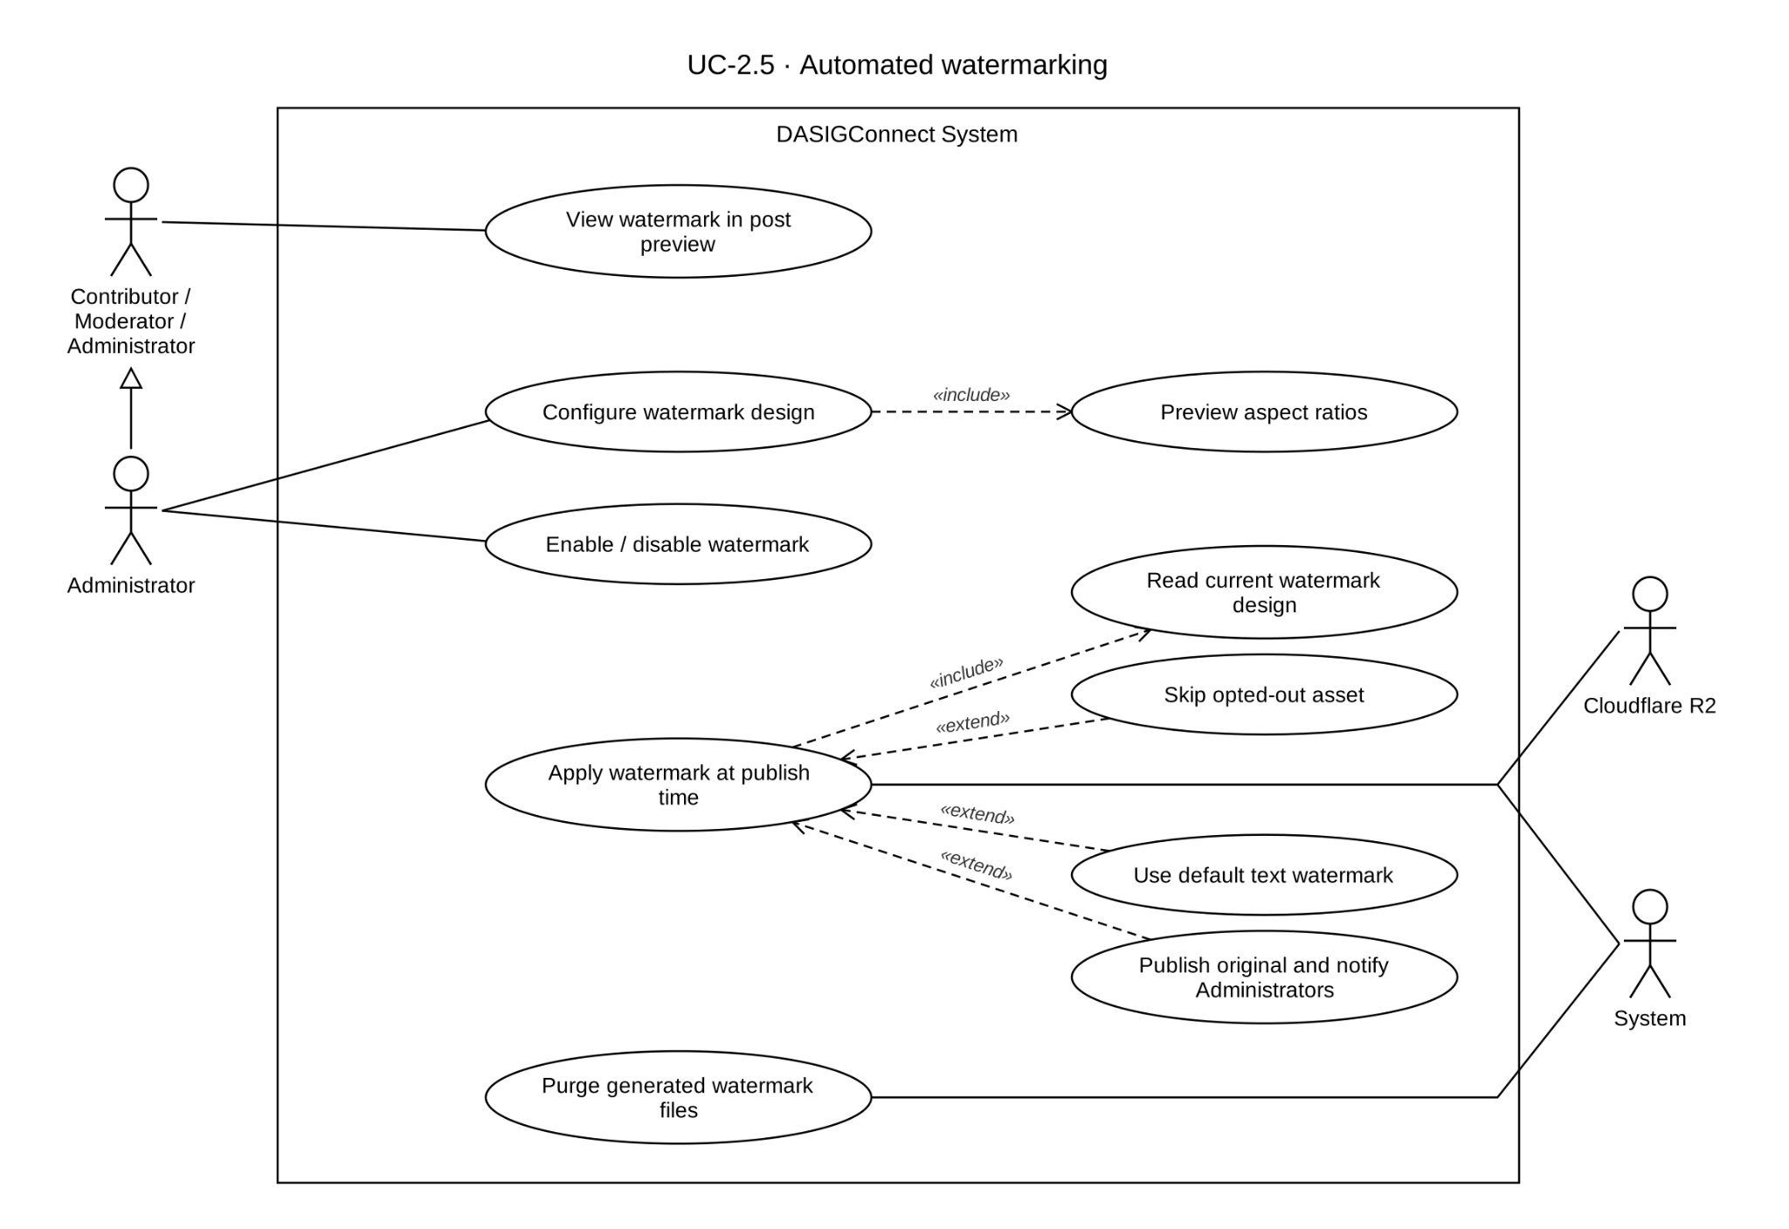

Use Case Description
Use Case ID | UC-2.5
Use Case Name | Automated Watermarking
Actor(s) | Administrator (configuration, write); any authenticated role (read, to render post previews).
Precondition(s) | For configuration: the actor is an authenticated Administrator.  For application: a submission containing at least one photo is being published.
Main Flow | Watermark Configuration  - An Administrator navigates to Page Settings and opens the Watermark configuration panel: a transparent canvas editor with 1:1, 4:5, and 16:9 aspect-ratio preview toggles.  - The Administrator adds up to 3 elements — image, text, or shape (rectangle, line, or gradient). Each element is positioned and sized as percentage-based coordinates and can be dragged or resized.  - The Administrator previews the design across the available aspect ratios.  - The Administrator saves; the system stores each element's position and size as percentage values, along with its type-specific properties (image reference, text content and font, or shape type and color), serialized as JSON.  Automatic Application  - Watermarking is applied at the moment of publication, not at approval. This happens immediately for a Live Event Fast-Track submission, or at the scheduled time for a Standard submission. Because the configuration is read fresh at the moment of publishing, an Administrator updating the watermark design between a submission's approval and its actual publish time will affect that already-approved submission.  - For each photo asset (JPEG, PNG, GIF, or WebP), the system reads the current network-wide watermark configuration, reads the photo's actual dimensions, and renders all configured elements at their proportionally scaled positions.  - The watermarked version is generated and used for publishing. The original, unwatermarked asset remains unchanged in the media library, and the watermarked derivative is transiently stored to hand off the URL to the publisher.  - Video assets are published without any watermark applied.
Alternative Flow(s) | A1 — No Watermark Configured: If no configuration exists at all, the system applies a built-in default text watermark (`@DASIGCentralVisayas`) rather than publishing unwatermarked. A submission publishes genuinely unwatermarked only if a configuration exists and has been explicitly disabled by an Administrator.  A2 — Update Existing Watermark Design: An Administrator may edit the watermark configuration at any time. Because the design is read live at each publish attempt, an update takes effect on any submission not yet actually published.  A3 — Watermark Application Failure: If rendering fails for any reason (an undecodable image, a download error, or any other exception in the render pipeline), the system publishes the original, unwatermarked image rather than blocking or delaying the post. Every failure is recorded in the immutable audit log and triggers an in-app and email notification to every Administrator, linking to the affected submission.  A4 — Mixed-Media Submission: For a submission containing both photos and video, only the photo assets are watermarked; the video publishes without a watermark.  A5 — Per-Asset Watermark Opt-Out: If the Contributor marked a specific photo as exempt during drafting, that opt-out is honored before any configuration lookup or rendering occurs — the asset publishes exactly as uploaded.
Postcondition(s) | Approved photo submissions carry the network-wide watermark design, rendered proportionally to each photo's dimensions, at the moment they actually publish — except assets marked for opt-out. Original, unwatermarked assets remain unchanged in the media library. Video assets publish without a watermark. A rendering failure results in the unwatermarked original being published, always accompanied by an audit log entry and an Administrator notification.

Activity Diagram
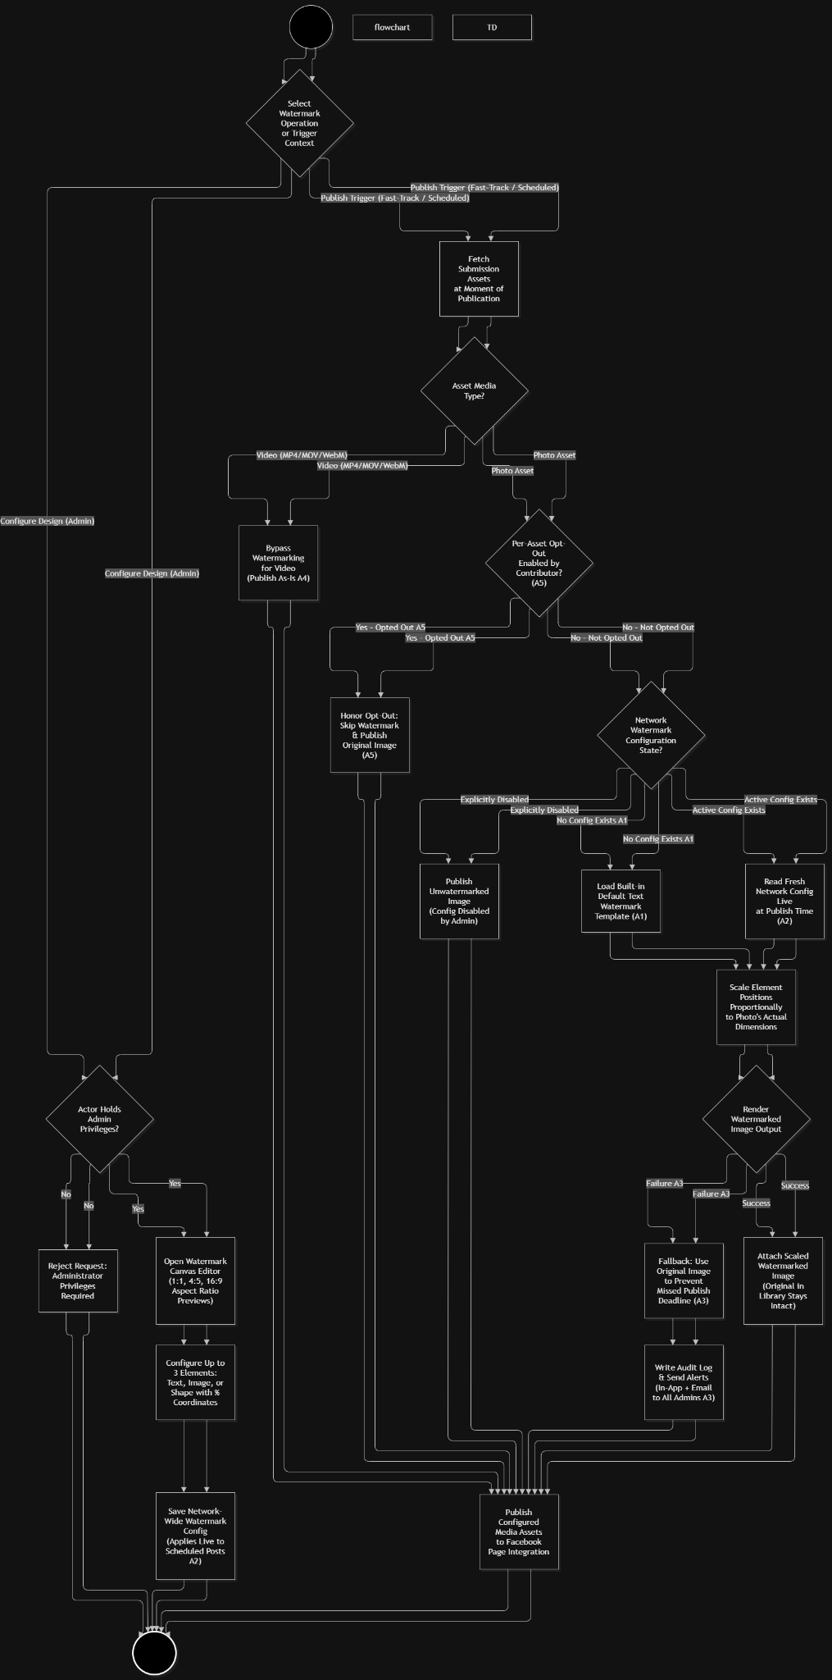

Wireframe
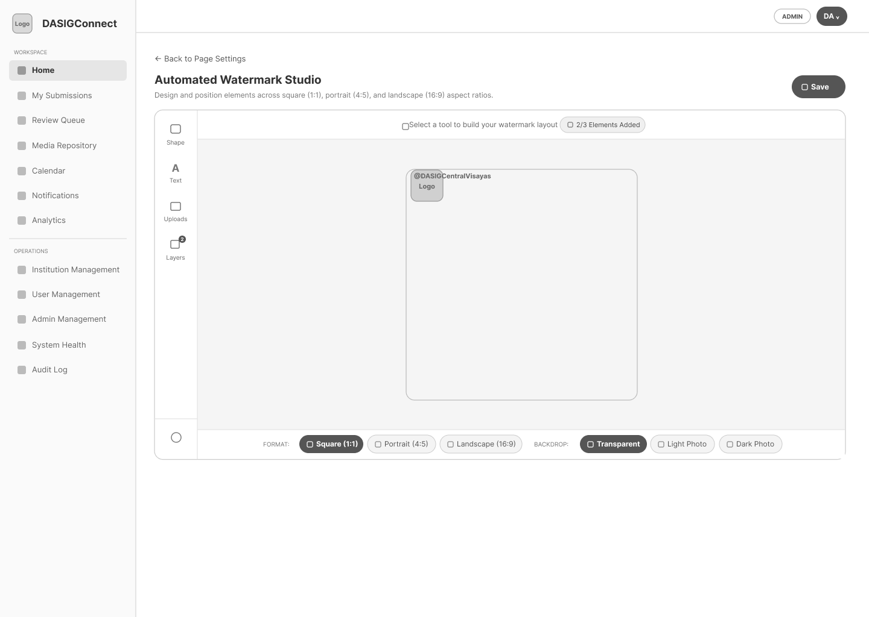

Module 3: Scheduling, Publishing and Analytics
Module 3 covers the master calendar (with role-differentiated visibility), automated Facebook post publishing via Graph API using the verified two-step method and analytics. Delivery target: end of Module 3 sprint.

Master Calendar Visibility

Use Case Diagram
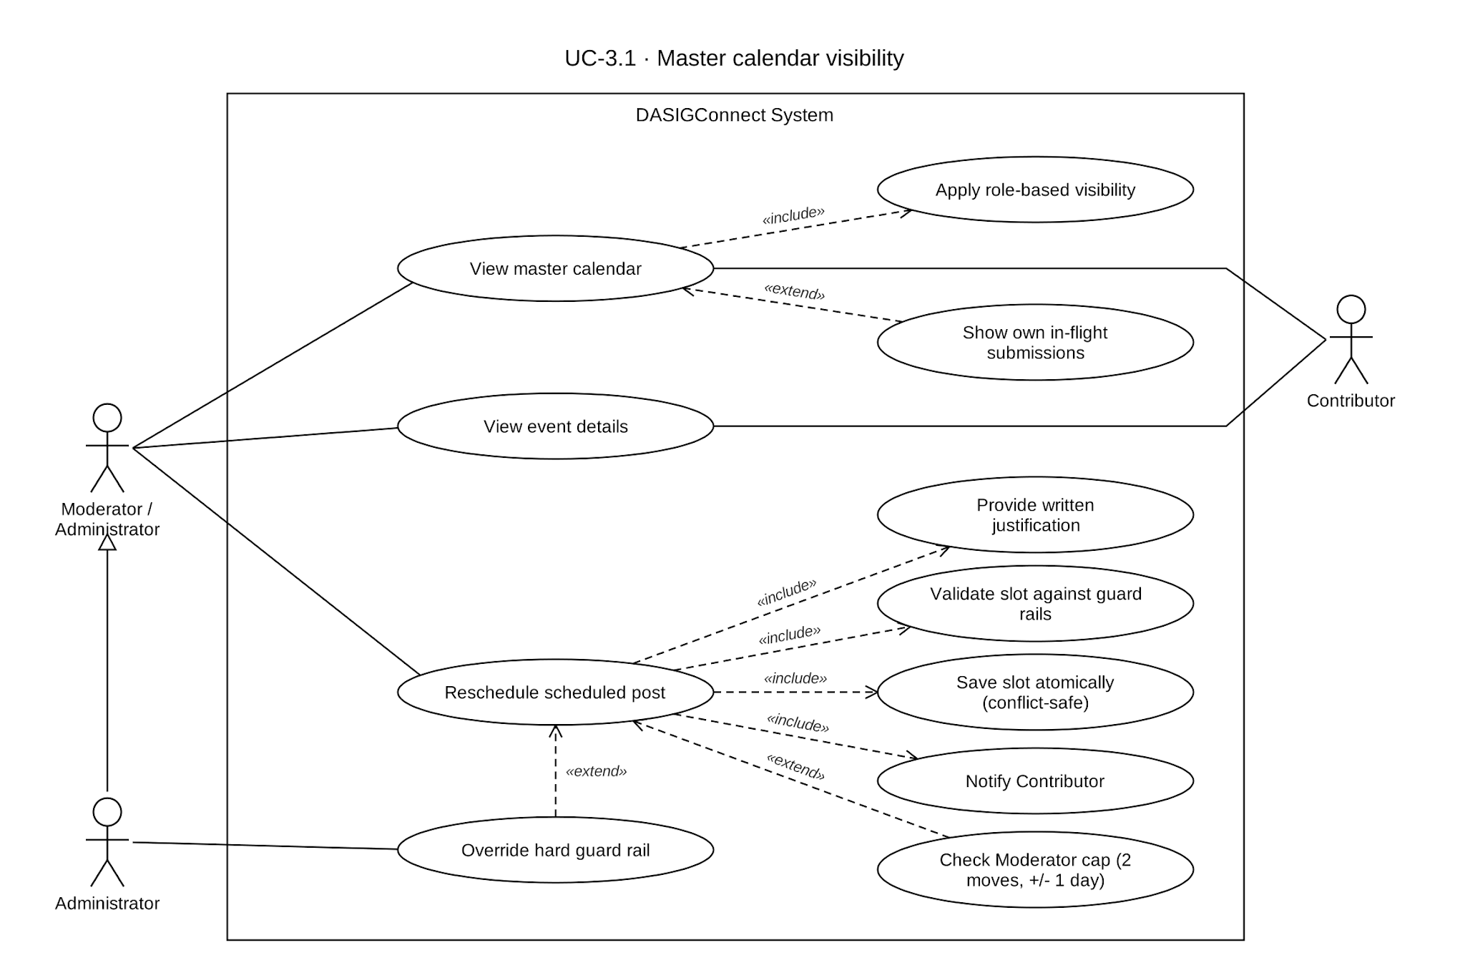

Use Case Description

Use Case ID | UC-3.1
Use Case Name | Master Calendar Visibility
Actor(s) | Contributor, Moderator, Administrator
Precondition(s) | The actor is authenticated. For reschedule: the target submission must currently be scheduled.
Main Flow | Calendar Visibility  - Any authenticated actor opens the calendar.  - Moderator or Administrator: sees every submission with a scheduled slot or publish time, network-wide, always rendered in full detail (caption, description, contributor identity, everything) — Moderator and Administrator have identical calendar visibility, with no scoping difference between them.  - Contributor: sees two combined sets of events:  - A network view, rendered in full detail for their own institution and the network-default institution ("DASIG Central Visayas"), and masked (caption, description, and contributor identity withheld) for every other institution.  - Their own in-flight submissions — including states not otherwise visible to anyone else on the calendar (Pending, In Review, Publish Failed, Missed Review) — always shown in full detail and clearly marked as their own, so a Contributor can track their own submissions through the whole pipeline even before they become calendar-visible to others.  Reschedule (Moderator/Administrator only)  - The actor drags a scheduled event to a new date/time.  - The system performs quick client-side checks (rejecting a same-slot drop or a drop within 1 hour of the current time).  - For a Moderator: the interface also pre-checks the reschedule cap and window (see A1) before allowing the action to proceed, giving fast feedback without a server round-trip. Administrators are exempt from both.  - A confirmation dialog opens requiring a written justification — this applies to every reschedule, regardless of whether the new slot triggers a guard rail warning, so that every calendar change carries a stated reason in the audit trail, not just contested ones.  - On confirmation, the system re-validates on the server: the submission must still be scheduled, a Moderator's cap/window is re-checked authoritatively (the client-side check is a convenience, not the real enforcement), and the new slot is validated against the guard rails.  - If the guard rails are satisfied, or the actor is an Administrator supplying an override reason, the reschedule proceeds as an atomic, conflict-safe write (see A3).  - The slot is reserved, the Contributor is notified, and the updated event appears on the calendar.
Alternative Flow(s) | A1 — Moderator Reschedule Cap & Window: A Moderator may reschedule a given submission at most 2 times, and only within ±1 day of the slot it was originally approved at (not the most recently rescheduled slot — anchoring to the original approval prevents drift through repeated small moves). Either limit is a hard stop for a Moderator, with no override available to them; they must ask an Administrator, who is exempt from both limits. If a failed publication is later retried onto a new schedule, both the count and the anchor slot reset, since that retry is effectively a fresh start.  A2 — Guard Rail Hard Block on Reschedule: If the new slot violates a hard guard rail, a Moderator cannot proceed under any circumstances, even with a written reason, and is directed to ask an Administrator. Only an Administrator may supply an override reason and proceed; doing so is recorded in the audit log with the violated rules, both the original and new slot, and the stated reason.  A3 — Concurrent Reschedule Protection: Reschedule writes are atomic and conflict-safe: if two reschedule attempts for the same submission are made at nearly the same time, only one succeeds: the other is rejected with a clear conflict message rather than silently allowed to overwrite or bypass a Moderator's cap.  A4 — Slot Conflict Integrity (Network-Wide, GR-H1): The ±30-minute network-wide conflict buffer between any two active posts is enforced at the database level, not just at the point a request is validated, so it cannot be bypassed by a timing race between two near-simultaneous requests. A submission's held slot is released once that submission actually publishes, so a completed post no longer occupies its buffer window indefinitely. This database-level enforcement includes one deliberate, narrowly scoped exemption: when an Administrator exercises their guard-rail override authority (A2) to reschedule into an otherwise-conflicting slot, that specific reservation is explicitly flagged as an authorized override and is excluded from the database-level block — every other reservation, including any other Administrator or Moderator action, remains fully enforced with no exception.
Postcondition(s) | Every actor sees a calendar reflecting their role's true scope — Administrator and Moderator see the full network in full detail; Contributor sees their own institution and the network-default institution in full detail, every other institution masked, plus their own in-flight submissions regardless of status. A scheduled submission may be moved by a Moderator (within their cap and window) or an Administrator (unrestricted, with override justification where a guard rail is violated), with every write guaranteed correct even under concurrent requests — including protection against a race with any other path that could claim the same slot, not only another reschedule attempt — and network-wide slot-conflict integrity enforced independently of the application layer, except for the single, explicitly tracked case of an authorized Administrator override.

Activity Diagram
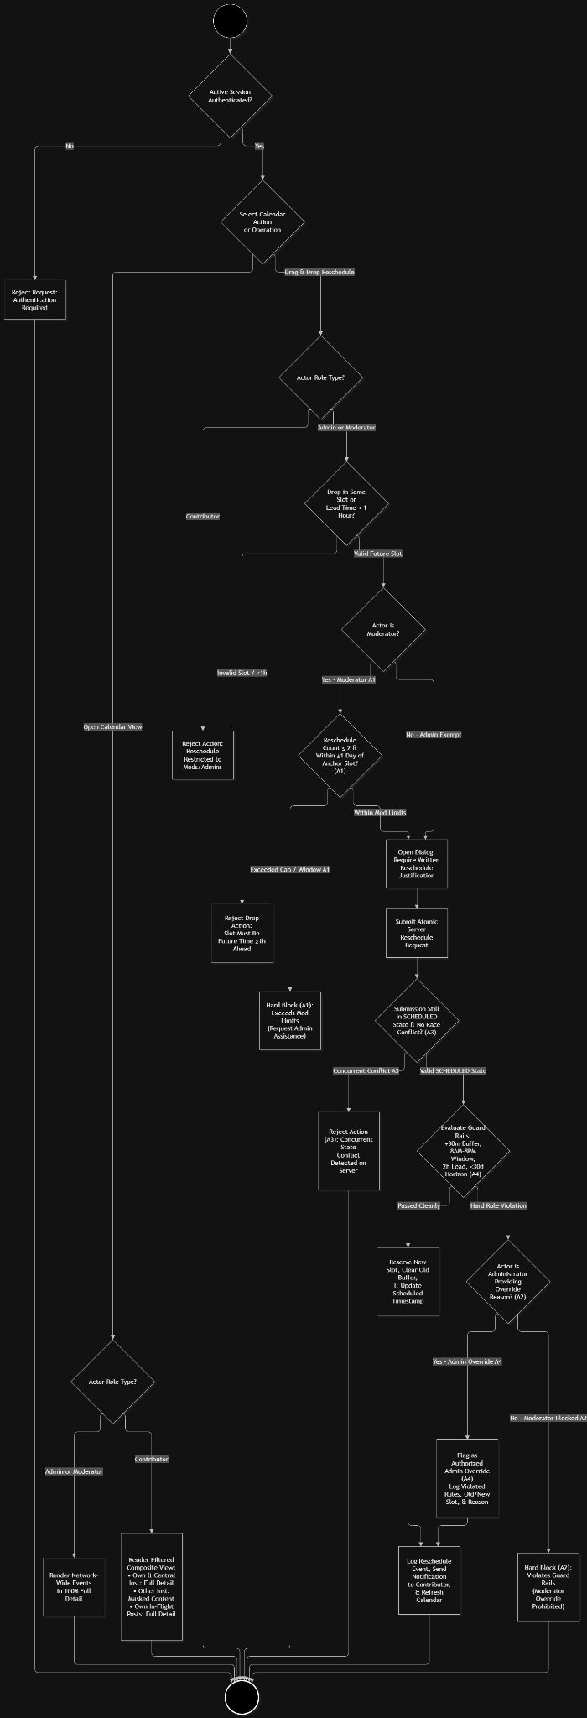

Wireframe
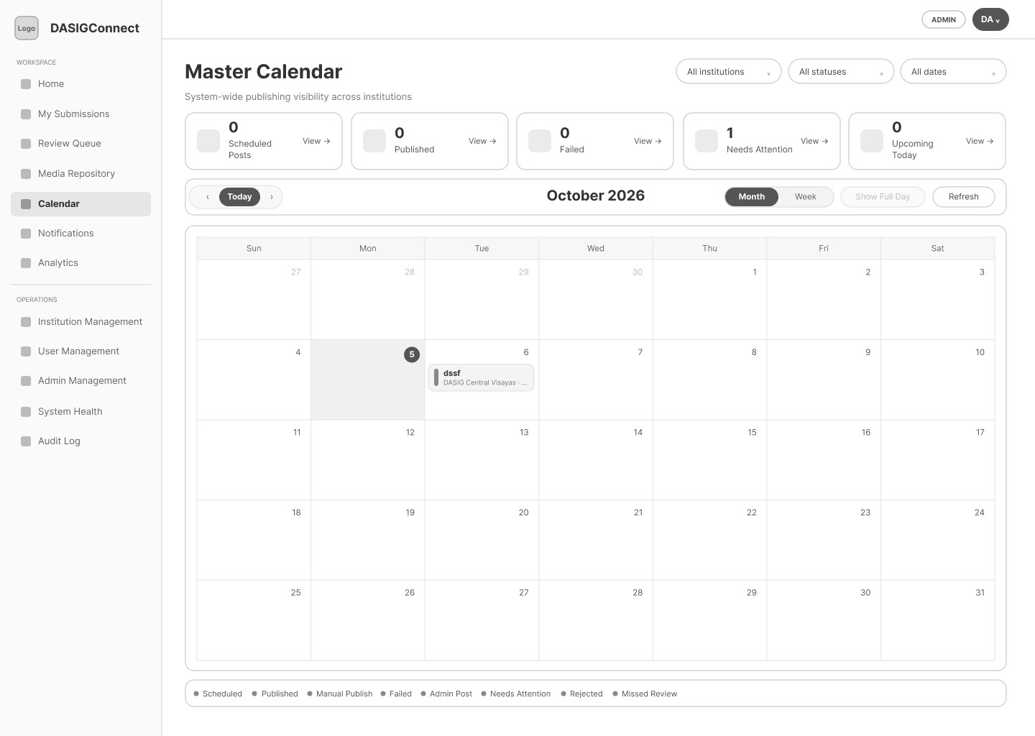
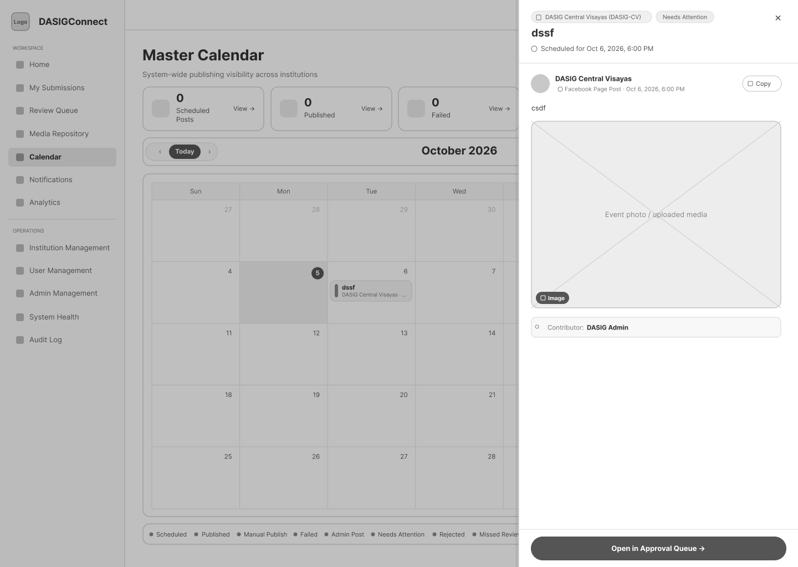

Automated Facebook Post Publishing

Use Case Diagram
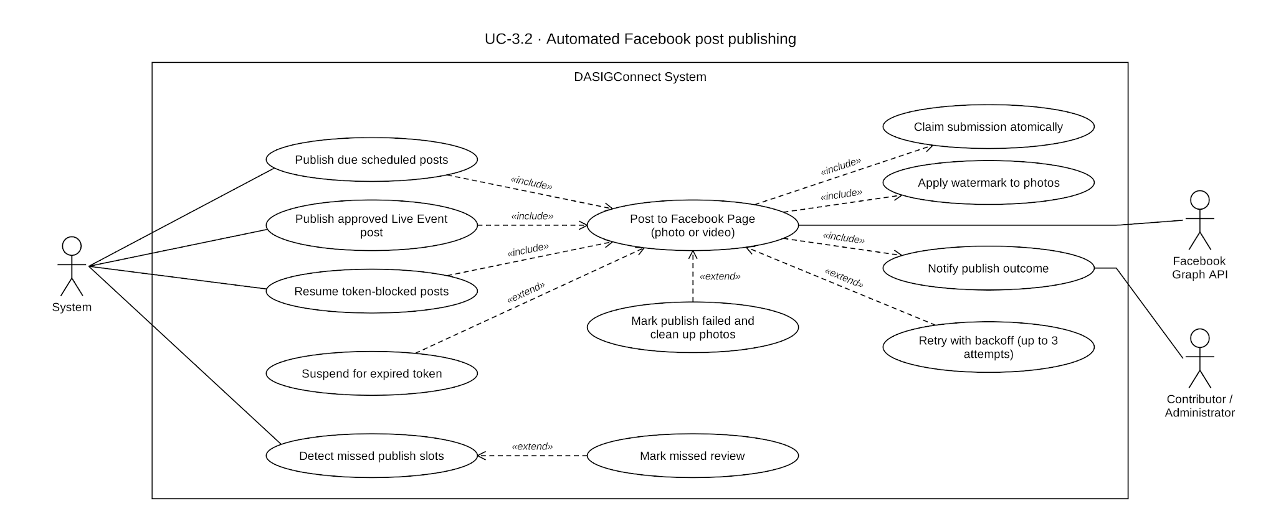

Use Case Description

Use Case ID | UC-3.2
Use Case Name | Automated Facebook Post Publishing
Actor(s) | System
Precondition(s) | At least one submission is scheduled with a slot that has arrived, or a Live Event Fast-Track submission has just been approved (UC-2.4).
Main Flow | - A background scheduler runs every minute, querying for due submissions whose slot falls within a 5-minute lookback window, accounting for brief server or scheduling delay. A Fast-Track submission bypasses this query entirely (A4).  - Each due submission is claimed — transitioned to an in-progress publishing state via an atomic database operation — before any external API call is made. If a submission has already been claimed by another scheduler pass, it is skipped. This claim is the actual mechanism preventing the same post from being published twice by two overlapping scheduler runs.  - The system fetches and decrypts the active Facebook Page token. If expired, see A3.  - TThe submission's media is inspected: image-only submissions use the two-step photo path (step 5); video-only submissions use the single-call path (step 6); mixed image-and-video submissions are immediately marked failed with no retry attempted at all.  - Photo publishing: each image is staged unpublished in a batch sequence. Each image includes its own per-asset caption, if one was set during drafting. Watermarking is resolved and applied immediately before staging, using whatever configuration is active at that instant. Once every image has been successfully staged, a single closing call finalizes the feed post using the submission's main caption and attaches all the staged photos.  - Video publishing (single call): the video and its caption are submitted in one call, with no staging step.  - On success: the submission is marked published (or its direct-post equivalent), the platform's post identifier and publish timestamp are recorded, the Contributor is notified, and the calendar reflects the successful publication.  - On failure: up to 3 attempts run with increasing delay between them. Exhausting all attempts marks the submission as failed, notifies the Administrator, and makes it available for manual recovery (UC-2.4 A12).  - A separate job runs every 5 minutes, sweeping for submissions whose scheduled time has passed without being published — see A2 for how this outcome differs depending on the submission's prior state.
Alternative Flow(s) | A1 — Photo Staging Failure: If any individual image fails during the batch staging process, or if the final feed post call fails, the entire publish attempt aborts. A cleanup routine immediately runs to delete any previously staged photos from Facebook to prevent orphaned media. The submission proceeds through the standard retry sequence like any other publish failure.  A2 — Missed Slot Detection: The 5-minute sweep produces two distinct outcomes depending on the submission's prior state, not one:  - A submission that was already approved and scheduled, but whose scheduler pass never actually ran (for example, the system was briefly unavailable), transitions to the standard failed state and follows the normal manual-recovery path (UC-2.4 A12).  - A submission that was never reviewed at all before its scheduled time passed transitions instead to a distinct Missed Review state, releasing its slot reservation. This is not treated as a publishing failure, since it was never approved to publish in the first place — it is listed in the Review Queue Failed tab, where choosing a new slot sends it back into the Approval Workflow as pending (UC-2.4 A8) rather than through manual publishing. The calendar displays this state with its own distinct color, separate from both a successful publish and a genuine publish failure.  A3 — API Token Expiry: API Token Expiry: An expired token blocks publishing without consuming a retry attempt, since the underlying issue is the connected Page's authentication, not the post itself. The submission is suspended and Administrator alerts escalate in stages — an initial warning, a 24-hour escalation, and a final notice — culminating in the submission transitioning to the failed state and becoming available for manual recovery if the token is not reauthorized within 48 hours. Resolving the token itself is UC-3.5's territory, not this use case's.  A4 — Live Event Fast-Track Immediate Publish: An approved Fast-Track submission publishes immediately upon approval, independent of the scheduled-time-based scheduler entirely, since a Fast-Track submission has no scheduled slot for that scheduler to ever match against.  A5 — Unsupported Media Configuration: Detected immediately and routed straight to the failed state with no retry attempted. This occurs if a submission contains both images and video (unsupported by the Facebook Graph API for automated posts), or if it contains no media assets at all (the system requires at least one image or video).
Postcondition(s) | On success, the submission is published with the platform's post identifier recorded, the Contributor notified, and the calendar updated accordingly. Analytics reflects a new publication within roughly 60 seconds in typical use. Submissions whose scheduled time passes unpublished are detected within 5 minutes and resolved into one of two distinct outcomes depending on whether they had already been approved: a standard publish failure with manual recovery available, or a return to the Approval Workflow if they were never reviewed at all. Token expiry suspends publishing with escalating Administrator alerts, culminating in failure and manual recovery if unresolved within 48 hours.

Activity Diagram
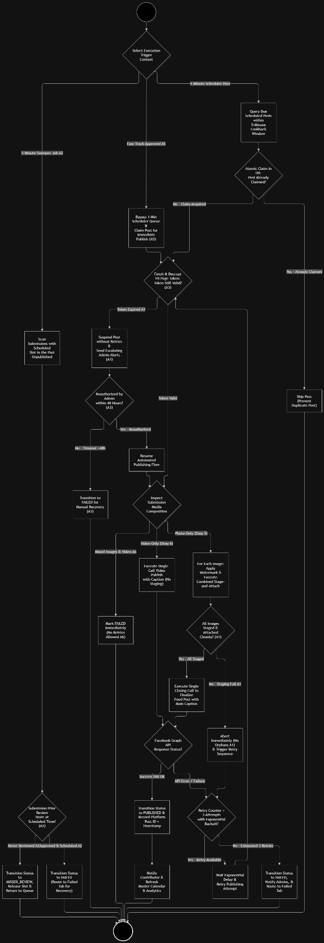

Wireframe
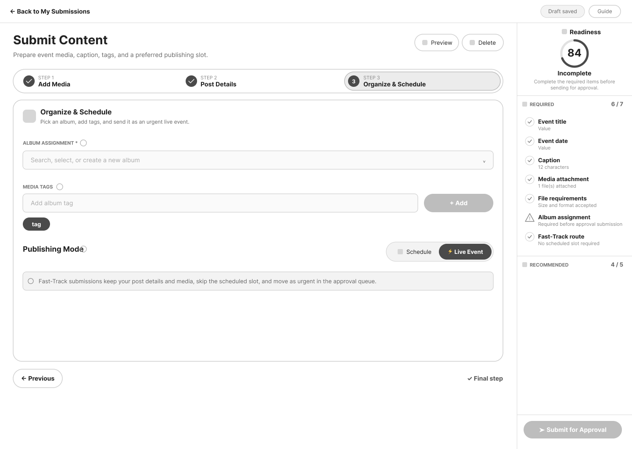

Automated Reminders & Alerts

Use Case Diagram
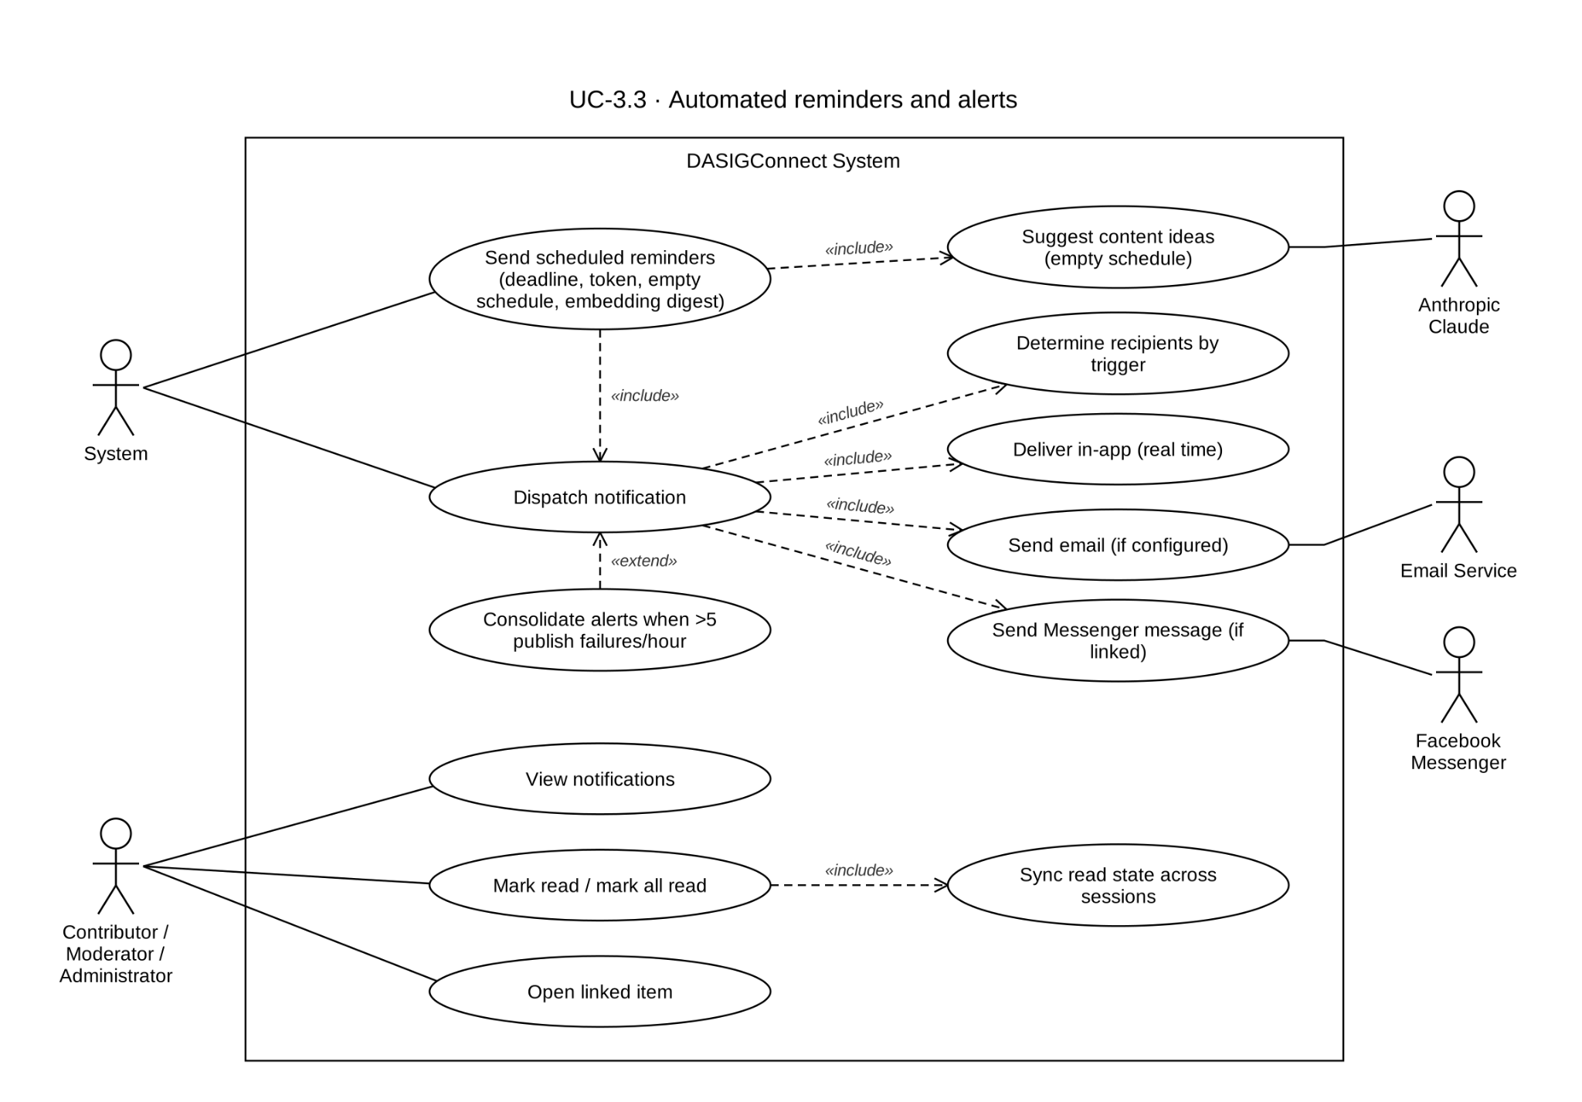

Use Case Description
Use Case ID | UC-3.3
Use Case Name | Automated Reminders & Alerts
Actor(s) | Contributor, Moderator, Administrator.
Precondition(s) | A triggering event has occurred (submission state change, publishing outcome, token health change, or a scheduling gap).
Main Flow | - The system detects a triggering event matching one of the defined notification triggers.  - The system determines the recipient set for that trigger based on its category, not a single fixed role:  - Review-related triggers (a new submission awaiting review, a submission returned to the queue) notify every active Moderator and every active Administrator — both roles, together, since either can act on the Approval Queue.  - Content-outcome triggers (approved, rejected, revision requested, edited, published, publish failed) notify the submitting Contributor.  - System/infrastructure triggers (token health, watermark rendering failures, the weekly embedding-failure digest) notify Administrators only, since Moderators have no access to system configuration.  - The system dispatches the notification via in-app (unless the recipient has turned in-app notifications off in Settings), email (for triggers configured to include it, unless the recipient has turned email notifications off; invitations and password resets are always sent), and Facebook Messenger (only for a recipient who has linked their personal account, per the recipient's individual opt-in).  - The recipient's in-app notification badge updates in real time via a live server-sent-events connection, without requiring a page refresh; a 3-minute background poll is used only as a fallback when that connection drops.  - The recipient may click a notification to navigate directly to the relevant submission, calendar entry, or settings screen.  - The recipient may view their full notification history, with read and unread state tracked per recipient.
Alternative Flow(s) | A1 — Email Delivery Failure: If an email fails to send, the failure is recorded in the email delivery log and is not retried automatically; the in-app notification is dispatched immediately regardless of the email outcome.  A2 — Notification Read State Sync: Reading a notification through any entry point updates its read state consistently across every active session for that recipient.  A3 — High-Volume Notification Handling: Publish-failure alerts are consolidated (GR-T6): within a rolling hour, the first 5 failures alert Administrators individually; the 6th sends one consolidated high-priority alert (in-app, email, and Messenger where linked) linking to the Failed tab, and later failures in that hour send no further individual Administrator alerts. Every failure still appears in the Failed tab and Contributors are still notified. Other event types are not consolidated; each triggering event generates its own notification.  A4 — Facebook Messenger Delivery: For a trigger configured to include Messenger, delivery additionally goes to any recipient in that trigger's set who has personally linked their Facebook account. Messenger delivery is opt-in per individual, not per trigger or per role — two Administrators could have different Messenger delivery outcomes for the identical event, based solely on whether each has linked their own account.  A5 — Messenger Not Linked: A recipient who has not linked their account is silently skipped for Messenger delivery on that trigger; their in-app and (where applicable) email delivery proceed normally and without error.
Postcondition(s) | Every recipient in the applicable set for a triggering event is notified via in-app delivery unless they turned it off, with email and Messenger delivered according to that trigger's configuration and each individual recipient's Messenger opt-in status. Notification read state is accurate and consistent across all of a recipient's active sessions.
Notification Trigger Matrix
T-01 to T-12 are the numbered triggers; the system defines 30 notification event types in total, and the remaining operational events (for example edit-during-review, revision requested, watermark failure, promotion and transfer requests) follow the recipient rules in step 2.
Trigger ID | Event Name | Trigger Condition | Recipient | Channel
T-01 | New Draft Submitted | DRAFT → PENDING_APPROVAL | Moderator + Administrator | In-app + Messenger (if linked)
T-02 | Post Approved & Scheduled | Moderator or Administrator approves → SCHEDULED | Contributor | In-app + Email
T-03 | Post Rejected | Moderator or Administrator rejects → REJECTED | Contributor | In-app + Email
T-04 | Post Published (Automated) | PUBLISHED via API | Contributor | In-app
T-05 | Post Published (Manual Fallback) | Admin marks PUBLISHED_MANUAL | Contributor | In-app
T-06 | Automated Publishing Failed | API fails after retries → PUBLISH_FAILED | Admin + Contributor | Admin: In-app + Email + Messenger (if linked); Contributor: In-app
T-07 | Empty Schedule Warning | Weekly scan finds 0 posts scheduled upcoming | Admin + Contributor | In-app
T-08 | Token Expiry Warning | FB token expires within 7 days | Administrator | In-app + Email
T-09 | Token Validation Failure | Token check fails / publishing suspended | Administrator | In-app + Email
T-10 | Post Rescheduled | Admin moves post to new slot | Contributor | In-app
T-11 | Live Event Fast-Track Submission | Fast-Track draft → PENDING_APPROVAL | Moderator + Administrator | In-app + Email + Messenger (if linked)
T-12 | Embedding Reconciliation Failure Digest | Weekly scan of assets whose embedding failed | Administrator | In-app + Email

Activity Diagram

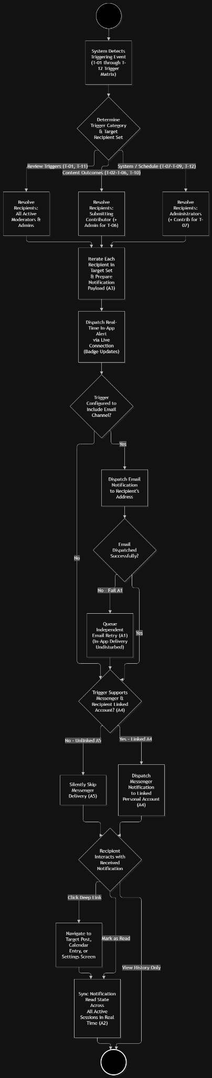

Wireframe

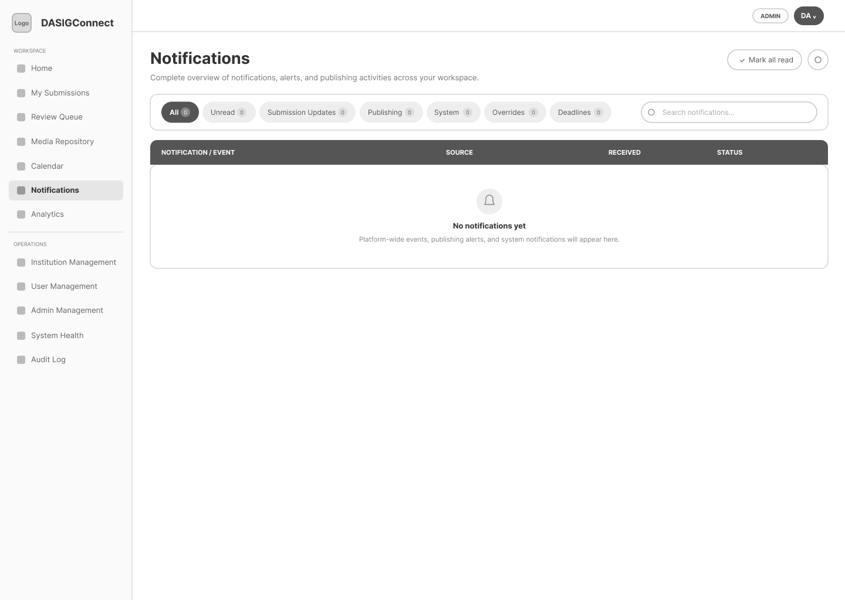

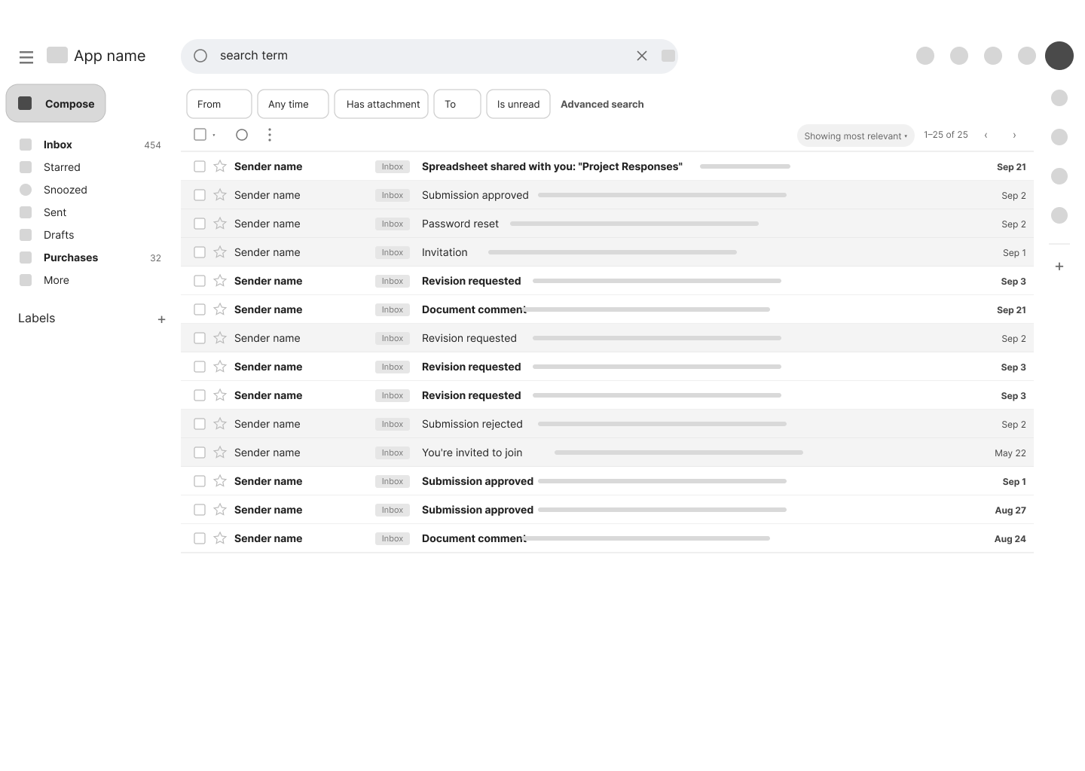

Social Engagement Analytics

Use Case Diagram
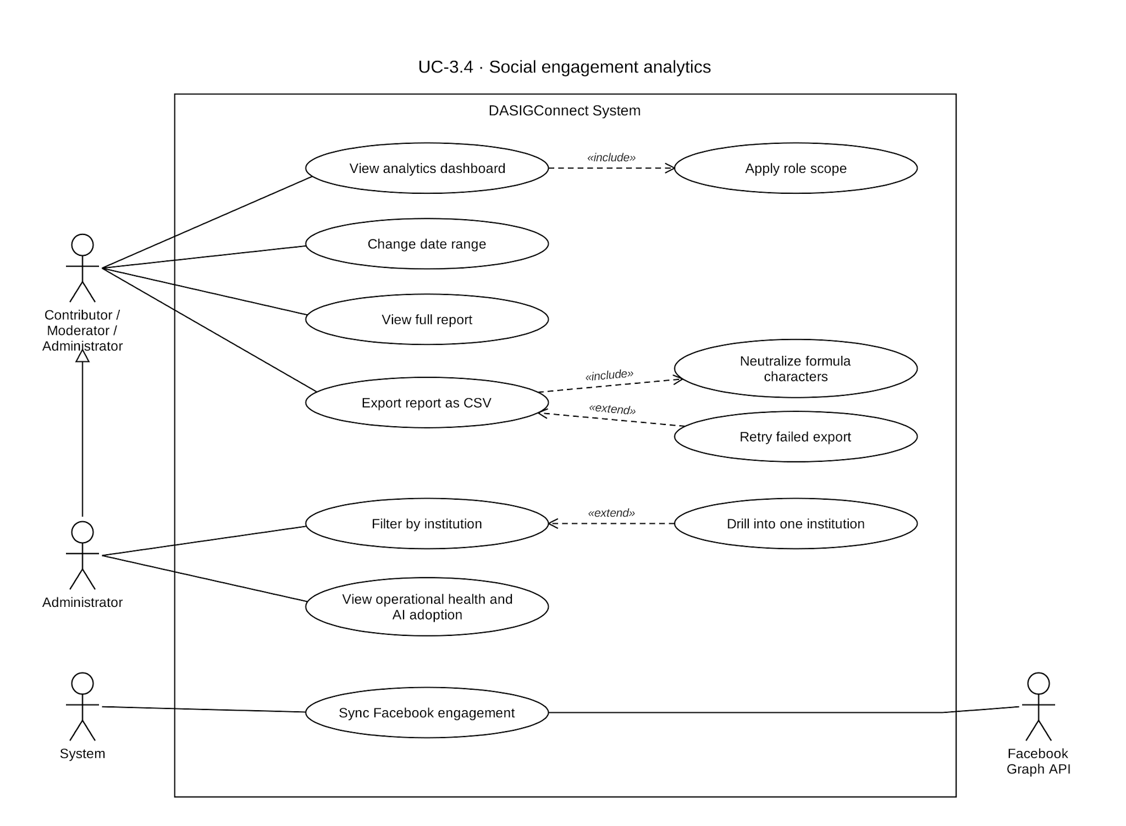

Use Case Description
Use Case ID | UC-3.4
Use Case Name | Social Engagement Analytics
Actor(s) | Contributor, Moderator, Administrator.
Precondition(s) | The actor is authenticated. At least one submission has been published to generate meaningful analytics data.
Main Flow | - The actor navigates to the Analytics dashboard.  - The system displays role-scoped analytics data. Contributors view metrics for their institution's posts. Moderators and Administrators view network-wide metrics across all institutions.  - The system displays two structurally distinct categories of data:  - Workflow metrics (posting frequency, submission-to-publish duration, content completeness rate, approval turnaround time) are computed from the database and cached for up to 60 seconds  - Facebook engagement metrics (reach, reactions, comments, shares) are read from a periodically-refreshed cache, not fetched live from Facebook on every page load. The dashboard always displays the most recent successfully cached figures, alongside an indication of when that cache was last refreshed.  - Contributor view: workflow and engagement metrics scoped to their own institution's published posts only.  - Moderator and Administrator view: both see network-wide metrics across all institutions, filterable by date range. Only Administrators may filter by institution; Moderators always see the whole network. There is no content-category filter.  - Administrators can view additional operational metrics, AI feature performance, and approval-turnaround-time statistics. Administrators can also view live Facebook Page-level insights distinct from per-post engagement. The operational-health and AI-performance reports and exports are Administrator-only.  - The actor may apply filters to narrow the displayed data. Administrators can filter by multiple institutions. All roles can filter by date range.  - The actor may export the current view for any metric to a CSV file or view it as an in-app report modal.  - Workflow metrics reflect new activity within the 60-second cache window, and the dashboard refreshes automatically every 5 minutes; engagement metrics reflect Facebook's actual figures only as of the last cache refresh, not the current moment.
Alternative Flow(s) | A1 — Insufficient Data for Metric: A filter combination with no published posts displays an empty state rather than an error.  A2 — Facebook Engagement Data Not Yet Cached: A recently published post that hasn't yet been included in a cache refresh cycle displays with an "engagement data pending" indicator, rather than showing zero or a stale figure from before it existed.  A3 — Export Failure: If an export fails, the system displays an inline error and allows the user to retry downloading without losing the current filter state.  A4 — Cross-Institution Access Attempt (Contributor): A Contributor attempting to access another institution's analytics receives an authorization error; their view is strictly scoped to their own institution.
Postcondition(s) | The actor views analytics accurately scoped to their role. Workflow metrics are current as of the moment of viewing. Facebook engagement metrics are current as of the most recent cache refresh, clearly timestamped so the actor can judge their freshness rather than mistaking a cached figure for a live one.

Activity Diagram

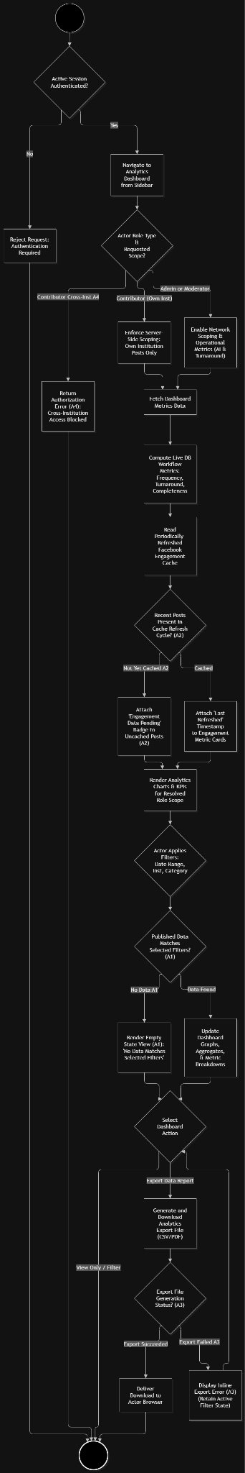

Wireframe
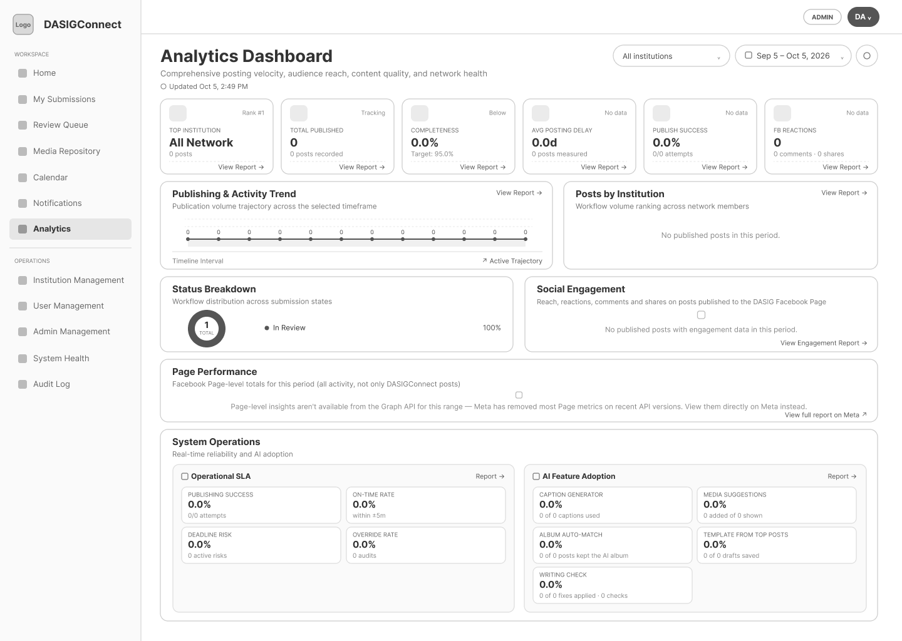

System Health Analytics

Use Case Diagram
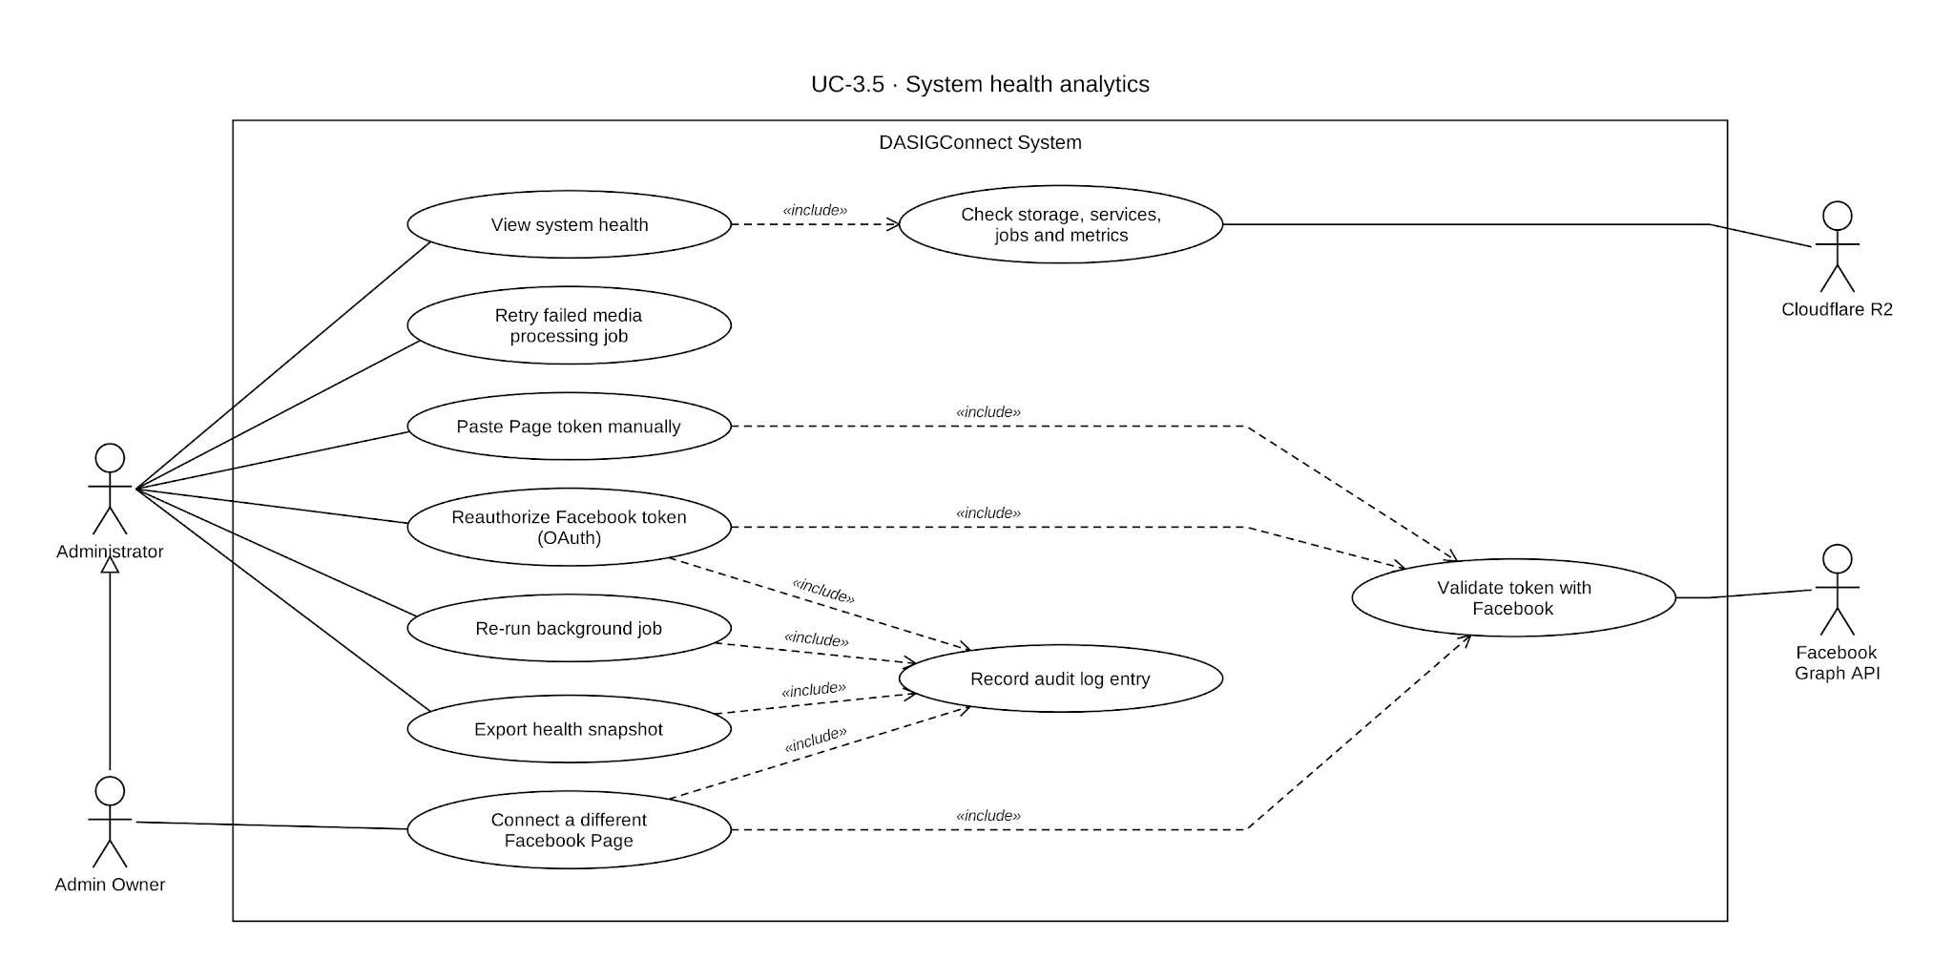

Use Case Description
Use Case ID | UC-3.5
Use Case Name | System Health Analytics
Actor(s) | Administrator
Precondition(s) | The actor is authenticated with Administrator privileges. All endpoints on this screen are restricted to the Administrator role.
Main Flow | - The actor navigates to System Health from the admin console. This screen is distinct from both the Analytics dashboard and the Resolution Center.  - The screen displays current infrastructure and operational health, grouped into four sections:  - Storage capacity. Database storage is measured directly from the database engine; media storage is measured via a live scan of the object storage bucket (including derivatives and orphaned objects), with a database-derived estimate used as a fallback if that scan fails. Both are shown against configurable platform-tier limits, defaulting to the current free-tier caps for the underlying database and object storage providers.  - External service connection status, for five probes:  - Facebook Graph API — live token status with a real expiry countdown.  - Supabase PostgreSQL — database connection probe  - Anthropic Claude and Voyage AI — reachability and API-key-configured checks (not full authenticated capability calls).  - Email Service Provider — reachability check against the configured mail API.  - Media Object Storage Health — bucket ping against the Cloudflare R2 bucket. Google Gemini is not probed; its health is visible through the AI telemetry metrics.  - Background job health, covering 16 tracked jobs: Publishing Scheduler, Review Lock Cleanup, Stale Submission Detector, Abandonment Detector, Token Publishing Escalation, Validation Deadline Notification, Embedding Reconciliation, Social Engagement Sync, Invitation Expiry, Media Asset Retention Purge, Generated Watermark Purge, Stale Draft Slot Release, Token Health Check, Scheduled Job Run Retention, Embedding Failure Digest, and Empty Schedule Warning. Each job has a known expected interval (ranging from one minute to weekly); a job is flagged stale only once its last run exceeds twice its expected interval, so infrequent jobs aren't misflagged for being quiet between runs.  - Operational metrics,computed over a rolling 30-day window. This covers 14 metrics in total: 6 core metrics (approval turnaround time, Edit & Approve rate, manual fallback resolution rate, publish success rate, missed-review rate, and Live Event Fast-Track submission volume) and 8 AI telemetry metrics (such as queue depth, completion rate, and embedding coverage). Publish success rate uses the same calculation as the Analytics dashboard, so the two screens always agree on that figure.  - An overall page-level status rolls up the worst status across all storage, service, job, and metric rows, with counts of how many items fall into each of WARNING, UNHEALTHY, and UNAVAILABLE, shown before the Administrator reviews individual sections.  - The Administrator can trigger any tracked background job on demand via a per-job Re-run control, independent of its schedule. A dedicated shortcut is available specifically for re-running the Token Health Check job. Every re-run is audit-logged. Two jobs — Publishing Scheduler and Token Publishing Escalation — run asynchronously when manually triggered, since they may retry multiple submissions with backoff delays; the Administrator sees a "started" acknowledgment rather than an immediate result, and refreshes to see the outcome. The remaining 14 jobs are fast, database-only operations and return their result synchronously.  - Storage, external services, background jobs, and operational metrics all use a consistent status vocabulary — HEALTHY, WARNING, UNHEALTHY, UNAVAILABLE, or SCHEDULED — shown as an inline status indicator on each item. Storage status changes at configurable thresholds (default 80% warning, 95% critical).
Alternative Flow(s) | A1 — Metric Unavailable. Any metric whose underlying check fails (database unreachable, object-storage probe and fallback both fail, no Facebook token configured, an external API key missing, a job that has never run and isn't due) is shown as UNAVAILABLE — a distinct status from UNHEALTHY, never presented as a false healthy or unhealthy reading.  A2 — Storage Threshold Warning. Storage status changes color at the configured warning/critical thresholds. This is shown as an inline indicator on the storage card itself (and reflected in the overall page status), remaining visible for as long as the condition holds.  A3 — Background Job Failure Detected. A failed or stale job is flagged WARNING or UNHEALTHY in the job list. There is currently no dedicated notification trigger for job failures; visibility is limited to this screen.  A4 — Export System Health Snapshot. The Administrator can export a point-in-time CSV snapshot of all storage, service, job, and metric rows. The export is audit-logged, and cell values are neutralized against spreadsheet formula injection.  A5 — Token Re-authentication. The Administrator can re-authenticate the Facebook integration via OAuth. This updates the stored token and is audit-logged. Resumption of any submissions suspended by the prior token failure, and clearing of their associated expiry-warning flags, happens per-submission as the escalation job's next scheduled check (or an individual submission's own retry) succeeds — not as an immediate effect of the re-authentication step itself, which typically completes within a few minutes.  A6 — Media-Processing Dead Letters. The Administrator can list media-processing jobs that exhausted their 5 attempts and retry any of them; each retry is audit-logged (MEDIA_PROCESSING_DEAD_LETTER_RETRIED).
Postcondition(s) | The actor views current, accurate infrastructure and operational health status, with threshold-based warnings on storage, background jobs, external services, and operational metrics. Any metric that cannot be computed is shown as UNAVAILABLE rather than a false reading.

Activity Diagram
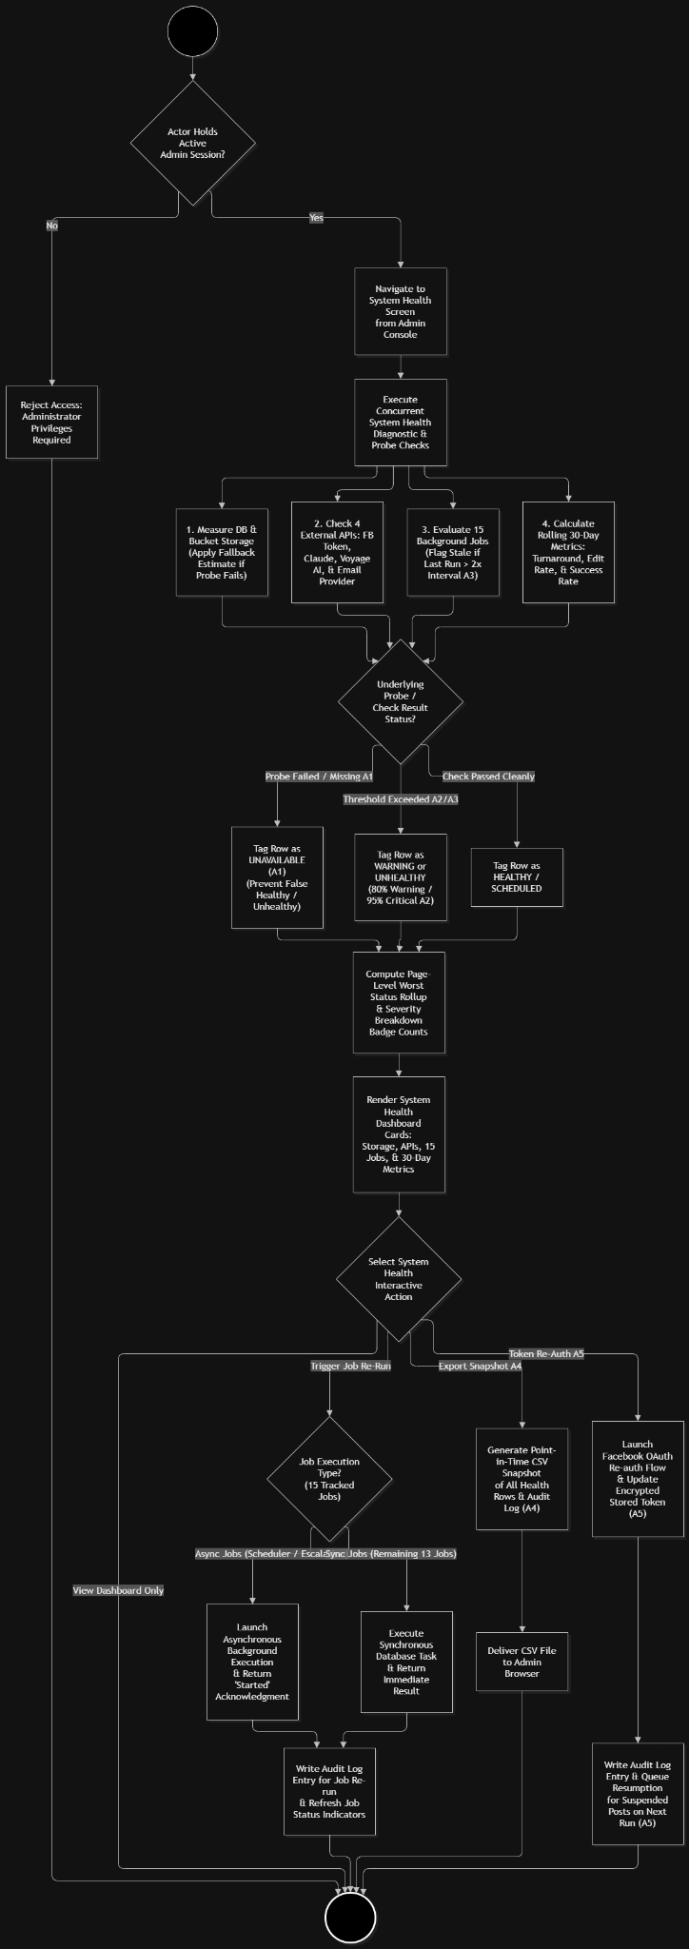

Wireframe

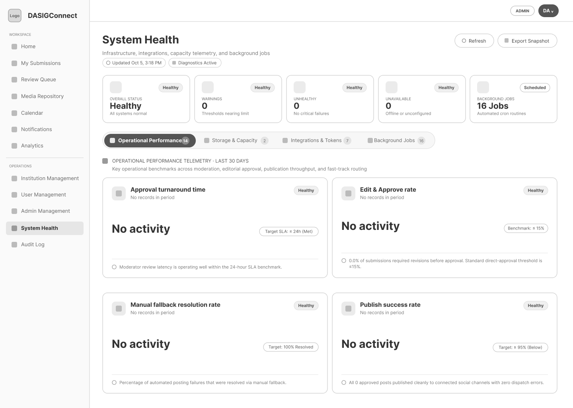

Audit Log Review

Use Case Diagram
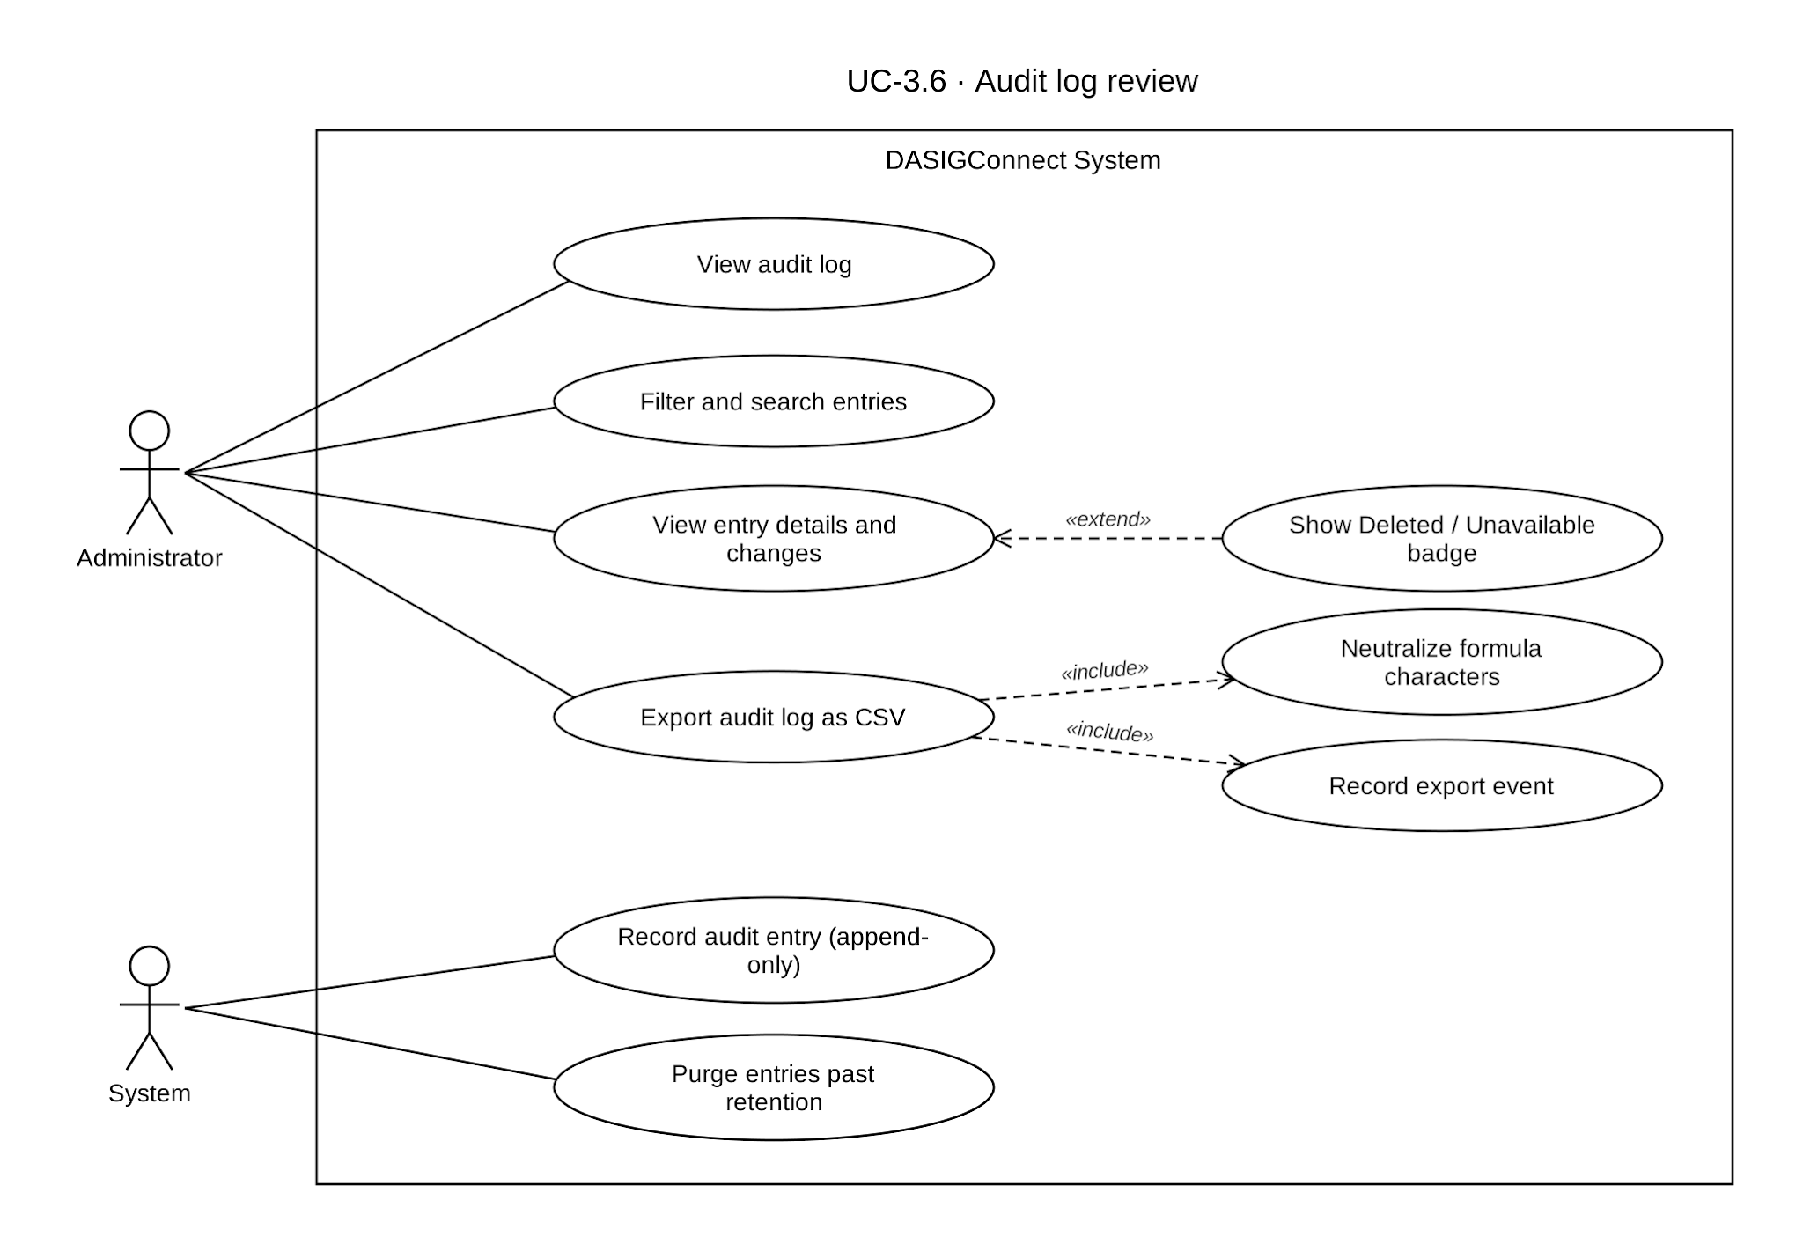

Use Case Description
Use Case ID | UC-3.6
Use Case Name | Audit Log Review
Actor(s) | Administrator
Precondition(s) | The actor is authenticated with Administrator privileges. At least one auditable action has occurred in the system.
Main Flow | - The actor navigates to Audit Log from the admin console.  - The screen displays a table of audit entries, newest first, with these columns: Actor, Timestamp (Asia/Manila), a combined Category/Action badge, Affected Entity, and a generated one-line Summary. Each row also carries additional data available in the detail view: the actor's role, institution, and Admin Owner flag; the target entity's live/deleted state; and the client IP address and user agent recorded at the time of the action.  - The actor can filter the log server-side by date range, actor (by ID or free-text name/email), category, specific action code, entity type, resource ID, and a general free-text search across actor email/name/action/IP — combinable, with paginated results.  - Categories (11): Approval, Rejection, Edit & Revision, Reschedule & Override, Publishing, Account Management, Institution Management, Media Lifecycle, Configuration, Security, Other. There is no standalone "Deletion" category — asset and album deletions fall under Media Lifecycle, and user or institution deletions fall under Account Management / Institution Management respectively.  - Entity types (8): Submission, Media Asset, Media Album, User, Institution, Facebook Token, Watermark Configuration, System.  - Selecting an entry opens a detail view showing:  - Actor & Execution details (name, email, role, institution, action code, client IP)  - Target Entity (type, a jump link to the live record or a "Deleted/Unavailable" badge, entity ID)  - A generated summary, including any override or justification reason provided at the time of the action  - A structured diff table (Field / Previous Value / Updated Value) for actions that changed data — covering edit/caption changes, schedule changes, status transitions, and account role changes — with a raw-detail inspector available for anything outside the structured diff types.  - The actor can export the currently filtered results as a CSV, which is itself recorded as an audited event.
Alternative Flow(s) | A1 — No Matching Entries: The table shows a standard empty state when the current filters return no results.  A2 — Entry References a Deleted Entity. If the entity an entry points to no longer exists, the table and detail view show a "Deleted/Unavailable" badge instead of a jump link. Live jump links are available for Submission, User, Media Asset, and Institution entities; Facebook Token, Watermark Configuration, and Media Album entities link to their general management screen rather than a per-entity deep link; System-typed entries have no jump link.  A3 — Export Failure. A failed export surfaces as a toast notification. The current filter state is preserved, so the actor doesn't need to reconstruct their filters to retry.  A4 — Large Date Range Query. The table view uses server-side pagination and is unaffected by range size. The CSV export caps at 5,000 rows; a filtered result set larger than that is truncated in the export without a user-facing warning.
Postcondition(s) | The audit log is append-only at the database level: the audit table's row-level security policy permits inserts only, with no update or delete policy defined, so entries cannot be modified or removed regardless of application-layer behavior. The only sanctioned mutations are a scheduled retention purge (see below) and a right-to-be-forgotten scrub that removes only the actor's email fields from an entry's metadata, without deleting the entry itself.

Activity Diagram
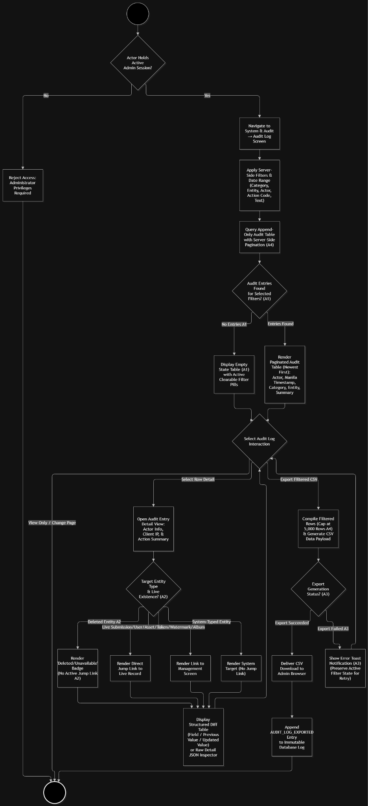

Wireframe
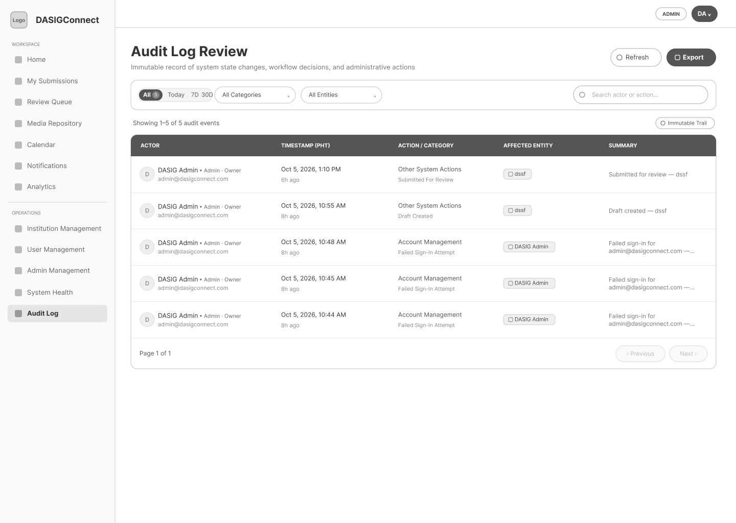

Business Rules and Guard Rails
This section defines system-enforced business rules that prevent scheduling conflicts on the shared DASIG Facebook Page and enforce minimum content-quality gates before publication. Rules are enforced automatically by the application, replacing what previously required manual coordination by a single Administrator. The hard- and soft-rule thresholds and the enforcement switch are adjustable by the Administrator in Settings → Page without requiring code changes, and are expected to be tuned based on operational experience during and after the pilot period. Trigger-rule thresholds are fixed in code or set by deployment configuration.

Guard Rail Rules

Hard Rules
Hard rules are absolute. The system rejects any action that violates them and provides an explanatory message with suggested alternatives.
Rule ID | Rule Name | Threshold | Enforcement Point | Rationale
GR-H1 | Conflict Buffer | No two posts within ±30 minutes on the shared DASIG Facebook Page | At slot selection (UC-1.8); re-validated at submission (UC-1.9); at Moderator and Administrator rescheduling (UC-3.1); enforced in the database by an exclusion constraint (UC-3.1 A4) | Prevents audience saturation and Facebook algorithm penalties on the shared single page
GR-H2 | Minimum Lead Time | Scheduled time must be ≥2 hours in the future | At slot selection; re-validated at submission (UC-1.9) | Ensures the Administrator has sufficient time to review content before publication. Does not apply to Live Event Fast-Track submissions (UC-1.5), which have no scheduled time.
GR-H3 | Maximum Lead Time | Scheduled time must be ≤30 days in the future | At slot selection; re-validated at submission | Prevents calendar chaos and stale content
GR-H4 | Posting Window | Scheduled time must fall between 8:00 AM and 8:00 PM (Asia/Manila) | At slot selection (UC-1.8); re-validated at submission (UC-1.9); at rescheduling (UC-3.1) | Publishes when the Page audience is active
GR-H5 | Approval-Before-Publish Gate | A submission cannot be published until an Administrator has approved it (state must be SCHEDULED, not PENDING_APPROVAL or IN_REVIEW) | At publishing scheduler query (UC-3.2) | Guarantees a quality control step before public posting. (Numbered GR-H4 in SRS v6.0; renumbered so that GR-H4 matches the rule code the system reports for the posting window.)
Configurable threshold table — Hard Rules:
Rule ID | Configurable | Default
GR-H1 | Yes — conflict buffer duration (default: 30 min) Settings → Page | 30 minutes
GR-H2 | Yes — minimum lead time (default: 2 hours) Settings → Page | 2 hours
GR-H3 | Yes — maximum lead time (default: 30 days) Settings → Page | 30 days
GR-H4 | Yes — window start and end hour, Settings → Page | 8:00 AM–8:00 PM
GR-H5 | No — structural rule, not a threshold | -

Enforcement of GR-H1–GR-H4 can be switched off network-wide in Settings → Page; a Standard post still needs a future time and a slot reservation. The database exclusion constraint behind GR-H1 uses a fixed ±30-minute range, so the buffer should stay at 30 minutes unless that constraint is migrated.

Soft Rules
Soft rules generate warnings but allow the action to proceed without blocking. Contributors and Administrators may proceed through a soft rule warning without explicit confirmation. Hard rule violations block the action entirely for Contributors; an Administrator may override a hard rule during their own actions (e.g., drag-rescheduling, UC-3.1 A2) with a mandatory written justification, but there is no Contributor-initiated override request mechanism in this version of the system.
Rule ID | Rule Name | Threshold | Enforcement Point | Rationale
GR-S1 | Per-Institution Active Quota | Each institution may have at most 3 scheduled-but-unpublished posts at any time. Does not apply to Live Event Fast-Track submissions, which do not enter a scheduled-but-unpublished state. | At slot selection (UC-1.8); re-checked at submission (UC-1.9) | Prevents one institution from monopolizing the calendar; ensures fairness across DASIG member institutions
GR-S2 | Daily Volume Cap | The DASIG Facebook Page may have at most 6 scheduled posts per calendar day across all institutions, inclusive of Live Event Fast-Track publications counted on their actual publish date. | At slot selection (UC-1.8); at approval for Fast-Track submissions (UC-2.4 A8) | Prevents audience fatigue from burst posting on the shared page
Configurable threshold table — Soft Rules:
Rule ID | Configurable | Default
GR-S1 | Yes — per-institution active post quota, Settings → Page | 3 posts
GR-S2 | Yes — daily volume cap, Settings → Page | 6 posts

Trigger Rules
Trigger rules cause the system to act autonomously — dispatching notifications, escalating priority, transitioning states, or performing cleanup — without human request.
Rule ID | Rule Name | Trigger Condition | System Action
GR-T1 | Approaching Publish Time Priority Flag | submission.state IN ('PENDING_APPROVAL', 'IN_REVIEW') AND scheduled_at < NOW() + 30 minutes | Show a priority badge ("Priority <30m") on the submission in the Review Queue (UC-2.4), computed each time the queue is read. The non-paginated queue endpoint also sorts these items first; the paginated queue used by the Review Queue screen orders Fast-Track first and then by the chosen sort, so there the item is flagged but not moved. No escalation notification is sent at this stage. If the submission remains unreviewed past its scheduled time, it transitions to MISSED_REVIEW per GR-T9 and is listed in the Approval Queue's Failed tab (UC-2.4 A8)
GR-T2 | Slot Reservation Cleanup | DRAFT submission with held slot reservation; no activity for 7 days | Automatically release the slot reservation. The DRAFT record is retained in the Contributor's Submission Queue. No notification is sent.
GR-T3 | Token Expiry Warning | facebook_token.expires_at < NOW() + 7 days | Send Administrator in-app + email notification (T-08).
GR-T4 | Token Validation Failure | Daily token health check API call fails or returns an invalid response | Record the failed check (the token row is not deactivated). Send Administrator in-app and email alert (T-09). Suspend automated publishing for all SCHEDULED submissions until the token is reauthorized (UC-3.5 A5).
GR-T5 | Publishing Retry Sequence | Publishing API call (UC-3.2) fails | Retry up to 3 times with exponential backoff (5s, 25s, 125s). If all retries fail, transition submission to PUBLISH_FAILED and alert Administrator (T-06).
GR-T6 | High-Volume Failure Consolidation | More than 5 PUBLISH_FAILED events within a rolling hour | Failures 1–5 alert Administrators individually; the 6th sends one consolidated high-priority alert (T-06; in-app, email, and Messenger per UC-3.3 A4) linking to the Failed tab; later failures in the same rolling hour send no individual Administrator alerts. Individual PUBLISH_FAILED records are still created and visible in the Approval Queue's Failed tab (UC-2.4 A8), and Contributors are still notified.
GR-T7 | Media AI Processing and Embedding Reconciliation | An image asset is uploaded, or an image asset lacks a current embedding | Scope: Image assets only. Video assets are permanently excluded from the classification and embedding pipeline supporting the media library, drafting, and album-matching features (UC-2.1, UC-1.7, UC-2.2) and will always have embedding = NULL by design. The asset type filter prevents the job from repeatedly attempting to embed video assets. Processing: each upload queues a classify-and-embed job in the durable media_processing_jobs queue; a worker polls every second, claims jobs under a lease, calls Google Gemini for classification and then Voyage AI for the image and semantic embeddings, and marks the asset READY. On success: the vectors are stored in media_asset_embeddings and the asset becomes immediately available for semantic similarity search, including AI-Suggested Media during drafting (UC-1.7). On failure: the job is retried with backoff up to 5 attempts and then moved to a dead letter, and the asset is marked FAILED; an Administrator can list and retry dead letters (UC-3.5 A6). Reconciliation: the EmbeddingReconciliationJob (default every 30 seconds) re-queues images still missing current embeddings, in bounded batches. The Administrator receives a weekly digest notification (T-12, in-app) of assets whose embedding failed. No user-facing error is shown to Contributors.
GR-T8 | Invitation Token Expiry Detection | account.state IN ('PENDING', 'PENDING_EMAIL_UNDELIVERED') AND account.invitation_token_expires_at < NOW() | Transition account to EXPIRED state. Retain account record. Surface in the account management panel with reason: "Invitation token expired without activation." No user-facing notification is sent. The Administrator may reissue a new token at any time (EXPIRED → PENDING, per the Account State Machine). Schedule: hourly.
GR-T9 | Stale Submission Detection | submission.state IN ('SCHEDULED', 'PENDING_APPROVAL', 'IN_REVIEW') AND submission.scheduled_at < NOW() − INTERVAL '5 minutes'; or a Fast-Track submission stuck in a publishing state for more than 5 minutes | If state = 'SCHEDULED': transition to PUBLISH_FAILED, reason "missed_publish_window — server dormancy or cron failure." If state IN ('PENDING_APPROVAL', 'IN_REVIEW') and no review lock is held: transition to MISSED_REVIEW, reason "scheduled time passed without review," and release the slot. A stuck Fast-Track publish transitions to PUBLISH_FAILED. Notify Administrators in each case. The submission is listed in the Approval Queue's Failed tab (UC-2.4 A8); a MISSED_REVIEW item returns to PENDING_APPROVAL once a new slot is chosen. Schedule: every 5 minutes.
Configurable threshold table — Trigger Rules:
Rule ID | Configurable | Default
GR-T1 | No — fixed in code | 30 minutes (linked with GR-H2)
GR-T2 | No — fixed in code | 7 days
GR-T3 | No — fixed in code | 7 days
GR-T4 | No — structural check, fires on failure | —
GR-T5 | No — fixed in code | 3 attempts; 5s, 25s, 125s
GR-T6 | No — fixed in code | 5 failures per hour
GR-T7 | Deployment configuration — worker batch, lease, attempts, poll and reconcile intervals | 5 attempts; reconcile every 30 s
GR-T8 | No — fires when token expiry timestamp is crossed | —
GR-T9 | No — fixed in code | 5 minutes

Override & Administrative Action Audit Requirements
All hard rule overrides by an Administrator (e.g., drag-rescheduling into a conflict, UC-3.1 A2) and all Edit & Approve actions performed by a Moderator or Administrator that modify submitted content before publication (UC-2.4 A9–A10) are recorded in the immutable audit log with the following fields:

Field | Description
Actor | User ID and name of the person (Administrator or Moderator) performing the action
Action type | Reschedule Override, Edit & Approve, or other logged action category
Rule(s) affected (if applicable) | Rule ID and name for any hard rule overridden (e.g., GR-H1), with threshold value at time of action
Before/after values | For Edit: the diff of changed fields. For reschedule overrides: original and new scheduled time
Written justification | Mandatory reason text entered by the Administrator. (Note: Required only for hard rule overrides; not required for standard Edit actions)
Timestamp | ISO 8601
Affected submission ID | The unique ID of the specific submission/post that was edited or rescheduled.
Audit Log Surfacing: All entries are accessible via System & Audit → Audit Log (UC-3.6), viewable and filterable by the Administrator or Super Administrator, with export available for DASIG/DOST Region 7 governance reporting.

Application Business Rules
This section consolidates operational rules extracted from the use case descriptions, collected here so that threshold values, constraints, and behavioral specifications have a single authoritative location in the SRS.

User Provisioning and Account Management
BR-ACC-01 — Contributor Provisioning Status Restriction. Contributor invitation (UC-1.3) is restricted to institutions in ACTIVE status only. Contributors may not be added to an institution that is inactive or pending setup.
BR-ACC-02 — Password Complexity Requirements. Passwords must satisfy all of the following simultaneously: minimum 12 characters; at least one uppercase letter; at least one lowercase letter; at least one digit; at least one special character; must contain no spaces; must not be a common or sequential password (enforced by the zxcvbn strength meter); must not include the user's name or email Enforced in real time with inline validation feedback per rule; the Submit button remains disabled until all requirements are met. Applies at account activation (UC-1.1/UC-1.3) and both password paths (UC-1.4 A5, A6).
BR-ACC-03 — Institutional Email Domain Matching. When sending an invitation to a Contributor and the assigned institution has a registered email domain, the recipient's email address domain must strictly match that domain (e.g., @university.edu). Mismatches are rejected by the system.
BR-ACC-04 — Invitation Token Validity. Invitation Tokens expire 72 hours after generation, are single-use, and are scoped to the recipient's institution (for Contributors) or network-wide (for Administrators). A token generated for one institution's Contributor cannot activate an account at a different institution; mismatch returns a generic invalid-token error. When a token is reissued, the previous token is explicitly invalidated before the new one is generated.
BR-ACC-05 — Password Reset Token Validity. Password Reset Tokens expire 1 hour after generation and are single-use. Any previously issued, unused reset token for the same account is invalidated when a new one is generated.
BR-ACC-06 — Post-Login Landing Route. On successful login, every role lands on /dashboard; the dashboard content and navigation are role-specific (UC-1.4 step 5).
BR-ACC-07 — Post-Login Feature Access by Role. On first login following account activation, the system grants the following role-specific access:
Feature | Contributor | Moderator | Administrator
Content submission form (Propose New Post) | ✓ (own institution) | ✓ (Posting As any institution) | ✓ (Posting As any institution)
Master Calendar | Read-only, network-wide timing | Full detail; reschedule within caps | Full edit access, with override
Media Library | Own institution + shared library | Network-wide | Network-wide; Trash
Analytics Dashboard | Institution-scoped, read-only | Network-wide (no institution filter) | Network-wide, with institution filter and Administrator-only reports
Validation Queue | — | Full access | Full access
Institution Management | — | Read-only | Full access
Invitations | — | Contributors only | All roles
System Health, Audit Log, Page and Watermark Settings, Admin and User Management | — | — | Full access
BR-ACC-08 — Administrator Headcount Cap. To enforce security and limit broad network access, the system restricts the number of Administrators — active Administrators plus outstanding Administrator invitations plus pending promotions — to a combined cap (default: 3, app.admins.max). If the network is at capacity, new Administrator invitations are blocked until an existing Admin is demoted or deactivated.
BR-ACC-09 — Deactivated Account Reactivation. An account that has been explicitly deactivated cannot be "re-invited" through the standard invitation flow to bypass their deactivated status. The system will throw a conflict error; they must be manually reactivated by an Administrator.
BR-ACC-10 — Invitation Role Hierarchy. Administrators can invite any role (Contributor, Moderator, or Admin). Moderators are network-wide and can invite Contributors to any institution, but they are forbidden from generating invitations for other Moderators or Administrators.

Content Submission
BR-SUB-01 — Accepted File Types and Upload Size Limit. Accepted image formats: JPEG, PNG, WebP, GIF. Accepted video formats: MP4, MOV, WebM. Each file's declared MIME type, extension, and size are validated on the client and the server before storage; file-content (magic-byte) inspection is not performed. Maximum file size: 50 MB per file.
BR-SUB-02 — Media Asset Limit per Submission. A submission may include a combined maximum of 10 media assets (device-uploaded, repository-linked, or AI-suggested). Enforced at the point of adding each asset, across all attachment methods (UC-1.7).
BR-SUB-03 — Draft Slot Reservation Timeout. A tentatively reserved slot held by a DRAFT submission is automatically released after a configured period of inactivity (default: 7 consecutive days) per the GR-T2 trigger rule. The DRAFT record is retained with no active slot; the Contributor must reselect a slot on next open. Does not apply to Live Event Fast-Track drafts, which hold no slot.
BR-SUB-04 — AI Processing Windows. AI classification tags and caption suggestions are expected within 10 seconds of upload or request. Media recommendations (AI-Suggested Media, UC-1.7) appear within 3 seconds of event-detail input. Target windows only; if AI services are unavailable, the system degrades silently (UC-1.6 A2).
BR-SUB-05 — Mixed Media Publishing Restriction. A single submission containing both images and videos cannot be automatically published via the Facebook Graph API. The system automatically flags any mixed-media post with requiresManualPublishing = true, requiring the Administrator to manually publish the content on Facebook and reconcile the status.
BR-SUB-06 — Caption Length Limit. The post caption must not exceed 3,000 characters (code-point count). Enforced both in the frontend composer UI and the backend validation service.

Media and Asset Management
BR-MED-01 — Network View Access. The Media Library allows Administrators and Moderators to view assets across all institutions. This Network View is the default scope for network-level roles, though they may explicitly filter the view down to individual institutions using the provided UI filters.
BR-MED-02 — Asset Deletion Precedence. Before deleting an asset: if referenced in a PENDING_APPROVAL, IN_REVIEW, or SCHEDULED submission, deletion is blocked. If referenced only in DRAFT or NEEDS_REVISION submissions, deletion is allowed with a confirmation prompt warning the reference will break. If referenced only in terminal-state submissions (REJECTED, PUBLISHED, PUBLISHED_MANUAL, PUBLISH_FAILED) or unreferenced, deletion is allowed with a simple confirmation. Deletion is a soft delete: the asset moves to the Trash, where an Administrator may restore or permanently delete it; items still in the Trash after 30 days are purged together with their stored file (UC-2.3 A5).

Content Approval
BR-APP-01 — Review Lock Timeout. If the Administrator or Moderator holding a review lock takes no action for 15 consecutive minutes, the lock expires and the submission automatically reverts from IN_REVIEW to PENDING_APPROVAL, becoming available for another reviewer (UC-2.4 A4).
BR-APP-02 — Revision Remarks Requirements. Revision remarks are mandatory when requesting a revision. Minimum length: 10 characters. Maximum length: 1,000 characters. The Request Revision action is blocked until the minimum is met, and the field rejects input beyond the maximum.
BR-APP-03 — Rejection Reason Codes. When rejecting a submission, the reviewer must select from the following standardized reason codes. Written notes are optional for all codes except OTHER. Missing or fixable content (e.g., wrong format, incomplete details) must be routed through Request Revision rather than rejected. A rejected submission is not final: the Contributor may edit and resubmit it.
Code | Label
INAPPROPRIATE_CONTENT | Content violates DASIG posting guidelines.
OUT_OF_SCOPE | Not a DASIG activity or related to the network.
DUPLICATE_EVENT | This event has already been submitted or published
NO_LONGER_RELEVANT | Event has passed and is no longer timely.
RIGHTS_OR_PRIVACY | Rights, copyright, or privacy issue.
WRONG_INSTITUTION | Content belongs to another institution.
OTHER | Other

BR-APP-04 — Self-Review Restriction. An Administrator or Moderator may not review, approve, request revisions for, or reject their own submissions. The system unconditionally blocks self-review; another privileged user must perform the validation.
BR-APP-05 — Fast-Track Override Restriction. Toggling the "Live Event Fast-Track" status of a submission during an active review session is restricted to Administrators. Regular Moderators may edit other submission details but cannot bypass the queue by converting a standard submission to Fast-Track (or vice versa).

Notification Behavior
BR-NOT-01 — Notification Delivery Timing. In-app: Real-time via Server-Sent Events (SSE). Email: within 5 minutes in ≥95% of cases. Facebook Messenger: best-effort, subject to Meta's Messenger Platform delivery. All notifications include a direct deep-link to the affected submission, queue tab, or relevant view — never a generic dashboard link.
BR-NOT-02 — Notification Bell and Read-State. The notification bell badge increments by one for each unread in-app notification and persists across page refreshes and sessions (read-state is server-persisted). A notification is marked as read when the user clicks the item or uses Mark All Read. Opening the notification panel alone does not mark notifications as read. The badge count decrements only as individual notifications are clicked or all are bulk-marked.
BR-NOT-03 — Notification Panel Behavior. The panel displays the 50 most recent notifications per user, newest first. View All Notifications opens a paginated full-history view. Notifications are retained indefinitely in the database; there is no automatic 90-day archive or purge (except upon account deletion).
BR-NOT-04 — Notification Preferences.Users may independently toggle their preferences for In-App and Email notifications via their account settings. Facebook Messenger delivery is strictly opt-in and restricted by role: only Administrators and Moderators may connect their accounts to Messenger; Contributors are blocked from this channel.
BR-NOT-05 — Cross-Session Synchronization. Notification read-state actions (read single, mark all read) instantly broadcast an SSE sync event to all active sessions for that user, ensuring the notification bell badge decrements simultaneously across all open browser tabs.

Analytics
BR-ANA-01 — KPI Definitions and Formulas.
- AVG POSTING DELAY — AVG(published_at − first_pending_at) where state IN (PUBLISHED, PUBLISHED_MANUAL) within the selected period. first_pending_at is the first transition to PENDING_APPROVAL. Display: Days (calculated as epoch seconds ÷ 86400). Target: ≤1.0 days.
- CONTENT COMPLETENESS — COUNT(posts meeting all required criteria) ÷ COUNT(all published posts) × 100%. Required fields: non-empty event title, non-null event date, non-empty caption, at least one valid media asset. Target: ≥95%.
- TOTAL POSTS PUBLISHED — COUNT(PUBLISHED) + COUNT(PUBLISHED_MANUAL) within the selected period. Target: ≥4 posts per institution per month.
BR-ANA-02 — Period-over-Period Delta Comparison Periods.
Selected Range | Comparison Period
7d | Previous 7 days
30d | Previous 30 days
90d | Previous 90 days
YTD | Jan 1 to same date, prior calendar year
If no data exists for the comparison period, the delta displays "N/A."
BR-ANA-03 — Sparkline Behavior. Each KPI tile shows a 12-week sparkline. For deployments with fewer than 12 weeks of data, weeks prior to deployment evaluate to zero (0) in the backend.
BR-ANA-04 — AI Performance Metrics Scope by Role. The AI-performance report and export are restricted to Administrators (other roles receive 403 Forbidden). AI feature adoption — caption suggestions, media suggestions, album Auto-Match, top-post templates, and the writing check — is shown to Administrators on the Analytics dashboard, network-wide and filterable by institution.
Minimum threshold for display: 20 total AI events (across all AI features combined) within the selected period/scope; otherwise dimmed with an insufficient-data notice.
BR-ANA-05 — Operational Health Metrics. These metrics are restricted to Administrators only.
Contributors and Moderators do not have access.
Metric | Contributor | Administrator
AI caption acceptance rate | Own submissions only | Network-wide (filterable)
AI tag manual-correction rate | Own submissions only | Network-wide (filterable)
- Minimum threshold for display: 20 total AI events (across all AI features combined) within the selected period/scope; otherwise dimmed with an insufficient-data notice.
BR-ANA-05 — Operational Health Metrics. These metrics are restricted to Administrators only. Contributors and Moderators do not have access.
Metric | Definition
Submissions Entered Workflow | Count of submissions that entered the pending state
Validation Deadline Risks | Count and percentage of submissions approaching the review
Override Audit Events | Count and percentage of administrative override actions taken
Missed review rate | Count of submissions transitioned to MISSED_REVIEW (GR-T9) per week
Publication Attempts | Total system attempts to publish to social channels
Successful Publications | Total successful publications and overall success rate
On-time Publication | Count and percentage of scheduled posts published on time (Target: ≥95%)
The missed-review rate (share of review outcomes in the last 30 days that were MISSED_REVIEW, flagged above 10%) is shown on System Health (UC-3.5), not on the Analytics dashboard.
BR-ANA-06 — Full Report Submission-Level Table Column Visibility.
Column | Contributor | Moderator | Administrator
Submission ID | ✓ | ✓ | ✓
Event title | ✓ | ✓ | ✓
Contributor name | — | ✓ | ✓
Institution | — | — | ✓
First submitted date | ✓ | ✓ | ✓
Published date | ✓ | ✓ | ✓
Publication state | ✓ | ✓ | ✓
Posting delay (hours) | ✓ | ✓ | ✓
Completeness | ✓ | ✓ | ✓
Revision cycles count | — | ✓ | ✓
Exported CSV files are named: DASIGConnect_Analytics_[Role]_[Institution or Network]_[DateRange].csv.

Publishing
BR-PUB-01 — Calendar Card State Specification.
Submission State | Card Label | Visual Indicator
DRAFT | "[Institution] — Draft" | Grey, solid border
PENDING_APPROVAL | "[Institution] — Pending Approval" | Light grey, dashed border
NEEDS_REVISION | "[Institution] — Needs Revision" | Amber, dashed border
SCHEDULED | "[Institution] — [Title]" | Institution color, solid border
PUBLISHING | "[Institution] — Publishing..." | Institution color, solid border with spinner
PUBLISHED | "[Institution] — [Title]" | Green, solid border
PUBLISHED_MANUAL | "[Institution] — [Title] (Manual)" | Teal, solid border
PUBLISH_FAILED | "[Institution] — [Title] (Failed)" | Red, solid border
MISSED_REVIEW | "[Institution] — [Title] (Missed review)" | Distinct missed-review color
Live Event Fast-Track submissions do not appear with a reserved slot (UC-3.1 A4); if shown, they appear as an unscheduled marker on their publish date. Each card shows the institution badge, title (truncated to 40 characters), and scheduled time.
BR-PUB-02 — Publishing Scheduler Windows. The primary publishing scheduler runs every minute and picks up SCHEDULED submissions whose scheduled time falls within a 5-minute lookback window, accounting for brief server lag or cron delay. To prevent duplicate posts across instances, submissions are atomically claimed and transitioned to a transient publishing state before any platform API calls are made. Transient API failures log to publication_attempts and are retried within this window.The secondary stale-submission scheduler (GR-T9) runs every 5 minutes and detects submissions missed beyond the 5-minute window, transitioning scheduled ones to PUBLISH_FAILED and unreviewed ones to MISSED_REVIEW.
BR-PUB-03 — Automated Publishing Asset Type Support.
Asset Type | Publishing Path
Image-only (JPEG, PNG, WebP, GIF) | Multi-photo two-step method: stage each image individually, then publish a single feed post with all photo IDs attached
Video-only (MP4, MOV, WebM) | Single-call video publish method via /{PAGE_ID}/videos
Mixed (images + video in same submission) | Mixed-media submissions transition to PUBLISH_FAILED; recovery via the Approval Queue's Failed tab (UC-2.4 A8).
BR-PUB-04 — Manual Publishing Audit Log Fields. The audit log entry on PUBLISHED_MANUAL transition includes: Administrator identity, submission ID, original scheduled time (if any), PUBLISHED_MANUAL timestamp, validated platform post URL, written notes, and prior state (PUBLISH_FAILED).
BR-PUB-05 — Manual Publishing Analytics Impact. PUBLISHED_MANUAL submissions are included in all three primary KPIs (BR-ANA-01): counted in TOTAL POSTS PUBLISHED, included in AVG POSTING DELAY, and evaluated in CONTENT COMPLETENESS.
BR-PUB-06 — Manual Publishing Workflow & Abandonment. The manual publishing fallback requires a valid live platform URL to be provided before the submission can be marked as PUBLISHED_MANUAL. The workflow enforces a 2-hour countdown window. If the Administrator cancels the flow, a MANUAL_PUBLISH_CANCELLED audit log is written. If the 2-hour window expires without completion, the system automatically clears the lock, sets lastManualPublishAbandonedAt, and writes a MANUAL_PUBLISH_ABANDONED event to the audit log.

AI Features
BR-AI-01 — Caption Generation Prompt Parameters.
Parameter | Value
Language | English
Role instruction | Social media content writer for a Philippine government-affiliated academic network (DOST DASIG)
Task | Generate one Facebook caption variants for the provided image(s) and event context. Apply intent detection on any existing text in the caption field: determine if it is a direct instruction to follow, or a draft caption to refine.
Tone variants | One of Professional (default), Community, or Energetic, chosen by the user. If user text is detected as an instruction, the caption follows that guidance within the chosen tone.
Output format | A single caption for the selected tone
Security | Enforces prompt injection defense on user-supplied text. The output-token limit is sized from the requested length.
Safety constraints | No profanity, hate speech, discriminatory language, political opinions, unsupported factual claims, or unrelated commercial endorsements; appropriate for a government-affiliated academic audience
Context inputs | Up to 4 base64-encoded images (resized <5MB), event title, event date, institution, media metadata and AI tags, existing caption text, and an optional instruction of up to 280 characters.
BR-AI-02 — Caption Suggestion Re-generate Debounce. Re-generate requests are debounced at 3 seconds. Repeated clicks within 3 seconds of a prior call trigger only one request. A loading indicator is shown during the debounce and API call period.
BR-AI-03 — Caption Interaction Logging Schema. Each caption suggestion interaction is logged with: whether a suggestion was shown, action taken (use / use_then_edited / edit / re-generate / dismiss), tone selected if applicable, submission ID, and timestamp. If the user applies the caption and subsequently modifies the caption field before submitting, the logged action is updated from use to use_then_edited to distinguish clean acceptance from accepted-but-revised for KPI accuracy.
BR-AI-04 — Image Classification Prompt Parameters (Google Gemini).
Parameter | Value
Task | Classify the image into exactly one of 14 predefined categories and one asset type, provide a factual description, and generate up to 30 tags plus enrichment signals (observed scenes, possible use cases, temporal classification)..
Category taxonomy | Food, People, Event, Technology, Research, Education, Sports, Culture, Nature, Document, Product, Architecture, Artwork, Other
Output format | JSON only — no prose or markdown (primary_category, asset_type, confidence, ai_caption, ai_tags, and enrichment fields)
Fallback rule | Always return the closest matching category even at low confidence; any value outside the taxonomy is stored as Other.
Provenance | Classification timestamp, model name, and tag source (AI vs MANUAL) are persisted to the database.
Safety constraint | Descriptions must not include personal information beyond visible roles or institutional contexts.
BR-AI-05 — Media Recommendation Similarity Parameters.
Parameter | Value
Similarity metric | Cosine similarity via pgvector cosine distance operator
Vector model | voyage-multimodal-3.5 (image) and voyage-4-lite (text), 1024 output dimensions
Relevance threshold | Hybrid score (semantic, visual, recency, tag, and category signals) ≥ 0.40
Search context | Event title, draft caption, media tags, and already-selected images
Fallback mechanism | If the vector query fails, fall back to keyword (tag and filename) matching.
Search scope | The submission's institution plus the shared DASIG Central Visayas library
Result count | Top 8 assets above threshold, ordered by descending score
Title input debounce | 500ms inactivity after each keystroke
Panel refresh trigger | Combined event context reaches at least 10 characters, or an image is selected
BR-AI-06 — Recommendation Interaction Logging Schema. Each recommendation panel interaction is logged with: event type (recommendation_shown / asset_previewed / asset_added / asset_ignored), asset ID if applicable, similarity score, event title text at time of query, submission ID, and timestamp.
BR-AI-07 — AI Rate Limits. Per user, per rolling hour: caption generation 30 requests, writing check 30 requests, template from top posts 10 requests. Exceeding a limit returns 429 Too Many Requests with the reset time.

Non-functional requirements

Performance
- Content submission form response time shall not exceed 3 seconds under normal operating load (up to 20 concurrent users).
- Master Calendar load time shall not exceed 2 seconds for displaying a 30-day window with up to 200 scheduled events.
- Guard rail validation (conflict check, quota check, lead time check) shall complete within 500 milliseconds at slot selection time, providing real-time feedback to the Contributor.
- Media asset search shall return results in ≤2 seconds for a media library of up to 1,000 assets.
- AI caption generation shall complete and display one caption within 10 seconds in ≥90% of cases. The system enforces a 30-second hard timeout to prevent hanging UI threads in the event of upstream API degradation.
- AI image classification and vector embedding shall execute asynchronously upon image upload to avoid blocking the submission response time. The asynchronous pipeline shall complete within 10 seconds of upload in ≥90% of cases.
- Media recommendation results (AI-Suggested Media, UC-1.7) shall be returned within 3 seconds of qualifying event-detail input (debounced at 500ms). This SLA is achieved by querying pre-computed pgvector embeddings rather than scanning images at request time.
- Automated post publishing shall occur within ±5 minutes of the scheduled time in ≥95% of scheduled publications, subject to the backend remaining available as described in Section 2.3 (Deployment Platform and Background Processing). During any period where the backend is unavailable, missed publish windows shall surface as PUBLISH_FAILED items and are resolved via the Approval Queue's Failed tab (UC-2.4 A8). Missed publications due to documented server dormancy do not count against the ±5 minute SLA for pilot evaluation purposes, provided they are resolved within 30 minutes of the missed window.
- In-app notification badges and lists shall update in near real-time (≤ 1 second) of a triggering event, utilizing persistent Server-Sent Events (SSE).
- Email notifications shall be dispatched within 5 minutes of a triggering event in ≥95% of cases.
- The analytics dashboard shall reflect updated metrics within 60 seconds of a relevant system event (submission, approval, publication).
- The Approaching Publish Time Priority Flag (GR-T1) shall be computed each time the Review Queue is read, so it appears on the first queue load after the 30-minute threshold is crossed.

Security
- All client-server communication shall be encrypted via HTTPS using TLS 1.2 or higher. Unencrypted HTTP connections shall be rejected.
- User authentication shall use a secure token-based mechanism (JWT). Tokens shall expire a fixed 8 hours after issue; API activity does not extend them. Tokens shall be invalidated upon explicit logout, and a password reset invalidates every token for the account (session_version). A refresh endpoint (POST /api/v1/auth/refresh) exists for re-issuing a token to an authenticated user, but the frontend does not call it and it is not rate-limited; the session-expiry experience is the warning banner and re-login modal. Session expiry handling (warning banner before expiry, re-authentication prompt, draft recovery) is defined in UC-1.4 A7 and applies to all authenticated users across all roles.
- Invitation Tokens shall be generated as cryptographically random 32-byte values, encoded as a 64-character lowercase hexadecimal string (or equivalent URL-safe encoding). Only a SHA-256 hash of the token shall be stored in the database. Generating a new invitation or resending an invite shall automatically invalidate any existing, unused tokens for that target email. Contributor tokens shall be scoped to the target institution and shall not be usable to activate accounts at a different institution.
- Passwords shall be hashed using bcrypt or an equivalent industry-standard adaptive hashing algorithm with cost factor ≥12. Plaintext passwords shall never be stored. (Implementation note: the current build uses bcrypt with the library default cost factor of 10; raising it to 12 is an open item.)
- All API endpoints shall enforce role-based access control. Requests that do not match the required role for an endpoint shall return a 403 Forbidden response.
- Tenant scope (institution data isolation) shall be enforced at the database level via row-level security policies and at the application interceptor level. No user shall be able to access submissions, media assets, or workspace data belonging to a different institution.
- The Facebook Page Access Token shall be encrypted at rest using AES-256-GCM as specified in Section 3.1.2. The encryption key shall be securely derived via a SHA-256 hash of the application's Facebook App Secret. This secret shall be stored as an environment variable and shall never be committed to version control, included in the repository, or exposed in any API response, log output, or error message.
- File uploads utilize a direct-to-bucket presigned URL architecture. The application backend shall strictly validate the client-provided upload metadata (declared MIME type, SHA-256 content hash, and max 50 MB file size). The MIME restriction (JPEG, PNG, WebP, GIF, MP4, MOV, WebM) is enforced on the declared type by the client and the backend. Content-level (magic-byte) inspection is not performed by the backend or the bucket in the current build.
- Rate limiting shall be applied as follows:
  - Login: protected by account lockout (below). Per-IP login rate limiting is not implemented and is deferred to the hosting or gateway layer.
  - AI endpoints (on-demand only): per user per rolling hour — caption generation and re-generate 30, writing check 30, template from top posts 10 (BR-AI-07). This protects against API cost abuse. When the limit is reached, "Suggest Caption" and "Re-generate" are disabled with a message indicating the time until reset. Automatic AI calls triggered by system events — image classification on upload and media recommendation queries on event-detail input (UC-1.7) — are not subject to the per-user rate limit and are governed by the API provider's own limits. If automatic classification calls approach provider-level limits, the GR-T7 reconciliation job provides recovery for assets that fail embedding generation.
  - Client-side debounce for AI buttons: "Suggest Caption" and "Re-generate" shall implement a 3-second client-side debounce; repeated clicks within 3 seconds trigger only one request, with a loading indicator shown throughout.
  - Upload and all other endpoints: no per-user request rate limit is implemented in this version; such limits are deferred to the hosting or gateway layer.
- Account lockout shall be enforced at the application level by User ID (Account-based) after 5 consecutive failed login attempts within 15 minutes; lockout duration is 15 minutes. The failed-attempt counter resets after the lockout period expires or upon a successful login. The login response is 401 Unauthorized with a lockout message showing the remaining duration; no lockout email is sent. (Note: IP-based rate limiting is deferred to the infrastructure/gateway layer).
- All state-changing workflow and governance actions (submissions, approvals, rejections, edits, publications, reschedule overrides, account and institution changes) shall be recorded in an immutable audit log including actor ID, action, timestamp, IP address, and resource identifier. Page Settings changes, including guard-rail threshold changes, are not yet audited (see 3.4.5).
- Hard rule overrides during Administrator rescheduling (UC-3.1 A2) shall require explicit written justification; Edit & Approve actions (UC-2.4 A9–A10) record a before/after diff without a justification. Both are subject to the audit fields defined in the Override & Administrative Action Audit Requirements.

Reliability
- The system shall target ≥95% uptime during the pilot deployment period within the academic semester.
- All database write operations for submission state changes and slot reservations shall be executed within ACID-compliant transactions to ensure data integrity.
- The publishing workflow shall be able to continue via manual recovery (UC-2.4 A8) in the event of sustained Facebook Graph API unavailability.
- The system shall handle Facebook Graph API failures gracefully: automated publishing failures shall trigger up to three retry attempts with exponential backoff (5s, 25s, 125s) per GR-T5. If all retries fail, the submission transitions to PUBLISH_FAILED status and the Administrator receives in-app and email alerts (T-06). Manual resolution becomes available via the Approval Queue's Failed tab (UC-2.4 A8).
- The system shall handle AI service unavailability (caption generation, image classification, embedding) gracefully without displaying errors to the user. All AI features degrade silently, and the submission workflow shall remain fully functional without AI assistance.
- Email notification delivery failures shall be recorded as failed in the email_delivery_log for administrative review; each email is attempted once, with no automatic retry. In-app notifications shall function independently of email delivery and are triggered instantly via an event-driven listener rather than a polling queue.
- Slot reservations shall be guaranteed atomic: two Contributors attempting to reserve the same slot simultaneously shall result in only one successful reservation, with the second receiving a clear "slot no longer available" message and a list of alternatives (UC-1.9 A4).
- The Approaching Publish Time Priority Flag (GR-T1) shall ensure no submission's urgency is silently missed: submissions nearing their scheduled time without a review decision carry a priority badge in the Approval Queue (UC-2.4). If a submission's scheduled time passes without a decision, it transitions to MISSED_REVIEW (GR-T9) and is listed in the Failed tab, where a new slot returns it to review (UC-2.4 A8).
- The system shall implement database backup procedures to prevent data loss. Backup frequency shall be at minimum once per day during the deployment period (provided automatically by Supabase managed backups).
- Background jobs shall record each run in scheduled_job_runs, be visible on System Health, and be re-runnable by an Administrator (UC-3.5). Only the latest run per job is exposed; a failed run is not restarted automatically and is retried on its next schedule. The 16 tracked jobs are:
  - Publishing Scheduler (every minute — UC-3.2)
  - Stale Submission Detector (every 5 minutes — GR-T9)
  - Token Publishing Escalation (every 5 minutes — UC-3.2 A3)
  - Validation Deadline Notification (every 5 minutes)
  - Abandonment Detector (every 5 minutes — manual publishing, BR-PUB-06)
  - Review Lock Cleanup (every minute)
  - Social Engagement Sync (every 15 minutes)
  - Embedding Reconciliation (every 30 seconds — GR-T7)
  - Invitation Expiry (hourly — GR-T8)
  - Stale Draft Slot Release (daily — GR-T2)
  - Media Asset Retention Purge (daily — 30-day Trash lifecycle)
  - Generated Watermark Purge (daily — 3-day derivative retention)
  - Scheduled Job Run Retention (daily)
  - Token Health Check (daily — GR-T3, GR-T4)
  - Embedding Failure Digest (weekly — T-12)
  - Empty Schedule Warning (weekly — T-07)
Also scheduled but not tracked on System Health: Audit Log Retention (daily), Revoked Token Cleanup (hourly), and the media-processing worker (polls every second).
- The system shall automatically attempt cleanup of orphaned staged Facebook photos (photos uploaded via the two-step publishing method where the subsequent feed post call failed) via DELETE /{photo_id} before transitioning a submission to PUBLISH_FAILED. If cleanup fails, the photo IDs that could not be deleted shall be recorded on the publication attempt and listed for the Administrator in a consolidated alert, ensuring no silent accumulation of orphaned content on the DASIG Facebook Page (UC-3.2 A1).

Scalability
- The system shall support at least 50 concurrent users without degradation in primary workflow performance.
- The system shall support at least 12 active member institutions, with the design accommodating future expansion to 25 institutions without architectural changes.
- The database shall support at least 10,000 submissions and 50,000 media assets without query performance degradation. This is guaranteed by the following optimized indexes:
  - submissions(institution_id)
  - submissions(status)
  - submissions(scheduled_at) — implemented as a partial index targeting only unresolved statuses (e.g., scheduled, publishing) to optimize scheduler memory.
  - media_asset_embeddings(embedding) — implemented via a pgvector HNSW index for highly scalable cosine distance searches.
  - users(institution_id)
  - notifications(recipient_id, created_at DESC) — composite index for fast inbox hydration.
- To prevent memory degradation during concurrent AI usage, image payloads are dynamically resized in-memory to < 5 MB prior to API transmission. Overall AI feature usage shall scale with the configured rate limits; cost is bounded by the per-user rate limits defined above.

Maintainability and Auditability
- All system actions involving state changes shall be auditable through the audit log table, viewable via Audit Log Review (UC-3.6).
- Operational health metrics (approval turnaround time, Edit & Approve rate, manual fallback resolution rate, publishing success rate, missed-review rate, Live Event Fast-Track volume) shall be exposed to Administrators on the System Health screen (UC-3.5), with on-time publication and related workflow metrics on the Analytics dashboard (UC-3.4).
- Guard rail thresholds (conflict buffer duration, per-institution quota, lead-time bounds, posting window, daily volume cap) and the enforcement switch shall be configurable by the Administrator without requiring code changes; trigger rule thresholds are fixed in code (Section 3.3), supporting iterative tuning based on operational experience. These thresholds are exposed in Settings → Page (UC-1.4). Each threshold displays its current value, a valid input range, and a plain-language description of its operational effect. Threshold changes record the updating Administrator and time on the settings row; writing them to the immutable audit log with previous and new values is required but not yet implemented (known gap). Changes take effect immediately on save and apply to all subsequent slot selections and guard rail evaluations network-wide.
- The system architecture (three-layer self-service / automation / exception model) is documented to support future maintainers in understanding the design philosophy and making consistent enhancement decisions.

Data Retention
- Submission records and media asset metadata shall be retained for the duration of the pilot deployment period plus six months.
- In-app notification panel entries shall display the Top 50 most recent notifications for immediate access. All older notifications shall be accessible only via the paginated full-history view (UC-3.3).
- Notification and email delivery logs (event type, target user ID, channel, message template ID, timestamp, delivery status) shall be retained indefinitely during the pilot deployment period, as no automated truncation is applied to these operational tables.
- Audit log entries utilize a tiered retention policy: routine operational actions (sign-ins, uploads, background jobs) are retained for 730 days. Compliance-critical events (state changes, hard rule overrides, access events, guard rail threshold changes) are append-only and retained indefinitely to guarantee a permanent compliance trail.
- Raw media files stored in Cloudflare R2 operate on a soft-delete lifecycle. Active media is retained indefinitely. When an asset is deleted it moves to the Trash and its AI vector embeddings are removed; after a 30-day grace period the MediaAssetRetentionPurgeJob permanently deletes the raw file from R2 and the asset record. An Administrator may restore an asset from the Trash, or permanently delete it earlier (UC-2.3 A5). Generated watermark derivatives are deleted after 3 days.

Accessibility
- The system's web interface shall conform to WCAG 2.1 Level AA success criteria for all primary user-facing pages, including: the login page, content submission form, validation queue, master calendar, media library, and analytics dashboard.
- All form fields shall include descriptive, programmatically associated labels.
- All informational images shall include meaningful alternative text. Decorative images shall use empty alt attributes (alt="").
- Color shall not be used as the sole means of conveying information. Submission status badges shall include both a color indicator and a text label (e.g., "PENDING" text alongside the yellow badge).
- All interactive elements (buttons, links, form inputs) shall be keyboard-navigable and shall display a visible focus indicator.
- The calendar reschedule confirmation dialog shall enforce basic role limits prior to confirmation. Heavy guard rail evaluations (slot conflicts, quotas) are enforced upon submission of the dialog, with violations displayed as inline errors to the user.

Usability
- The system shall achieve a minimum System Usability Scale (SUS) score of ≥70 (Proposal GO2; above the 68 "average" threshold per Bangor, Kortum, and Miller, 2009) as measured through formal SUS evaluation during the pilot deployment window.
- SUS evaluation shall be conducted with a minimum of 10 participants drawn from the pilot user population (Contributors and Administrators combined).
- Participants shall complete evaluation tasks covering the primary workflows: content submission, content approval, failed-publication recovery, account provisioning, and master calendar access.
- A SUS score below 70 shall trigger a mandatory usability review and targeted revision cycle before any full deployment proceeds.
- SUS scores shall be recorded per role (Contributor, Administrator) in addition to the aggregate score, to identify role-specific usability issues.
- Learnability (REQ-126): first-time users shall complete their role's core task without assistance in ≥95% of attempts, measured from the task-event log (Section 3.6.2) and confirmed by SUS ≥70 after the pilot.
- Mobile operability (REQ-218): see Section 3.6.4.
- MVP validation result (13–21 September 2026, 16 sessions): SUS 61.8 (66.1 excluding straight-lined responses) and 6 of 16 sessions completed without help — both below target; see Section 3.6.

Tenant Isolation (Multi-Institution Data Separation)
Because DASIGConnect is a multi-tenant system serving multiple independent institutions, the most critical security boundary in the system is the strict separation of data between institutions. A Contributor at CIT-U must never see a submission from Silliman; a Contributor at USC must never see media from CIT-U. This subsection defines how tenant isolation is enforced.

Core Principle
Every Contributor user is permanently associated with exactly one institution at the time of account creation, recorded as users.institution_id. Every submission, asset, and institution-scoped record carries an institution_id foreign key. The system enforces that users can only access records whose institution_id matches their own.
Administrators and Moderators are the only users with institution_id = NULL, signifying network-wide authority. They bypass tenant filters by design to perform exception-handling and governance functions.

Enforcement Mechanism (Defense in Depth)
Tenant isolation is enforced through four complementary layers, ensuring that no single point of failure can result in cross-institution data leakage:
- Layer 1 — JWT-Based Tenant Binding. When a user authenticates, the JWT token issued contains their institution_id as a verified claim, signed by the server using HS256 and a secret key (JWT_SECRET), making it tamper-proof. On every authenticated request, the server verifies the token signature and reads the institution_id claim, attaching a tenant filter to the request context before any controller logic executes. Moderators and Administrators receive a null filter (network-wide access); Contributors receive a filter restricted to their own institution.
- Layer 2 — Application Query Filters. Every database query that accesses institution-scoped data (submissions, assets, notifications, audit logs) must apply the tenant filter from the request context. This is enforced through code review and a dedicated test suite that verifies every controller method respects the filter. Queries are written using parameterized statements to prevent SQL injection: WHERE institution_id = $1, with the value bound to the institution_id resolved from the authenticated user's security context.
- Layer 3 — PostgreSQL Row-Level Security. As a database-level safeguard, Row-Level Security (RLS) policies are enabled on all institution-scoped tables. The policies enforce that even if a developer mistakenly omits the application-layer tenant filter, the database itself returns zero rows for cross-institution queries. The RLS policies reference application-set session variables (app.current_institution_id, app.current_role, and app.current_user_id) that are bound to the database transaction via TenantScopeService at the start of each request based on the authenticated user. (The user ID is specifically required so the database can expose pending, un-instituted staged media uploads back to their creator).
- Layer 4 — Server-Derived Institution Identity. The system never trusts client-supplied institution_id values. When a Contributor creates a new submission, the institution_id of the new record is automatically set from the authenticated user's session identity, not from the request body. Even if a malicious client attempts to specify a different institution in the request payload, the server overrides it.

Visibility by Role and Feature
The following table summarizes how tenant isolation manifests at each user-facing feature:

Feature | Contributor | Moderator | Administrator
Review Queue | No access | Network-wide | Network-wide
Master Calendar (timing) | Network-wide, read-only | Network-wide, editable (Subject to reschedule caps & time windows) | Network-wide, editable
Master Calendar (content detail) | Own institution only | Network-wide | Network-wide
Media Library | Own institution + shared DASIG Central Visayas library | Network-wide | Network-wide (always on; no toggle)
Analytics Dashboard | Own institution only | Network-wide (no institution filter) | Network-wide with optional institution filter
Audit Logs | Not accessible | Not accessible | Network-wide
User Management | Not accessible | Not accessible | Network-wide
Master Calendar (content detail): Own institution only (plus the "DASIG Central Visayas" network-wide default institution, visible in full to all Contributors).
The Master Calendar's timing layer is intentionally network-wide for read access, even for Contributors. This deliberate exception supports the self-service scheduling model: Contributors must see what slots are taken across all institutions to choose realistic times. However, full content (caption, media, description) of posts from other institutions is never returned in API responses to non-Administrator users — only timing and institution badge.

Cross-Institution Access Attempts
When a Contributor attempts to access a resource belonging to another institution (via URL guessing or manipulated API requests), the system intercepts the request at the service layer. A submission belonging to another institution returns HTTP 403 Forbidden. A media asset outside the user's visible institutions returns HTTP 404 Not Found, so its existence is not revealed (UC-2.2 A2). Database RLS backs up both. A request to an endpoint the user's role may not use returns 403 Forbidden.

Audit Logging of Administrator Cross-Institution Actions
Any Administrator action that changes data for a specific institution — resolving a failed publication on an institution's behalf (UC-2.4 A8), reassigning a user, moving assets between institutions, or overriding a guard rail — is recorded in the audit log with the affected institution's ID and, where applicable, the reason for the cross-institution action. Read-only views, including institution-filtered analytics and Network View browsing in the Media Library (BR-MED-01), are not audited; routine non-decision events were removed from the audit log on 21 September 2026.

Tenant Isolation Testing
Tenant isolation is verified through automated unit and controller-slice tests (for example TenantScopeServiceTest, InstitutionControllerAuthTest, MediaAssetServiceTest, AccessDeniedAuditRecorderTest). A full cross-institution test of every API endpoint against a live database has not been performed and is planned for the pilot (STD v2.1). The tests are intended to verify that:
- All query results are correctly filtered by institution.
- Direct-access attempts by ID are refused (404 for media assets; 403 for submissions).
- All direct-access attempts by ID return 404.
- All write attempts to other-institution resources are rejected.
- Administrator users correctly bypass filters when their role is verified.
- Audit log entries are written for cross-institution Administrator actions that change data.
These tests run in the backend CI workflow on pushes to main and on pull requests into main, and must pass before merging to the main branch.

Validation-Driven Requirement Changes
These requirements come from the MVP Validation Findings & Refactoring Priorities (12 Oct 2026). Each is Approved — not implemented in release v3.0.2 unless stated otherwise. Acceptance tests are in STD v2.1 (Case-29, Case-30) and traceability in RTM v2.1 Section 4.

3.6.1. Submission Gate Separate from Quality Tips — REQ-124 (RP-01, VF-01; High)
- Finding: a Contributor with a complete, valid post saw "90 %" and believed submission was blocked; it was the only task failure in the study (GO1, SO 1.7, RQ2).
- Requirement: UC-1.5 and UC-1.9 "readiness" is redefined as the required-check gate only. The composer shall show a binary status ("Required: 7 of 7 — Ready to submit"), name the next missing item with a jump link while incomplete, and make Submit the primary always-visible action when the gate passes. Recommended items shall appear separately as optional tips ("Tips: 3 of 5 applied") with no percentage.
- Acceptance: STD Case-30a; re-validation first-attempt completion ≥ 95 %; share of gate-passed drafts not submitted within 24 hours.
- Status: Not implemented (blended score still shown).

3.6.2. Next Action, Plain-Language Status, and Task Instrumentation — REQ-125, REQ-126 (RP-02, VF-02; High)
- Finding: 15 of 16 participants were satisfied, but only 6 of 16 sessions were completed without help; SUS 61.8 (GO2, SO 1.3).
- REQ-125: each role's home screen shall lead with the single most important pending action (Contributor: "Finish your draft — 1 required item left"; Moderator: "3 submissions awaiting review — Review next"; Administrator: "1 failed publication needs action"). Every submission status shall state what it means and who acts next, using the same wording in the UI and notifications (e.g., "Needs revision — the Moderator asked for changes. Edit and resubmit."). The system shall record the start and finish of each role's core task to compute first-attempt completion and Time-on-Task.
- REQ-126 (NFR — learnability): see Section 3.4.8.
- Acceptance: STD Case-30b; re-validation and pilot logs.
- Status: Implemented (refactor/p2-first-time-independence — role Next Action prompt, shared statusCopy/statusGuidance across UI and notifications, and V123 task-completion telemetry).

3.6.3. AI Caption on Upload, Media First, Log-Based Measurement — REQ-320, REQ-321 (RP-03, VF-03; High)
- Finding: captions were generated only on request; 6 of 16 participants met any AI feature; 4 of 5 who saw a caption accepted it (GO3(c)(d), SO 1.6, RQ5).
- REQ-320: once a draft has ≥ 1 image and an event title, the system shall generate a caption suggestion in the background and offer it inline as "AI draft ready — Use / Edit / Dismiss", never inserting it automatically. For each suggestion the system shall log generated, used, used-after-edit, or dismissed, a one-click 1–5 quality rating at decision time, and the time from opening Post Details to saving a caption. Existing rate limits apply; failure falls back to manual entry without blocking.
- REQ-321: suggested media shall be the default media-picker view once there is enough event context; GO3(c) and GO3(d) shall be computed from these logs over ≥ 20 pilot submissions (coverage = suggestions ÷ submissions with images; acceptance = used + used-after-edit ÷ generated; quality = mean rating).
- Acceptance: STD Case-30c.
- Status: Not implemented.

3.6.4. Mobile Operability of Role-Critical Actions — REQ-218 (RP-04, VF-04; Medium)
- Finding: 8 of 16 sessions were on phones or tablets; a Moderator could not find the review button; Moderator SUS 58.1 (GO2(a)(b), SO 2.4, SO 3.3, SO 1.9, RQ6).
- Requirement (NFR): at 360 px width each role-critical action — submit, approve, request revision, reject, reschedule, resolve a failed publication, accept an invitation — shall be reachable on its screen without horizontal scrolling, through a persistent primary-action bar. Messenger and email alerts shall open the exact submission in review mode.
- Acceptance: STD Case-29 on 360 × 800 and 768 × 1024 viewports, automated in Playwright.
- Status: Partially implemented (responsive My Submissions, review-queue mobile layout, sticky composer actions); not verified.

3.6.5. Bulk Invitations with Preview and Batch Audit — REQ-127 (RP-05, VF-05; Low–Medium)
- Finding: form-by-form invitations (≤ 15 emails, one role and institution per form, errors only after sending) will not scale to network provisioning (SO 1.3, SO 1.10, GO1).
- Requirement: Administrators and Moderators shall upload or paste rows of email, role, institution. Before sending, every row is validated and shown with its status (duplicate in batch, invalid email, unknown or inactive institution, active account exists, deactivated account — use Reactivation, pending invite to be superseded, would exceed the Administrator cap). Only valid rows are sent, in one confirmed action, through a server batch endpoint that repeats the validation and returns per-row results. One batch-summary audit record links the per-invitation records. Moderators may batch-invite Contributors only. Open self-registration is rejected for this version (conflicts with SO 1.4) and recorded as a possible future feature behind an approval queue.
- Acceptance: STD Case-30d; Administrator time per provisioned user (10–20 users, ≥ 2 roles and institutions).
- Status: Not implemented.

3.6.6. Status Wording for Notifications and Submissions
Covered by REQ-125: notification messages and status labels shall use one shared plain-language copy table so the same sentence appears in the UI, email, and Messenger.

